**NEWS RELEASE**

**COUNTDOWN TO YEAR 2017 AT**

**“CLARKE QUAY’S SUPERNOVA COUNTDOWN PARTY”**

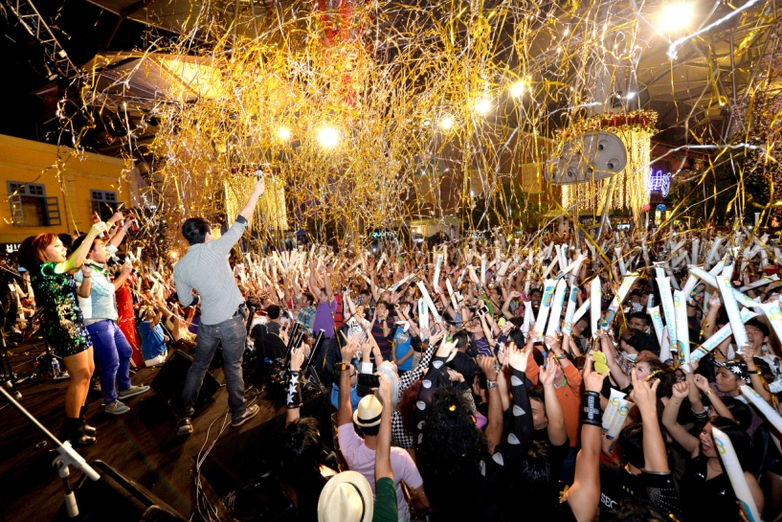

**SINGAPORE, December 2016** – The countdown begins as **Clarke Quay** ushers in 2017 with a massive New Year’s Eve party, hosted by **Class 95** **Muttons In The Morning**, **Kimberley Wang**, and **Simone Heng** on **Saturday 31 December 2016 from 9pm till late**.

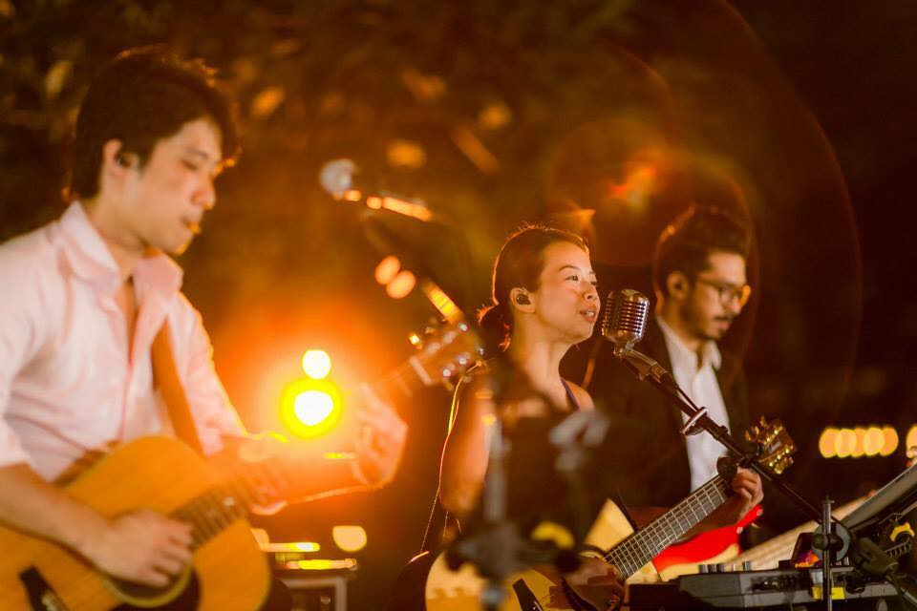

This year, *Clarke Quay Fountain Square* transforms into a massive “live show” with jubilant revelers partying amidst a giant retro television stage backdrop. The outdoor celebration stars Singapore’s most prominent cover band, **53A** – a dynamic six-member group who sang the 2016 National Day Parade theme song. Dance and jump to their electrifying repertoire of contemporary hits, pop, rock and even some classics!

***Photo Credit:facebook.com/53A***

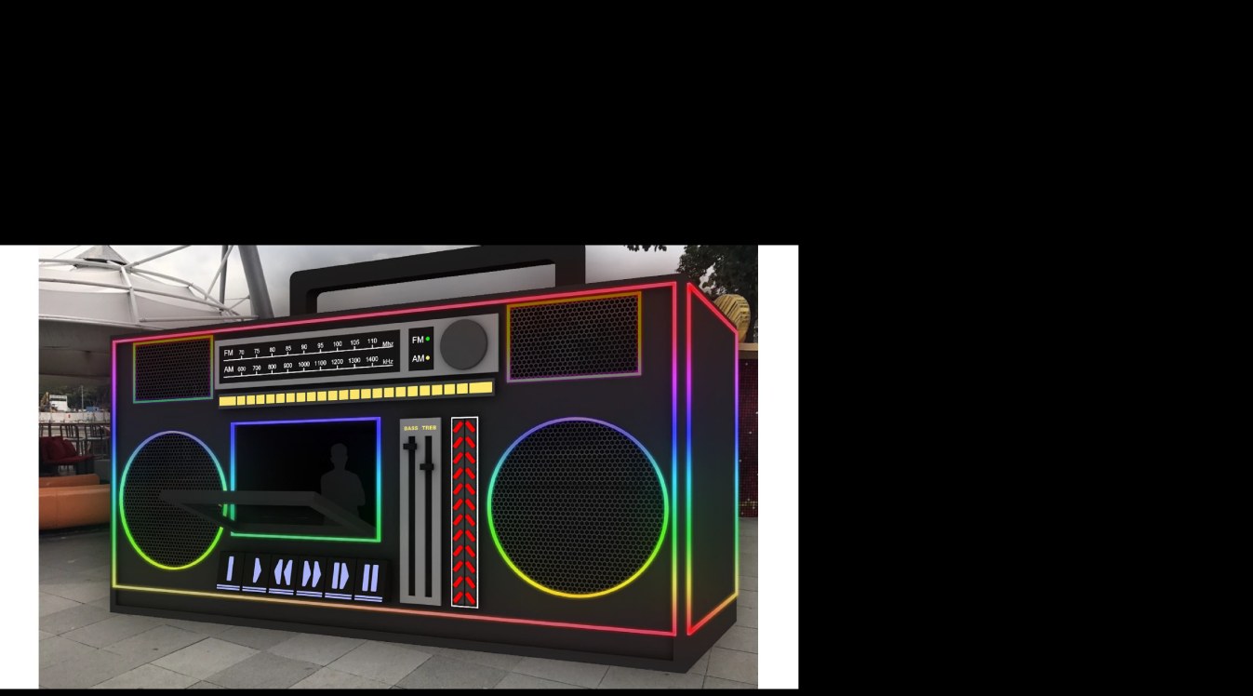Over at *Tan Tye Place,* dance to the anthems at the larger-than-life supernova boom box! On the deck is **DJ Ko Flow** who has performed with international artists such as Mariah Carey, Kanye West, Akon, and Black Eyed Peas; and also appeared in prominent events such as MTV Asia Award post parties, Chingay, and the Asian Hip Hop Festival in Bangkok.

***Supernova Boom Box at Tan Tye Place***



Performing with DJ Ko Flow are a highly energetic crew of **Bboy Sherman**, **Bboy Felix**, **Bboy Jadyn**, **Xiao Mei**, **Jolene Lee**, and **Rachel Tan**, all who have represented Singapore in many hip hop, R&B, and waacking competitions around the world.

Performing near the *Taxi Stand* is the **CYR Wheel** artist who will have you spell bound with his dazzling moves in a spinning wheel.

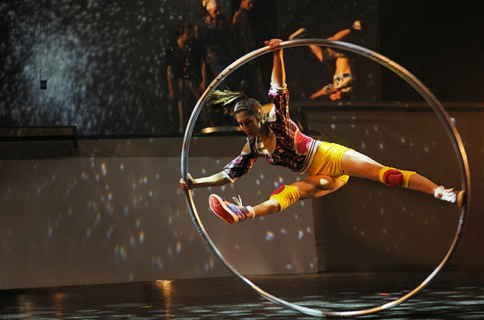Revelers can fill up all night at the myriad of dining and drinks promotions available at **Hooters**, **Pump Room**, **Señor Taco**, **Maziga**, **Octapas Spanish Tapas Bar** and more. Hit the dance floor at **Attica**, **f.Club**, **Neverland**, or the newly opened **Zouk** to start the new year with a blast.

***CYR Wheel in action***

***Bboy Jadyn***

**CapitaStar** is offering **10,000 STAR$\*** ($10 CapitaVoucher) for new sign-ups from 1 December to 31 December 2016. Existing CapitaStar members will receive a bonus of **5,000 STAR$\*** ($5 CapitaVoucher) with a minimum spending of $120 in a single receipt at any outlet in Clarke Quay from now till 31 December 2016.

For more details on New Year’s Eve dining deals and fabulous parties in Clarke Quay, visit <http://www.clarkequay.com.sg>.

###

* Every effort has been made to ensure that the information here is accurate at time of publication. However, changes to the information may have occurred since going to press. Please also check with individual outlets for more information of the respective promotions.

**About Clarke Quay**

Located along the iconic Singapore River at the fringe of Singapore’s Central Business District, Clarke Quay sits on a historical commercial site dating back to the 19th Century. Today, Clarke Quay has been boldly restored and refurbished into five beautiful waterfront godowns under a climate controlled canopy illuminated by coloured lighting, creating a modern and cosmopolitan ambience amidst the tradition and history. Owned by CapitaLand Mall Trust and managed by CapitaLand Mall Asia, Clarke Quay plays host to a wide array of over 60 restaurants, wine bars, and entertainment outlets, attracting about one million visitors every month.

Clarke Quay was crowned Singapore’s best nightspot at the 2014 AsiaOne People’s Choice Awards, orgniased by AsiaOne, Singapore’s leading news portal. Last year, Clarke Quay was awarded the 2015 Certificate of Excellence by TripAdvisor and identified by TripAdvisor as one of 50 iconic places to visit in Singapore, based on the travel website’s data on most-reviewed attraction and eateries.

Website: [www.clarkequay.com.sg](http://www.clarkequay.com.sg)

Like us on Facebook: <http://www.facebook.com/ClarkeQuay>

Follow us on Instagram: <http://www.instagram/clarkequaySG>

Media Contacts

**Elene Foo (Ms)**

Manager, Marketing Communications

Clarke Quay

Tel: +65 6557 7063

Email: elene.foo@capitaland.com

**Aaron Goh (Mr)**

Executive, Marketing Communications

Clarke Quay

Tel: +65 6557 7061

Email: aaron.goh@capitaland.com

**Cristal Tan (Ms)**

Executive, Marketing Communications

Clarke Quay

Tel: +65 6557 7052

Email: cristal.tan@capitaland.com