**Bäckman’s begins the season with a start in TCR Germany**

**This weekend, August 14th-16th, Andreas and Jessica Bäckman joins the ADAC TCR Germany series with team Target Competition in Hyundai i30 N TCR cars. This is to make the final preparations for their main goal of the year, the TCR Europe Championship, which has the season start next weekend, August 21st-23rd at the Paul Ricard track in France.**

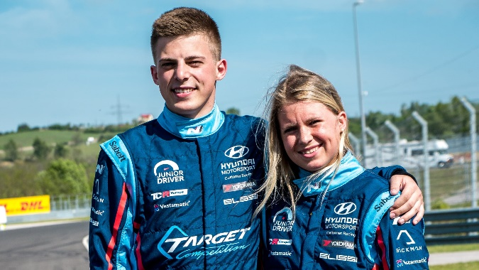

After the approximately ten months break since the last round of TCR Europe 2019 at the Monza track in Italy, the Bäckman siblings will now kick start the 2020 season in the ADAC TCR Germany championship. This to get fully prepared for the season start in their main series for 2020 - TCR Europe which begins the weekend after.

The race takes place at the famous Nürburgring track in Germany, where they run Formula 1, DTM and 24 hours races, among other races. Andreas and Jessica will compete as usual with the Italian team Target Competition in one Hyundai i30 N TCR car each.

This means that the upcoming two weeks will be intense, as the season start of the TCR Europe championship will take place in Paul Ricard, France next week on August 21st-23rd.

ADAC TCR Germany is one of the most competitive TCR series around the world and attracts many spectators and media to the events. The series has a high status of drivers and is driven on the well-known racing tracks in Germany. Last time Andreas and Jessica Bäckman competed in the series, they showed great speed, when Andreas ended up on a stable 2nd place on qualifying. While Jessica showed good race pace and ended up on a well-deserved 2nd place in Race 2 at the Formula 1 track in Hockenheim last year, which bodes well for the siblings’ comeback in the series.

– It will be exciting to be back and compete in ADAC TCR Germany again. It is a series that is ranked high and has a high standard of drivers, so it will not be easy, but it feels good to get back out on the racetracks and to compete again. It will also be a good preparation for next weekend when we are back in TCR Europe after the long break, says **Andreas Bäckman**.

Jessica is also looking forward to race again.

– I’m looking forward to race again after the long brake, and it is extra fun to be back and join ADAC TCR Germany again. In addition, it is a perfect preparation for next weekend when our main series TCR Europe kicks off in France, says **Jessica Bäckman**.

**Timetable for this weekend’s race:**  
All times is local time (German time)

**Friday August 14th:**  
10:35 Free Practice 1  
15:05 Free Practice 2  
17:50 Qualifying (Q1)  
18:20 Qualifying (Q2)

**Saturday August 15th:**  
11:50 Race 1 (LIVE at ADAC TCR Germany on Facebook and on ADAC at YouTube)

**Sunday August 16th:**  
11:25 Race 2 (LIVE at ADAC TCR Germany on Facebook and on ADAC at YouTube)

**Live-streaming**  
Both races will be live-streamed at the [ADAC TCR Germany Facebook page](https://www.facebook.com/adactcrgermany/), and on [ADAC on YouTube](https://www.youtube.com/user/ADAC).

**Live-timing**  
All practice sessions, qualifying and races can be followed via [live-timing here](https://www.adac-motorsport.de/livetiming-sportresult.php?series=32a66e85-b84a-4055-8845-5d6152fa4db3).

**About the track:**

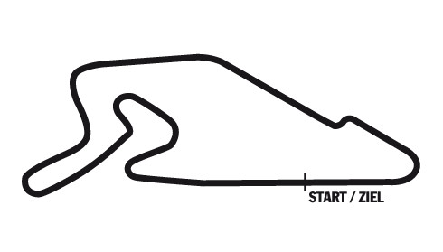

**Located in:**Nürburg, Germany

**Length:**3,629 km

**Corners:** 11

**Race duration:**30 minutes + 1 lap

*Free rights to use the pictures.*