**COX POWERTRAIN PREVIEWS WORLD’S FIRST PROFESSIONAL 300HP DIESEL OUTBOARD AT EURONAVAL**

*Euronaval 2016, Paris Le Bourget, 17th to 21st October, Stand G12*

British diesel engine innovator, Cox Powertrain, is previewing its pioneering professional outboard motor, the CXO300, at Euronaval. Cox has brought together highly skilled engineers from Formula 1 racing and premium automotive engine design to develop this completely new concept diesel engine, providing gasoline outboard performance, with diesel economy and reliability.

Cox will display a full sized model of the CXO300, which has been designed specifically for professional marine users. Delivering 300hp and weighing only 300kg, the engine is a high performance, lightweight diesel engine ideal for marine outboard applications on the fast, rigid inflatable boats used by the Royal Navy. The CXO300 has been built to operate in the demanding conditions of a military application in which extreme diesel performance, light weight and small package size are critical to mission performance, and must be delivered alongside robustness and high reliability of operation.

Backed by the UK Ministry of Defence (MoD), the Cox Powertrain engine concept is based on a supercharged, two-stroke diesel opposed piston architecture with Scotch Yoke crankshaft and a central injector position. This engine topology provides power-to-weight ratio comparable with high performance gasoline engines, whilst delivering diesel fuel consumption and a package volume around half that of a state-of-the-art diesel engine. Crucially for military applications, it also offers much longer service intervals for heavy use.

Cox Powertrain is led by former Cosworth CEO Tim Routsis who commented, “Euronaval is an important venue for us to showcase our technology to the military market. The development of the CXO300 is now entering the final stages of a five year development programme so we are excited at the prospect of introducing this game-changing technology to the market ahead of its launch. We have brought together some of the UK’s foremost experts in engine design to turn this concept into a reality. Owners can be confident that this new diesel outboard is ready for the tough and demanding environment in which it will operate. ”

Cox is a British company based in West Sussex, dedicated to answering the demands of commercial, government and military marine operators, for a reliable and powerful diesel outboard. With petrol now not permitted on-board military ships, in addition to many commercial vessels and superyachts, the development of a viable diesel outboard for RIBs and tenders, offering the comparable power and weight of a gasoline engine, has been an important factor in the rapid expansion of Cox Powertrain.

For further information, visit [www.coxmarine.com](http://www.coxmarine.com)

ENDS

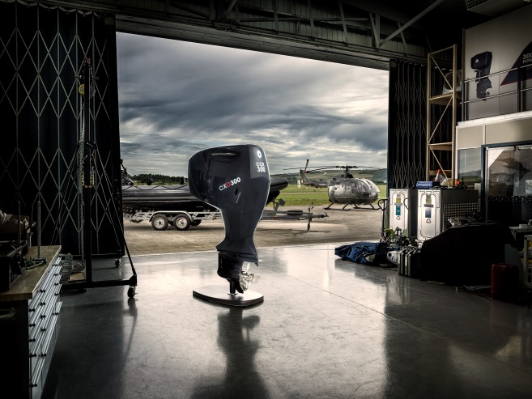 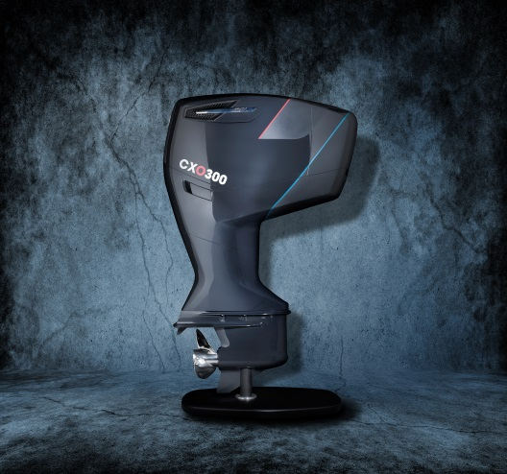

Photo Caption: The CXO300

High resolution images can be downloaded at: <http://bit.ly/2aTUybY>

**About Cox Powertrain**

Cox Powertrain is a world-leading British designer and builder of diesel engines developed for worldwide and multi-market applications.

Based on the South Coast of England, Cox Powertrain is backed by the Ministry of Defence and a solid shareholder base of private and institutional investors. As a result, the company has been able to implement a long-term development programme of ground-breaking new products.

Led by ex-Cosworth CEO, Tim Routsis, whose background lies in engine development in global automotive, aerospace and marine markets, the company’s mission is to deliver a completely new concept in diesel engines that has the potential to revolutionise the marine market.

With a strong pedigree in Formula 1 racing and premium automotive design, Cox’s highly skilled team of engineers has decades of experience in combustion engines and understand the many difficulties customers are challenged with.

Cox’s first ground-breaking diesel outboard engine, the CXO300, is the highest power density diesel outboard engine ever developed. As a low weight, high power, single fuel engine, the CXO300 delivers the same performance and efficiency of an inboard but with the convenience and flexibility of an outboard.

For further information, visit www.coxmarine.com

**Media contacts:**

Reena Bayley, Marketing Manager

Cox Powertrain Limited

Tel: +44 (0) 1273 454 424

E: reena.bayley@coxpwertrain.com

**Media information & images:**

Karen Bartlett

Saltwater Stone

Tel: +44 (0) 1202 669 244

E: k.bartlett@saltwater-stone.com