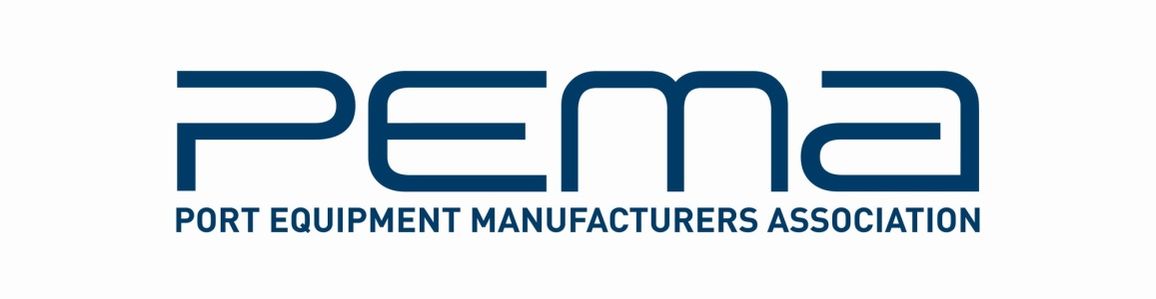

Media Release

Port Equipment Manufacturers Association welcomes four new members

ZPMC, Nantong Heavy Rainbow Machineries, Spohn + Burkhardt and INTERCON Technical Information Systems join global industry trade body for port equipment and technology

London, January 14, 2015 – The Port Equipment Manufacturers Association (PEMA), the global industry body for port equipment and technology, has announced four new member companies: ZPMC, Nantong Rainbow Heavy Machineries, Spohn + Burkhardt and INTERCON Technical Information Systems.

Headquartered in Shanghai, ZPMC is the world’s largest supplier of container cranes and other heavy-duty equipment. The Chinese state holding company has 8 production bases across the country, covering nearly 7,000 hectares and 10km of coastline, and owns a fleet of 26 heavylift ships to deliver its products around the world. Today, ZPMC equipment is used in over 150 ports in nearly 80 countries.

Nantong Rainbow Heavy Machineries (RHM) also supplies heavy-duty cranes and other machines on a global basis to the ports, mining, shipbuilding, manufacturing and offshore industries, among others. In the ports sector, RHM supplies both container and bulk handling equipment. RHM is based in Nantong, China, where it operates manufacturing and research facilities.

German company Spohn + Burkhardt produces a broad spectrum of control systems and stations for transport, construction and handling equipment, including container cranes and ships. The family-owned company was established in 1920 and today operates two production facilities in the southwest of Germany, providing both electric and electronic control solutions.

Based in Abu Dhabi, UAE, INTERCON Technical Information Systems (TIS) provides drive and motion control systems for cranes, including low and high voltage electrical designs and diesel generator sets as well as automation and process control solutions, consultancy and project management services. The company serves the Middle East and Africa.

“We are delighted to welcome two major Chinese crane manufacturers and two experts in equipment control technology as our latest members,” said Ottonel Popesco, President of PEMA. “With nearly 80 member companies today, PEMA is the trusted industry body representing all facets of port equipment and technology on a global scale.“

About PEMA
Founded in 2004, PEMA provides a forum and public voice for the global port equipment and technology sectors. The Association has seen strong growth in recent years, and now has nearly 80 member companies representing all facets of the industry, including crane, equipment and component manufacturers; automation, software and technology providers; consultants and other experts. www.pema.org

For more information on this media release, please contact Rachael White, PEMA Secretary General at: Tel +44 20 8279 9403 | rachael.white@pema.org

