Press Release |  | 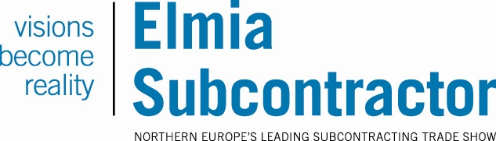
Elmia AB
2014-11-06

Tesla team visits Elmia Subcontractor:

“We’re always looking for world-class suppliers”

An entire team from the American electric car manufacturer Tesla Motors will be at Elmia Subcontractor next week.
“Right now we’re probably the world’s fastest growing vehicle manufacturer and we need many new suppliers,” says the head of the company’s Scandinavian operations, Peter Bardenfleth-Hansen.

The Tesla team is primarily interested in finding technologically advanced companies that can offer speedy deliveries, have world-class production facilities and are highly committed to sustainable solutions. The plan is to explore the terrain with a totally open mind and send interesting suggestions back to headquarters in Silicon Valley, USA.
“We’re looking forward to visiting Elmia Subcontractor,” Bardenfleth-Hansen says. “Because all our production is currently done in the US, at the moment we’re looking primarily for suppliers of products that can be easily shipped. Various types of connections, infotainment, advanced control systems and not least lightweight materials are of interest.”

Elmia Subcontractor’s project manager Karla Eklund welcomes the Tesla team’s visit.
“The purpose of the fair is to create business benefit and showcase innovations. That’s something we at Elmia are constantly working to make a reality. The fact that Tesla is now choosing to source its suppliers at Elmia Subcontractor is proof to me of the fair’s importance to the industry.”

While at the fair Bardenfleth-Hansen will also be participating in Företagarna’s event called “Masters of Mistakes” and sharing some of Tesla Motors’ successes and setbacks.
“This is the first time we’re doing a niche activity with an industrial angle,” explains Frida Boklund, regional manager of Företagarna. “It will be extremely exciting to hear how Tesla works. It’s great that they’re taking the time to come here.”

