Contact Details:

For more information, contact Mike Williams, Press Officer on 07748620235 or newsdesk@ukbjja.org

**\*For immediate release\***

**New martial arts programme gets Newcastle youngsters rolling**

A new programme designed to get young people active and involved in sports has started at a Newcastle Upon Tyne martial arts studio.

Get Rolling is a six week programme backed by Tyne & Wear Sport and Sport England designed to give people between 14 and 25 a taste of Mixed Martial Arts (MMA) and Brazilian Jiu Jitsu (BJJ).

It runs at Origin Dojo located at King Edwards Bridge, Off Pottery lane. The head instructor is Ian Malone, a highly respected Brazilian Jiu Jitsu Black Belt and veteran of a number of professional MMA fights. The sessions incorporate BJJ along with Muay Thai kickboxing, wrestling, MMA and some self defence too.

Part of the Sport England ‘Spirit of 2012’ initiative, Get Rolling is aimed at attracting kids and youngsters who aren’t physically active and get them interested in taking an part in new sports at a low cost (the Get Rolling programme costs just £10 for six weeks).

Ross Heaton, who completed the six taster sessions in the summer has continued to train at Origin and now hopes to compete. According to Ross, “You get physically fit, but more so down here at the club there's such a group vibe, you know, everyone is so happy to help everyone out and it creates a really good atmosphere to learn and progress. Everyone is nervous when they first come in, because you think it's going to be an intimidating atmosphere and you don't know anybody - but everybody will welcome you with open arms. I'd love to compete, you learn all these new skills, so you want to test yourself, don't you?”

Origin Dojo also runs thriving adults and kids’ classes and hosts the North East Kids’ BJJ League which offers kids in the North East a chance to compete and earn points for the official national UKBJJA rankings.

Lesley Harrison, one of the Junior Coaches at Origin said “we’ve got kids coming to train from as far as Berwick and Carlisle, and the Kids’ League competitions are getting loads of support from clubs all across the region. We’ve got high hopes for the future of the sport.”

Although relatively new to the UK, Brazilian Jiu Jitsu is now one of the fastest growing sports in the world with over 10,000 people regularly training in gyms across the UK. The governing body is the UKBJJA (<http://www.ukbjja.org>) which aims to get more youngsters and women active in the sport through regular kids’ competitions and the recently launched Unstoppable Girl programme.

*ENDS*

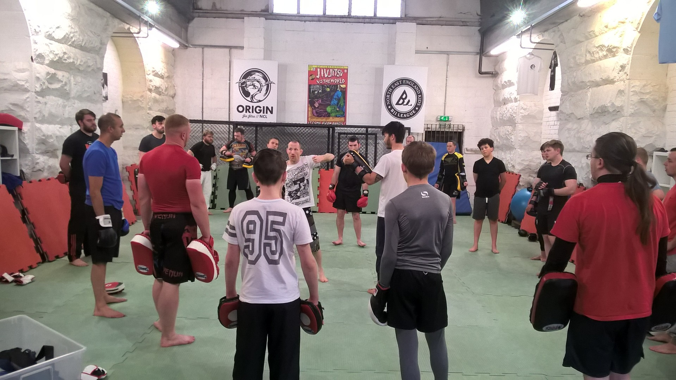

*Head instructor Ian Malone puts kids and adults through their paces at Origin*

About the UKBJJA:

The UKBJJA ([www.ukbjja.org](http://www.ukbjja.org/)) is a not-for profit organisation which aims to provide a governance structure for the martial art of Brazilian Jiu-Jitsu, that promotes and develops the sport while allowing individual clubs and practitioners the space and freedom to practice the martial art in the way they enjoy. The UKBJJA is currently under assessment to be recognised by Sport England as the governing body for Brazilian Jiu Jitsu in the UK.

The UKBJJA was formed in 2013, and the association’s goal is to foster the development of BJJ at elite, community and grassroots levels, raising the profile of the sport but also providing pathways for development and involvement across communities in the UK. Visit UKBJJA at [www.ukbjja.org](http://www.ukbjja.org/) or follow us on Twitter @ukbjja.

Additional Info:

Origin BJJ Newcastle: <http://originbjj.co.uk/contact-us/>

Tyne & Wear Sport: <http://www.tynewearsport.org>

Contact Details:

For more information, contact Mike Williams, Press Officer on 07748620235 or newsdesk@ukbjja.org