THE MARINE TECHNOLOGY EXPERIENCE
‘Proven by adventure’

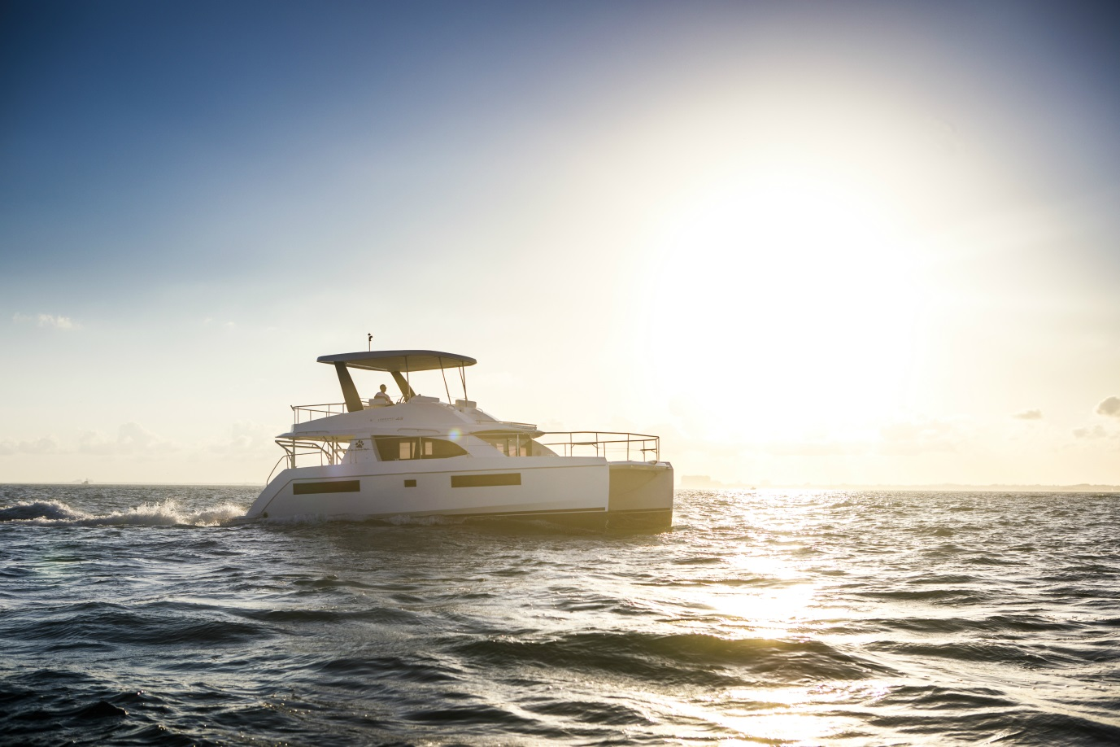

For many adventure-seekers travelling to their dream destinations, a power yacht or catamaran is typically how the journey of a lifetime begins.

The yacht charter industry has long had the ability to capture the hearts of boaters and non-boaters alike. However, as in other sectors, continuous innovation is vital in order to keep pace with the needs of consumers.

As modern society moves from material to experiential spending, power yachts and catamarans remain the ideal platform for those with a trailblazing spirit to push the boundaries in the search of new experiences.

To satisfy their needs, the charter industry continues to rely on flexible technology partners who can facilitate the lifestyle expected by consumers. At all times, they must remain as pioneering as those who delight in the thrill of sailing to new horizons.

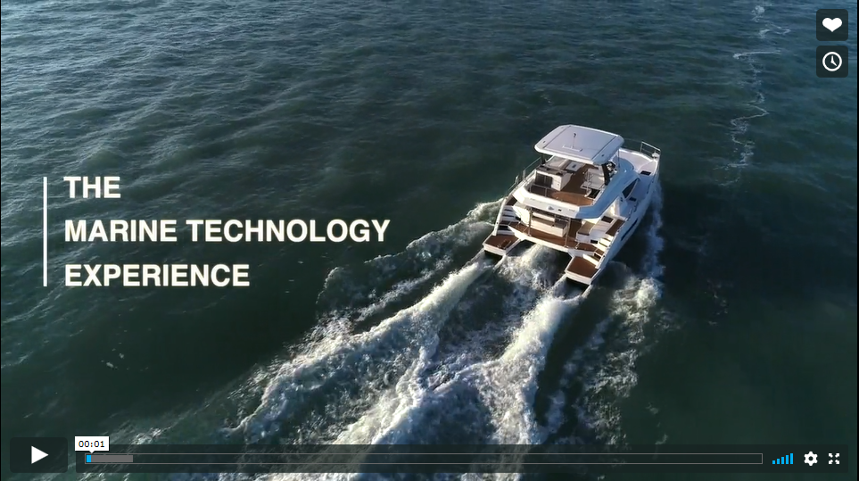

The adventure begins

Three marine brands – Leopard, The Moorings and Sunsail – are working to provide unforgettable travel experiences for those in search of original and dramatic sailing and yachting adventures.

Launched in 2001, and now operating under the Travelopia umbrella, Leopard is the number one catamaran in North America and one of the top brands globally.

“Purchasing a Leopard is the start of the adventure for our owners and they demand reliability in order to have complete peace of mind,” explains Leopard’s VP of Yachts, Franck Bauguil. “For customers, our brand and what we represent is important, but for us, it’s all about what happens inside the boat.”

Setting a high standard in the industry is important to all three brands. However, as The Moorings was established in 1969, and is arguably one of the most well-known companies in this sector, taking the lead and being seen as a pioneer are important considerations.

To power their vessels and support their customers’ adventures, Leopard, The Moorings and Sunsail turned to a world leader in marine diesel engines as their partner of choice.

At the heart of every adventure is a clean Yanmar diesel engine and, crucially, it works in close cooperation with all three companies to deliver the best marine experiences possible.

After all, adventures are best remembered when they reliably exceed people’s expectations…

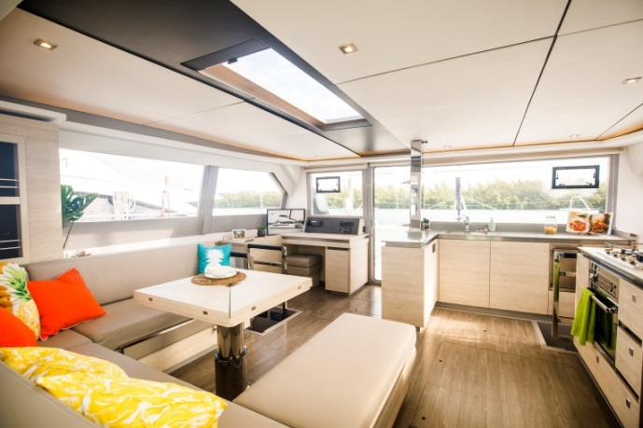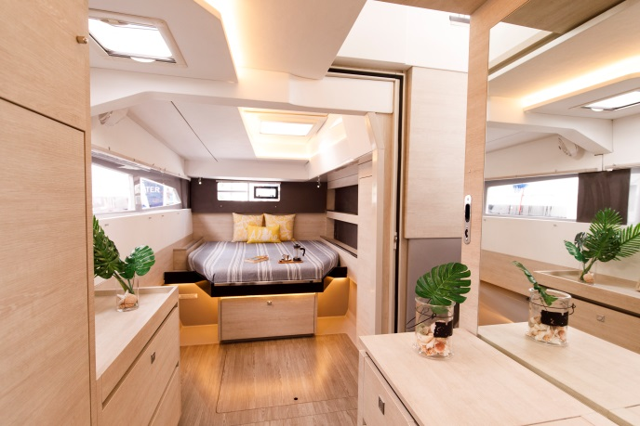

Innovation is key

Given their pedigree in the charter market, it is no surprise that The Moorings and Sunsail look to continuously co-create with trusted suppliers. Innovation is essential, and as such, the two companies continually implement feedback from customers, owners, and operational teams.

This is also an important topic for Leopard, as Franck confirms: “We receive feedback from different stakeholders through different touchpoints. Then, we collect that data and use it to improve our products and develop solutions, often in close cooperation with Yanmar.

“They’ve listened to our needs over time, and there’s always a positive exchange between Yanmar’s engineers and our technical department. It’s great to have a long-term partner, who responds to our findings and is able to match our requirements.”

For VP of Sales and Marketing for The Moorings and Sunsail Josie Tucci, this arrangement can be summarised perfectly: “We like to think of ourselves as the vessel through which our customers can seek adventure, and that is all powered by Yanmar.”

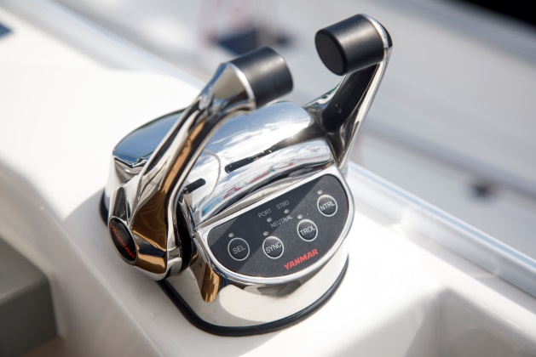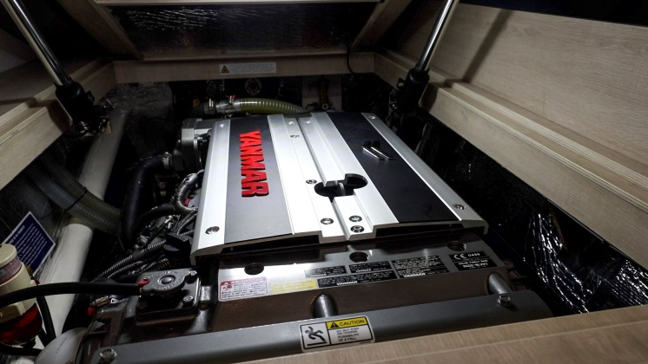

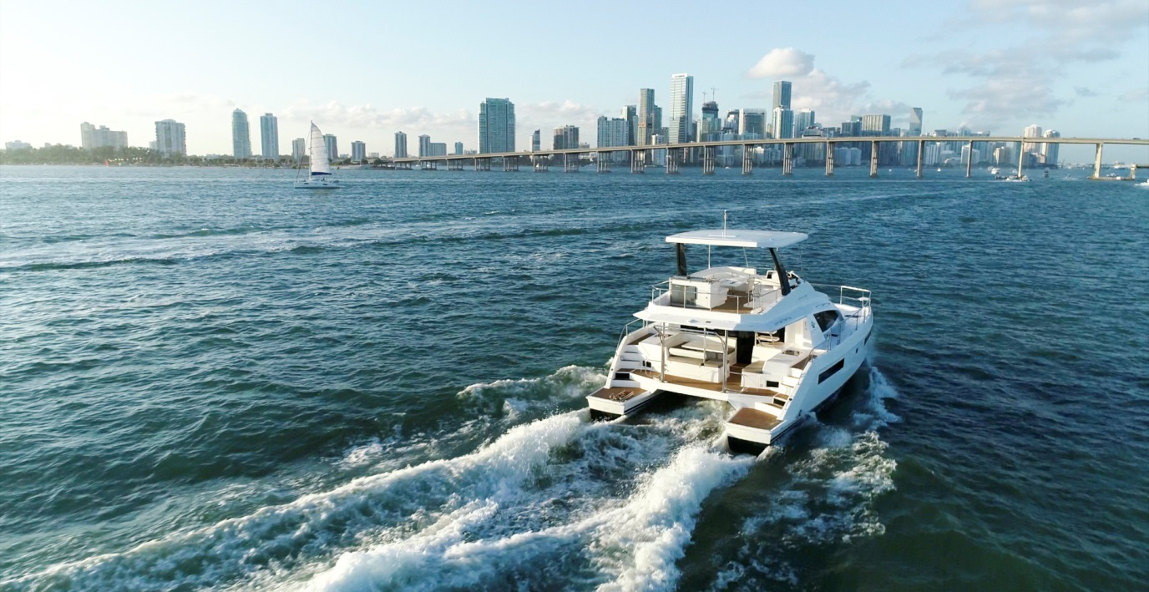

Two of a kind

In Josie’s opinion, there have been significant changes in the charter market over the past five decades: “People’s expectations have changed dramatically since we started out in 1969, and technology continues to play a large role. In the early days, everyone had to put up the sail themselves and there was no GPS.

“However, everything is now electronic and fully integrated, including the Wi-Fi and sound systems. Put simply, people want to be as comfortable on board as they are at home.”

To meet the demand for increased power and reduced fuel consumption, The Moorings and Sunsail rely on one major commonality – the Yanmar engine.

“Our customers want a home away from home on their travels, and thanks to Yanmar, they can be adventurous and go further than ever before. They are safe in the knowledge that their Yanmar engine can take them wherever they want to go.”

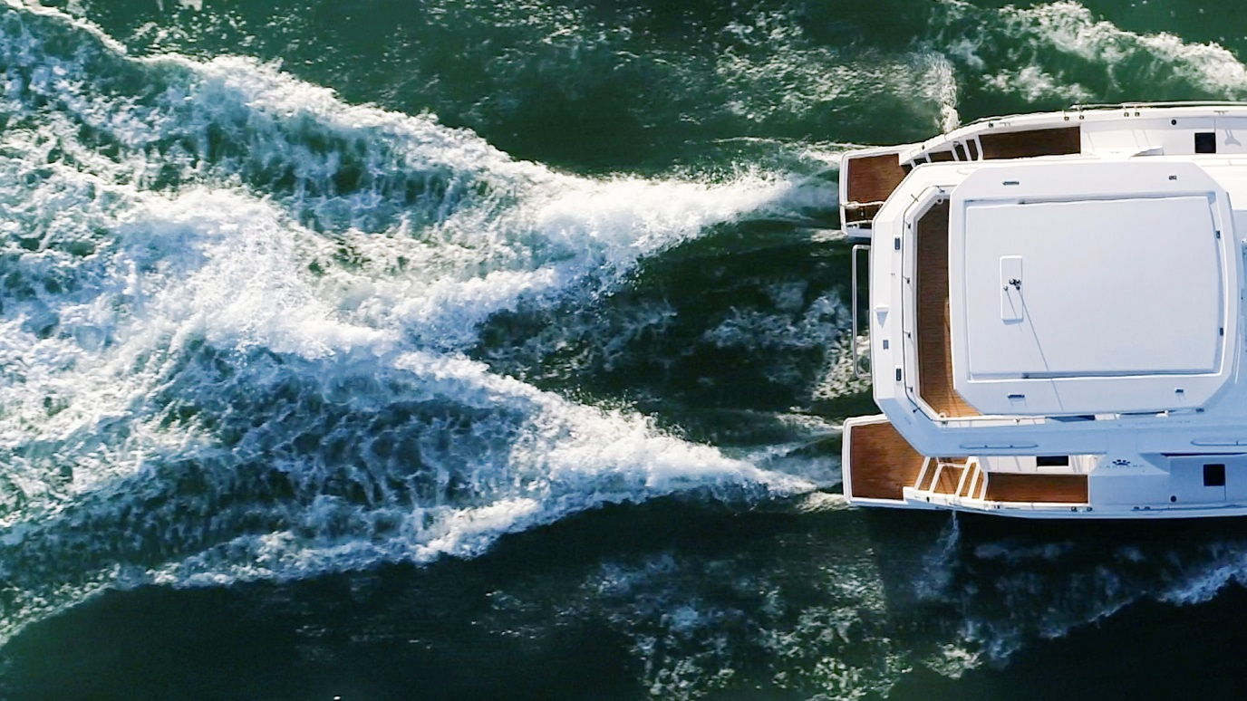

A future without limits

There is a line in a famous poem by John Donne that reads: ‘No man is an island’. The same can also be applied to those journeying to new horizons. Anyone exploring distant shores to enjoy the beauty of nature must also take responsibility to reduce the impact of their activities on the planet.

For Josie, Yanmar is the ideal partner to challenge the industry and help deliver environmentally friendly adventures: “Clean power and simplified systems are more important than ever. For this reason, the industry needs to ask itself how to generate power and use less fuel at the same time.”

Working in harmony to expand their customers’ horizons – and powered by Yanmar – The Moorings, Sunsail and Leopard will be able to guarantee their customers unforgettable adventures for a long time to come.

