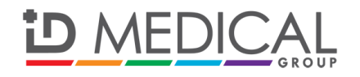

**PRESS RELEASE**

**For immediate release: Tuesday 17 February 2015**

**Making a big difference to patient care: ID Medical School to offer cutting-edge language courses**

**[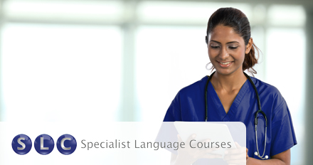](http://www.id-medical.com/english-language-course)**

### Specialist Language Courses (SLC) is the latest addition to ID Medical School’s repertoire of medical education focused deliverables, strategically appointed to encourage international healthcare professionals to improve their practical communication skills.

### SLC’s 100-hour CPD accredited online course ‘Online English for Nurses: Getting the Essentials Right’ is offered at an exclusive discounted rate to ID Medical’s registered international nurses (with courses dedicated to HCAs from March and doctors from July 2015), and is written by English language professionals in conjunction with practising medical professionals.

Chris Moore, managing director of SLC commented, “Communicating accurately and effectively in consultations and every day interactions is critical to the safety, care and wellbeing of patients. We must be acutely aware that the way patients perceive information being communicated by the healthcare professional can often have a detrimental effect, as found in a [recent study](http://www.exeter.ac.uk/news/featurednews/title_432073_en.html) by the University of Exeter Medical School.

### The practical online language course available through ID Medical School will certainly make a massive difference to the quality of a healthcare professional’s work, and ultimately a big improvement in real areas of patient care.”

### Caryn Cooper, head of ID Medical School added, “Communication with patients is a prominent theme within the healthcare industry of late. This month saw the major launch of the #hellomynameis campaign founded by Doctor and terminally ill cancer patient Kate Granger, who made the stark observation as an in-patient that many NHS staff did not introduce themselves before delivering care.

### ID Medical supports this campaign and recognises the increasing requirement from its NHS client Trusts for effective communication to be integrated into training, which is why we are delighted to include SLC in our strategic partnerships programme, to add further value to our medical education and client services offerings, always intending to create better working relationships and consequently better patient outcomes.”

## ENDS

**Notes to editors**

Recent [research](http://www.exeter.ac.uk/news/featurednews/title_432073_en.html) conducted by the University of Exeter Medical School published in the American Journal of Medicine found that the effects of patients feeling their healthcare professional doesn’t believe or understand them, can be damaging both emotionally and psychologically.

**About Specialist Language Courses (SLC)**

SLC is a specialist technical and business language training consultancy, designing, delivering and facilitating flexible, high quality language training programmes around the world.

Read more about Specialist Language Courses and the online English for Nurses course available through ID Medical School [here](http://www.id-medical.com/english-language-course).

**About ID Medical School**

ID Medical School formed in 2014 is an educational sub-brand of award-winning, multi-discipline healthcare recruiter ID Medical Group – the UK’s leading supplier of locum doctors, nurses, allied health professionals and clerical staff, holding preferred supplier contracts with over 90% of NHS hospitals and private medical sector organisations.

Through collaborative working with a number of prestigious and established medical education focused organisations, ID Medical School strives to enrich the careers of healthcare professionals, presenting various educational strands to the recruiter’s registered doctors, nurses and allied health professionals, supplementary to ID Medical’s existing innovative workforce solutions and services.

Above all, ID Medical School has been established with three key pledges: 1) Help to alleviate staffing pressures in the NHS by equipping professionals with up to date medical training with CPD credits, 2) Support international healthcare professionals with medical English communications and practical up-skilling and 3) Support the next and ongoing generation of healthcare professionals, laying the foundations for safe, motivated and skilful junior NHS staff.

For more information please visit our website at <http://www.id-medical.com>, view our [Facebook](https://www.facebook.com/IDMedical) page or follow us on Twitter [@IDMedical](https://twitter.com/IDMedical). You can also contact ID Medical’s head of marketing Caryn Cooper direct on:

**Caryn Cooper**

head of marketing and ID Medical School

Description: markdes

ID MEDICAL - ID House - 1 Mill Square - Wolverton Mill South - Milton Keynes - MK12 5ZD

**t:** +44 (0) 1908 555 498 **f:** +44 (0)1908 552 825

**w:** id-medical.com   **e:** [caryn.cooper@id-medical.com](mailto:caryn.cooper@id-medical.com)

[cid:image002.png@01CF5FCD.A84FA500](http://www.facebook.com/IDMedical)  [cid:image003.png@01CF5FCD.A84FA500](http://www.twitter.com/idmedical)  [cid:image004.png@01CF5FCD.A84FA500](https://plus.google.com/104338735298043774830/posts)  [cid:image005.png@01CF5FCD.A84FA500](http://www.youtube.com/user/IDMedical2012/videos)