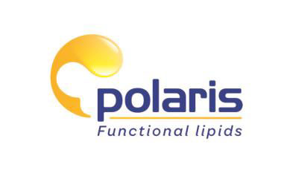
For immediate release: 19 October, 2018

Omega-3s will boost Polaris director on transatlantic yacht race

The Scientific Director of Polaris is increasing his Omega-3 supplementation as he prepares to take part in one of the world’s toughest yacht races.

Gildas Breton is an experienced amateur yachtsman and will compete in next month’s Route du Rhum, a solo race that starts in St Malo in France and finishes 3,500 miles away in Guadeloupe.

He is also the Scientific Director of Polaris, a French-based company which manufactures, develops and formulates natural and concentrated Omega-3 oils from fish and microalgae for functional food and supplements.

Knowing as well as anyone the health benefits of Omega-3s ― which include higher quality sleep, reduced anxiety and improved cognition ― Gildas has been increasing his supplementation in preparation for the gruelling race.

Gildas Breton, said: “Crossing the Atlantic solo is a huge challenge, so you need to do everything you can to get an edge. Two of the biggest problems are getting enough sleep and staying mentally sharp ― both areas where Omega-3s can help. I’ve increased my consumption and I’ll be taking supplements on the journey with me. I’m hoping they’ll put some extra wind in my sails!”

The Route du Rhum takes place every four years and 120 yachtsmen will be taking part in the 2018 event, which begins on 4 November. Polaris will be sponsoring Gildas Breton: the company’s name and logo will be prominently displayed on his boat, a 40-foot trimaran named BO Carre.

Gildas added: “The Route du Rhum has an almost mythical status ― it’s the race every sailor dreams of. I’ve always been passionate about the sea and I’m lucky to have had the opportunity to balance my love of sailing with a career in marine biotechnology.”

Polaris’ Omegavie® marine oils are made in state-of-the-art facilities in France according to strict standards. They benefit from the company’s unique Qualitysilver® process, which makes them ultra-stable.

About POLARIS
POLARIS is a leading worldwide expert in the field of functional lipids from fish and micro-algae.
With state-of-the-art facilities in France, it manufactures, develops and formulates natural and concentrated Omega-3 oils.

POLARIS’s «Omegavie®» range of oils is produced under a unique patented process (Quality silver), which helps it achieve high stability and a unique sensory profile.

POLARIS is an active member of GOED.

For more information, visit www.polaris.fr

Company contact:
Mrs Véronique SANCEAU
Marketing & Communication Manager
Phone:+ 33 (0) 2 98 54 75 45
Email: marketing@polaris.fr

For more information or to request an interview, contact:
Steve Harman
Account Director
Ingredient Communications
Phone: +44 (0)7538 118079
Email: steve@ingredientcommunications.com

*

