Why Use TestStand If You Don’t Use the Results?
The test world is divided in two parts, either you really love TestStand or you hate TestStand, the test administrator from National Instruments.
So, what do I think? Well, it depends on the application and especially how it is going to be maintained.
Sometimes TestStand can be the perfect simple solution for automated tests, but sometimes it is easier to build a special application yourself. I’ve seen many TestStand applications that has been both well written and also those that were a total mess and very difficult to understand and change.
But one of the most interesting aspects are: why waste time and money on TestStand if you don’t take full advantage of the tool? All TestStand applications have one thing in common, they generate tons and tons of test reports that no one really cares about nor have time to analyze.
Why, is a good question, since they consists of extremely valuable information about your measurement process?

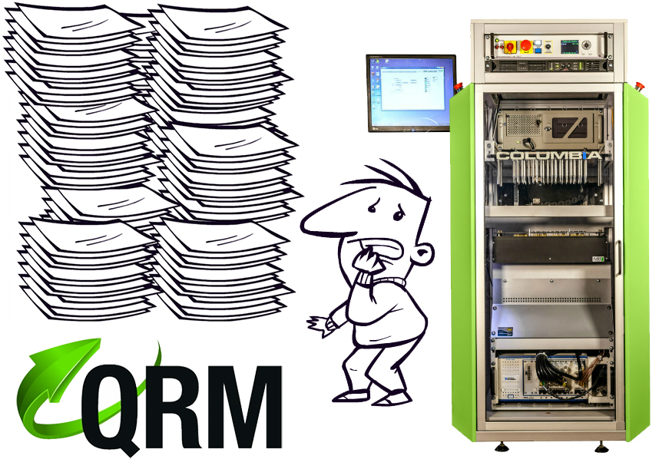

If you don’t use the information in your test reports; then why waste time and money on TestStand?
Maybe you do use the simple database connector, but more often this becomes the “black hole of test result data”. Whatever gets in never gets out.

In 2012 National Instruments introduced a completely new result processor in TestStand where you can plug in any kind of result processor. The result processors are working asynchronous, which means there is no waiting time for the results to be processed and TestStand can continue testing the unit to be tested.
If you manage, and take care of your results - your TestStand investment really pays off!

The QRM (Quality Result Management) from AddQ has a TestStand Result Processor Plugin
After installing the QRM result processor, any TestStand sequence can export results immediately without any change.
The QRM plugin will then post the test results as an ATML/XML report to the background via the QRM web service that will then forward the results to a cloud based database, which is then easily viewed and analyzed through the QRM Web Application.
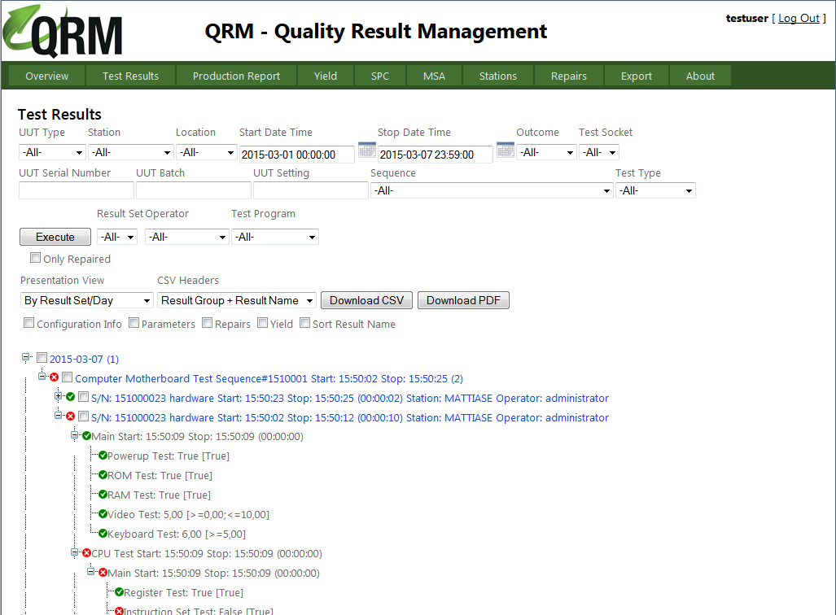
(*) the infamous TestStand motherboard demo sequence shown in the QRM Web Application.

About the author
Mattias Ericsson is R&D Manager at AddQ Consulting and is a LabVIEW Certified Architect. He has been working more than 15 years with LabVIEW development and is one of the main architects behind the award-winning toolkit G# Framework and the new result management system QRM.

