Viagame to broadcast LCS live from gamescom

STOCKHOLM, August 13, 2014. Viagame will be broadcasting the LCS EU playoffs exclusively in several languages live from gamescom, the largest gaming event in Europe.

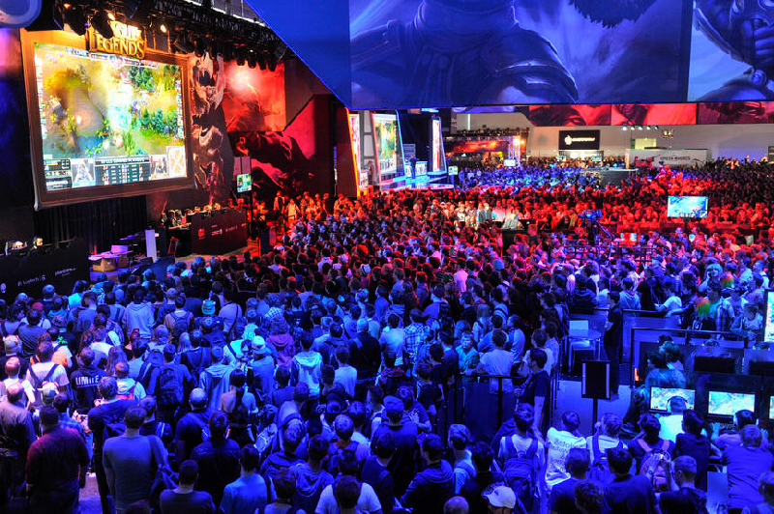
Viagame have acquired the rights for the exclusive broadcasts of the LCS EU playoffs in Romanian, Bulgarian and Swedish. This year the play-offs will take place at Europe’s largest gaming convention, gamescom in Cologne on August 14-17. Live and on demand coverage of the playoffs will be available, as well as pre-shows and talk shows from the event. Viagame will also provide the official English stream live and on demand.

gamescom is the central platform for the European computer and video game industry and takes place in August every year since 2009 in Cologne, Germany. The 2013 event had more than 340,000 visitors. Read more here: www.gamescom-cologne.com

For any questions, please contact Isabelle Ewert, PR Manager at Viagame Isabelle.ewert@mtgx.se

Viagame is a global streaming channel providing eSport content to a global audience. We deliver premium live and on demand content from the biggest leagues including The International and Dreamleague. We also deliver casual content such as review shows and interviews. Our service is available on our website and on mobile and tablets. Viagame is a part of MTGx, the digital accelerator of international media company Modern Times Group (MTG).

