Press release
Düsseldorf, 16/03/2023
HT auctions machinery of insolvent Postel Druckguss GmbH
Postel Druckguss GmbH, a specialist for aluminium and zinc die-casting solutions, has filed for insolvency in 2020 and is being supported by HT Hanseatische Industrie-Consult GmbH. Over 800 machines and operating equipment will be sold in an online auction until 30/03/2023.
Postel Druckguss GmbH is a renowned specialist for die-casting solutions made of aluminium and zinc. The company, based in Cologne, was hit hard by the Corona pandemic and had to file for insolvency in 2020. The parties involved in the insolvency proceedings are being supported by HT Hanseatische Industrie-Consult GmbH. HT is one of the leading service providers for the valuation and realisation of mobile assets and industrial goods in the insolvency business in Germany. The company has made a name for itself in the market, particularly in the field of successfully organising international industrial auctions.
Postel: Precision in die-casting
At Postel, aluminium and zinc die-cast products are manufactured. The company portfolio is broad – from the design of the customised component to the packaged and ready-to-install product.
For the metalworking industry, the Postel insolvency means that numerous high-quality machines are entering the used machinery market. More than 800 items are available at industrial auctioneer HT until 30/03. The auction includes various die-casting cells, CNC machining centres, measuring technology for quality assurance as well as lots of tools and factory equipment. Curious buyers can stroll through the facility in a 3D tour and take a look at the machines and examine them closely.
There have also been recent changes at HT
At the beginning of 2023, HT shareholders Holger Haun and Tom Thomsen sold their business shares to the industrial auction house Surplex and long-time Surplex employee Christoph Partzsch. Mr. Partzsch has been working in auction houses for 20 years and he will now complement HT's management.
“With the change in ownership, nothing will change for HT’s business partners and employees for the time being. HT will continue to concentrate on its existing business with a focus on the insolvency market,” says Christoph Partzsch. With Surplex, HT has a complementary partner at its side. The Postel insolvency marks the start of the cooperation.

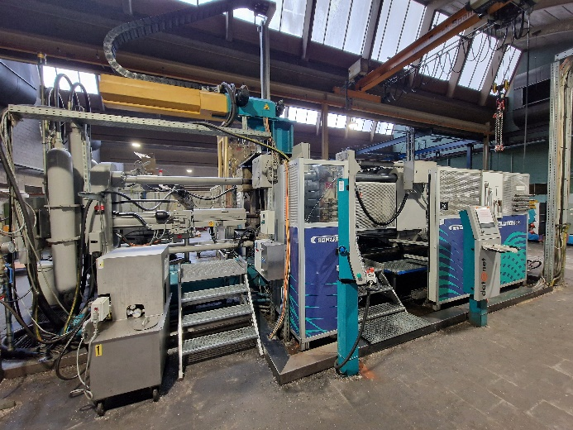 | Photo 1  Insolvencies mean for the industry that high-quality, newer equipment is available on the used machinery market. They are cheaper than new and immediately available – like this aluminium die-casting cell. It is up for auction at HT until 30/03.  (© HT).
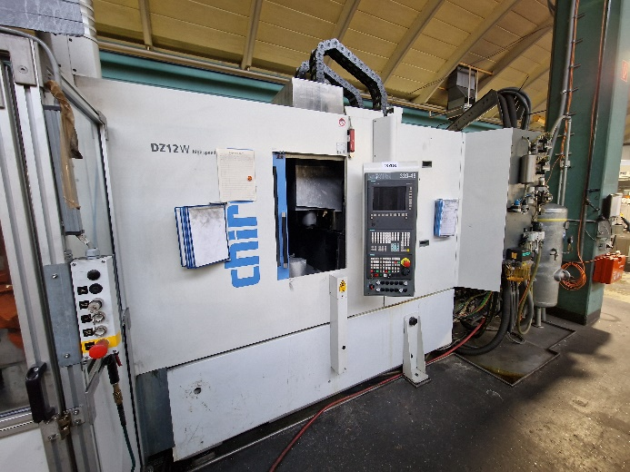 | Photo 2  A machining centre is the name given to a multi-axis CNC machine for the complete machining of components by turning, milling and drilling and changes the tools automatically. They are expensive to purchase. With a service life of well over 30 years, a used purchase is therefore worthwhile.  (© HT).

