Press release
Kongsberg Digital adds Recogni as a new partner on the Kognifai Marketplace

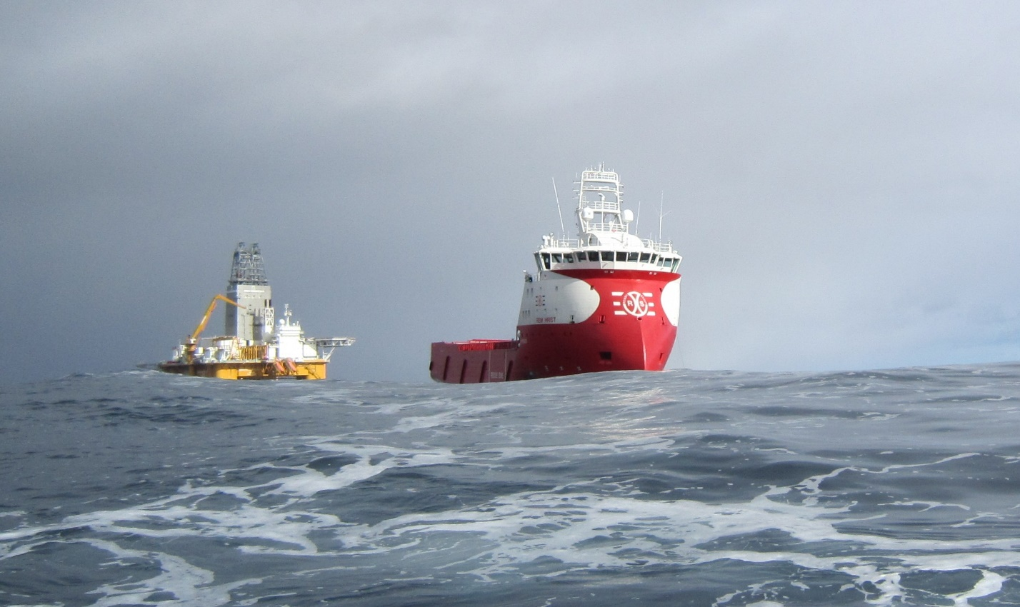
Recogni’s energy efficiency tool is now available on the Kognifai Marketplace. It can reduce fuel consumption by more than 15%

Asker, Norway, June 28th, 2021 – Kongsberg Digital has signed a partnership agreement with Recogni to add their Blue Power EMS application to the Kognifai Marketplace. The application, which is big data based, is an energy efficiency tool that can reduce fuel consumption with more than 15 percent.
Blue Power EMS will help ship owners and operators to reduce fuel consumption by combining operational data from the vessel with weather data, such as ocean currents and wave height. The crew receives optimal parameters, like best speed and engine configuration, in real time, on a dashboard on the bridge. Furthermore, the data collected from the ship is logged and can be used for reporting, comparison, and learning.
“Recogni is an innovative, well renowned company that we are pleased to partner with at a time when the maritime industry is under vast pressure to cut emissions, take control of fuel consumption and report accordingly,” says Eirik Næsje, Senior Vice President of Vessel Insight, Kongsberg Digital. “Due to low margins, there is also a need to find smart and cost-effective ways to optimize operations. Blue Power EMS has proven to be a valuable tool for this, and will be well received on the Kognifai marketplace.”
Blue Power EMS uses Kongsberg Digital’s Vessel Insight infrastructure to collect real time data from the ship’s AIS, GPS and other relevant sources, such as flow meters. Intelligent algorithms use this information, together with worldwide weather data to account for sea state, to calculate recommendations for the most efficient operations. To make all aspects of the solution relevant, all recommendations are tailored to each vessel, according to specific requirements and operations.
“Kongsberg Digital is a leader in the digitalization of the maritime industry, and we are very pleased to partner with them to help the industry become more efficient and sustainable through digitalization,” says Stian Grønning, CEO, Recogni. “For the maritime and offshore industry there is a need to demonstrate real action on fuel efficiency and environmental measures to win contracts. Blue Power EMS is the perfect tool to get control of fuel consumption, and I am confident it will benefit Kognifai’s Vessel Insight subscribers.”
Blue Power EMS will be available to Vessel Insight subscribers on the Kognifai Marketplace from
August 2021.

KONGSBERG DIGITAL
Kongsberg Digital is a provider of next-generation software and digital solutions to customers within maritime, oil and gas, and renewables and utilities. The company consists of more than 500 software experts with leading competence within the internet of things, smart data, artificial intelligence, maritime simulation, automation and autonomous operations. www.kongsbergdigital.com
KONGSBERG
KONGSBERG (OSE-ticker: KOG) is an international, leading global technology corporation delivering mission-critical systems and solutions with extreme performance for customers that operate under extremely challenging conditions. We work with nations, businesses and research environments to push the boundaries of technology development in industries such as space, offshore and energy, merchant marine, defense and aerospace, and more. KONGSBERG has about 11,000 employees located in more than 40 countries, creating a total revenue of NOK 25.6bn in 2020. Follow us on kongsberg.com, Facebook, Twitter and LinkedIn.
RECOGNI
Recogni is an innovative and agile company that helps ship owners to conserve fuel and protect the environment. The company consists of analysts and AI-specialists that specialize in automatic and continuous big data optimization. Our platform, Blue Power EMS, notifies the crew on a dashboard when there is room for improvement. Furthermore, it is a source of insight and knowledge that proves valuable in planning, logistics and reporting. We have a proven track record, helping our customers reduce fuel consumption by 15%. recogni.no

CONTACT:  Mathilde Magnussen  VP Communication and Marketing  Kongsberg Digital  (+47) 456 78 255  mathilde.magnussen@kdi.kongsberg.com | Stian Grønning  CEO  Recogni  (+47) 996 44 468  stian@recogni.no

