Kongsberg Maritime to supply propulsion and control systems for an additional four new vessels   
for Mystic Cruises

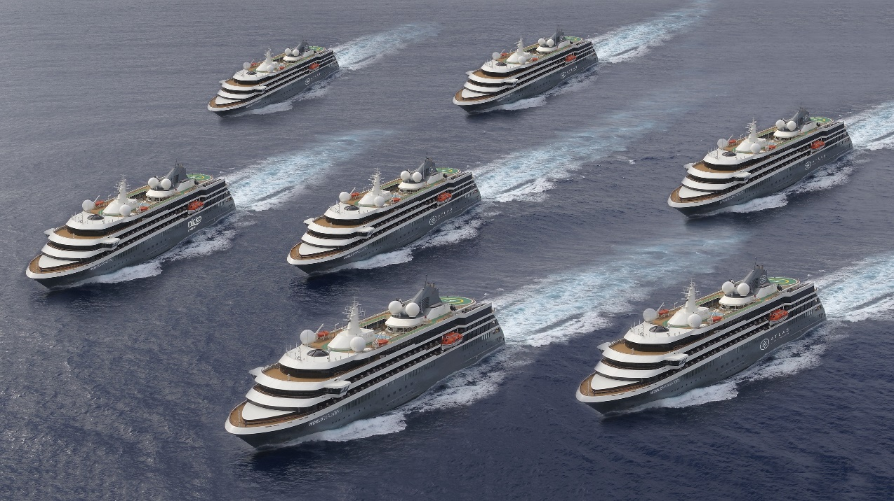

Four new Kongsberg Maritime-equipped ships will soon be added to Mystic Cruises’ fleet   
of adventure cruise vessels, bringing the total to seven

**Horten, Norway, 25th February 2020** – Kongsberg Maritime has won contracts worth approximately 300 MNOK to equip three adventure cruise ships, with a fourth to follow. Built by WestSea Viana Shipyard in Portugal and destined for delivery to Portuguese cruise company Mystic Cruises, the vessels are to be used for expeditions in the polar regions.

The 126m, 9,300-tonne luxury craft will join an existing trio of sister ships to bring the fleet to seven identical vessels, the first of which – *World Explorer* – entered service in 2019. Designed by Italian naval architect Giuseppe Tringali, the ships have an operating cruise speed of 16 knots and have hulls and propellers strengthened for use in ice, making them suitable to visit destinations which are not accessible to larger cruise liners. Each has luxury suite and cabin accommodation for an exclusive 200 passengers.

Vitor Figueiredo, Board Member, West Sea Shipyard, commented: *“These new orders reflect the excellent work achieved with the three previous ships. Having been entrusted by Mystic Cruises with the expansion of its fleet of Explorer vessels, we look forward to successfully overcoming this new challenge in partnership with Kongsberg Maritime, maintaining of course the highest quality standards.”*

Kongsberg Maritime will deliver main engines, auxiliary engines, motion control, propulsion, power electric systems, automation and control systems. The hybrid

propulsion system allows the engines to operate at variable speeds, maximising their efficiency for the required power and reducing fuel consumption and CO2 emissions, while KONGSBERG’s dynamic positioning technology allows the vessel to hold position without using anchors, protecting fragile ecosystems on the sea bed.

Egil Haugsdal, President, Kongsberg Maritime, said: *“These repeat contracts are a strong endorsement of Kongsberg Maritime’s commitment to the active cruise market, which is growing rapidly, as shown by this fleet expansion to seven ships. It is a great pleasure to work with WestSea Viana and Mystic Cruises, both leaders in their industries, to deliver these truly innovative vessels. Our advanced propulsion and control systems continue to make us a clear choice for customers looking for efficient, reliable technologies that minimise the impact of maritime activities on our ocean environment, and we are confident that our equipment will continue to deliver efficient and sustainable operation for Mystic Cruises as they explore some of our planet’s most remote locations.”*

The equipment is scheduled for delivery on a per-vessel basis throughout 2020 and 2021.

Ends

For further information, please contact:

Gunvor Hatling Midtbø, VP Communication

Kongsberg Maritime

Tel: +47 9921 4209

[gunvor.hatling.midtbo@km.kongsberg.com](mailto:gunvor.hatling.midtbo@km.kongsberg.com)

David Pugh

Saltwater Stone

Tel: +44 (0)1202 669244

[d.pugh@saltwater-stone.com](mailto:d.pugh@saltwater-stone.com)

**About Kongsberg Maritime**

Kongsberg Maritime is a global marine technology company providing innovative and reliable ‘Full Picture’ technology solutions for all marine industry sectors including merchant, offshore, cruise, subsea and naval. Headquartered in Kongsberg, Norway, Kongsberg Maritime has manufacturing, sales and service facilities in 34 countries.

Kongsberg Maritime solutions cover all aspects of marine automation, safety, manoeuvring, navigation, and dynamic positioning as well as energy management, deck handling and propulsion systems, and ship design services. Subsea solutions include single and multibeam echo sounders, sonars, AUV and USV, underwater navigation and communication systems.

Training courses at locations globally, LNG solutions, information management, position reference systems and technology for seismic and drilling operations are also part of the company’s diverse technology portfolio. Additionally, Kongsberg Maritime provides services within EIT (Electro, Instrument & Telecom) engineering and system integration, on an EPC (Engineering, Procurement & Construction) basis.

Kongsberg Maritime is part of Kongsberg Gruppen (KONGSBERG), an international, knowledge-based group that celebrated 200 years in business during 2014. KONGSBERG supplies high-technology systems and solutions to customers in the oil and gas industry, the merchant marine, and the defence and aerospace industries.

Web: [Kongsberg Gruppen](https://kongsberg.com/) | [Kongsberg Maritime](https://www.km.kongsberg.com)

Social media: [LinkedIn](https://www.linkedin.com/company/kongsberg/) | [Twitter](https://twitter.com/kogmaritime?lang=en) | [Facebook](https://www.facebook.com/KongsbergGruppen/)