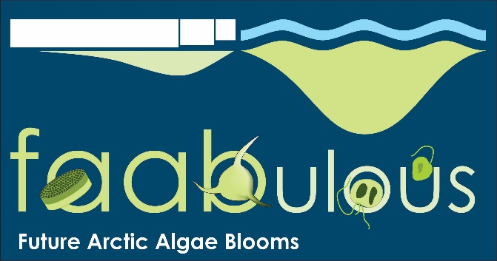

|  |  |
| --- | --- |
|  | 🞂FAABulous: Future Arctic Algal Blooms – and their role in the context of climate change  Research project 2015-2020, funded by the NRC |
|  |  |
|  | **Eva Leu** 🞂Akvaplan-niva AS 🞂 |
|  |  |
|  |  |

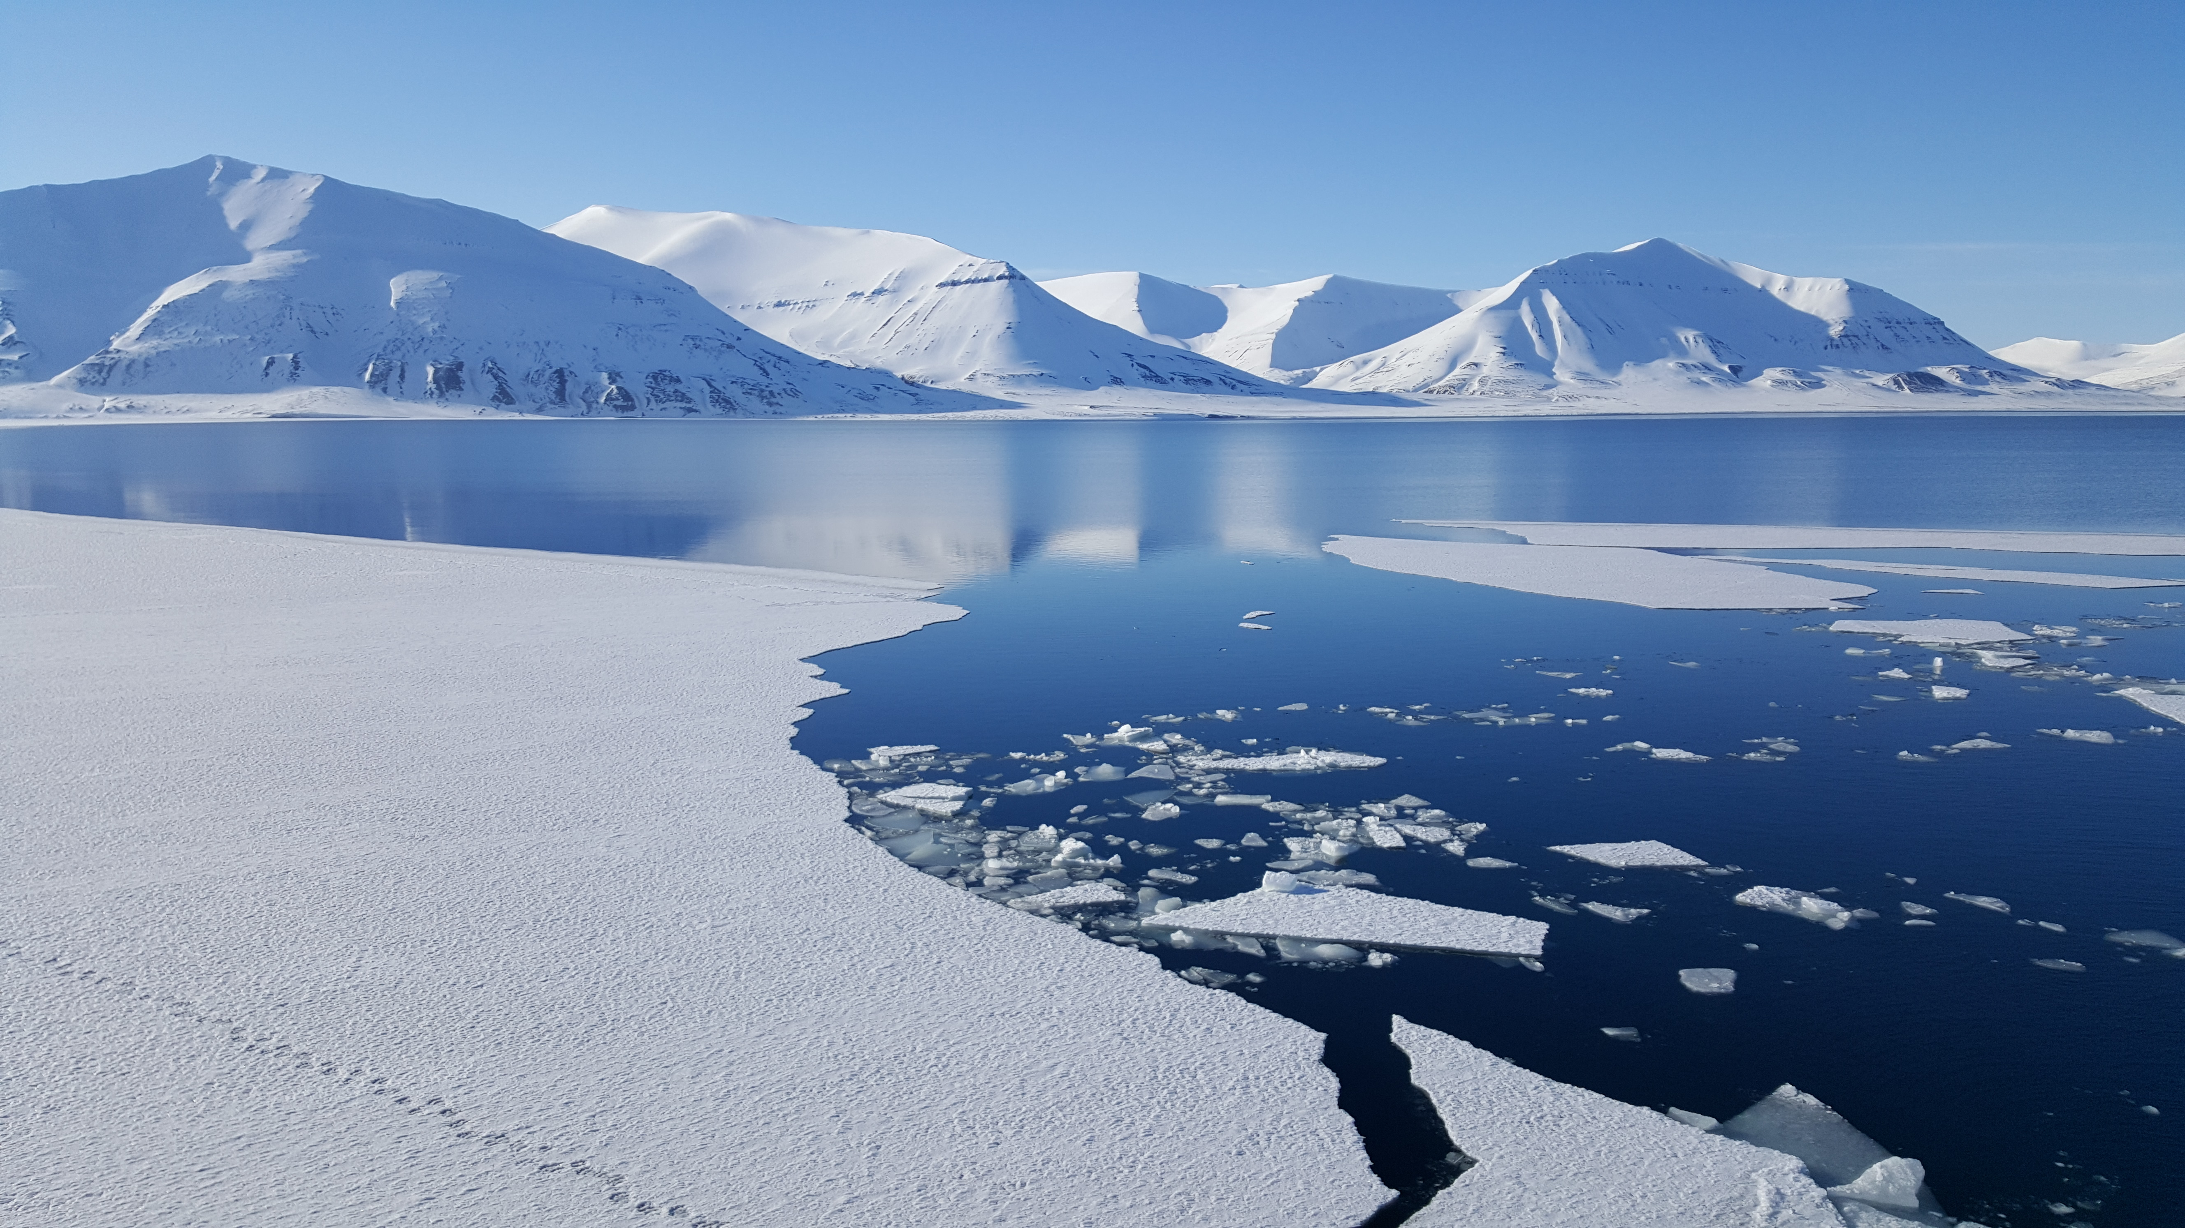

    

    



FAABulous: Future Arctic Algal Blooms – and their role in the context of climate change

Research project 2015-2020, funded by the NRC

The aim of the FAABulous project is to understand how Arctic marine algal blooms in sea ice and water will change in the future in response to the ongoing climate warming. To this end, we combine the collection of year-round field data from two Svalbard fjord systems with contrasting oceanographic characteristics, experiments in lab and field and modeling. Our project group consists of five Norwegian and four international research institutions.

# Background

Environmental conditions in the Arctic are currently changing at an unprecedented rate. Most prominently, temperature rise leads to a decrease in sea ice cover and thickness, increasing the amount of light in the water fundamentally. This has far-reaching implications for Arctic marine ecosystems that are to date still poorly understood. Unicellular algae living in sea ice and water are key in the coupling of environmental changes to ecosystem structure and function: they utilize sunlight to build up the entire biomass the system is based upon – by means of photosynthesis. This is important because they serve as food source for small crustaceans that then are fed upon by fish, seabirds and others – but also because they remove CO2 from the atmosphere.

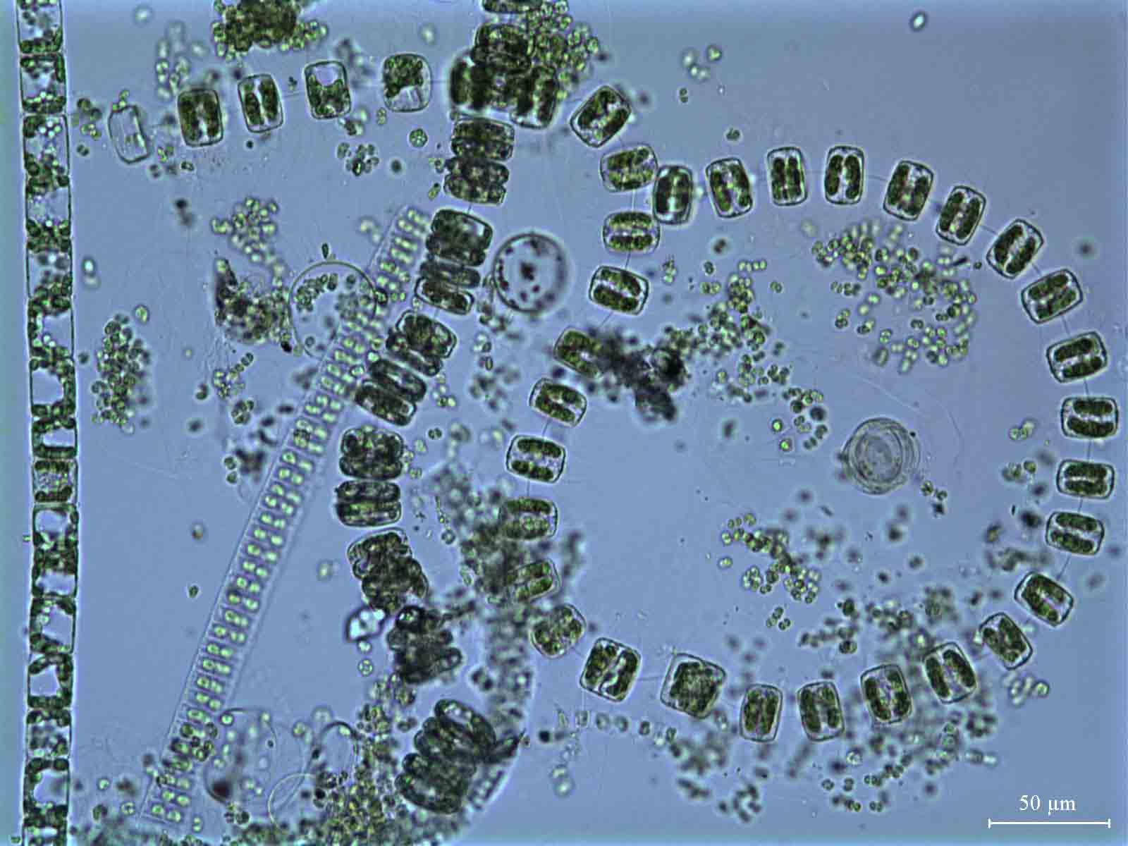

Fig. 1: Chains of algal cells under the microscope: these organisms constitute the basis of the Arctic marine food web! (from a spring bloom in Kongsfjorden, 2003)

Because these algae are so dependent on light and nutrients, their seasonal development is controlled by the changes in temperature and light conditions throughout a year (see Fig. 2) – and it changes immediately in response to alterations of those.

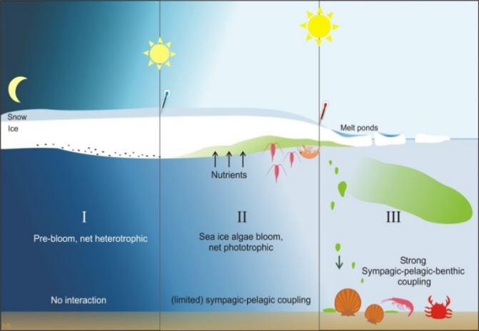

Fig. 2: Seasonal development of algae blooms in sea ice and water during the transition from winter (I) to early summer (III) (Leu et al. 2015)

# Research questions

* How will the timing, duration and quantity of these algal blooms develop under the changes in sea ice conditions we observe?
* How will the increased CO2 concentration in the atmosphere and ocean affect their physiology?
* How will the species composition of Arctic algal blooms change if more temperate species are transported to the Arctic, and can survive there because of increased temperatures?

# Research approach

To address such complex questions, we need to combine different approaches:

## Field observations

We have chosen two very different fjord systems on the west coast of Svalbard: **Kongsfjorden** that has been almost completely ice-free during the past decade, as a consequence of strong inflow of warm Atlantic water year-round – and **Van Mijenfjorden** where an island at the fjord mouth prevents the warm water to enter the fjord, resulting in lower water temperatures, and, usually, a relative extensive coverage with sea ice.

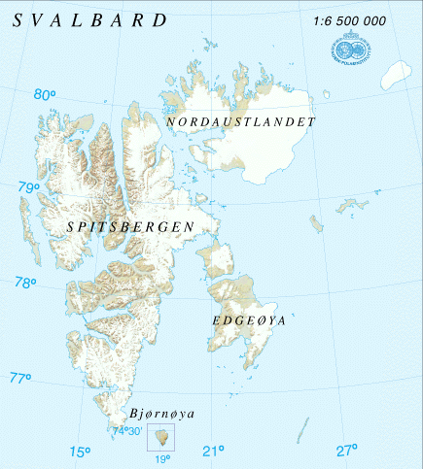

Fig. 3: Kongsfjorden (upper) and Van Mijenfjorden (lower) in western Spitsbergen

By combining continuous measurements from ocean and sea ice observatories with regular sampling campaigns, we obtain detailed data about the seasonal changes of the environmental conditions and the algal development in these systems.

Unfortunately, however, the ongoing warming has been so dramatic since the project started in 2015 that we have severe difficulties to carry out the sampling program as planned. Due to exceptionally high winter temperatures in the Arctic, sea ice formation in Van Mijenfjorden is so strongly reduced that we had to postpone our main campaign by one year.

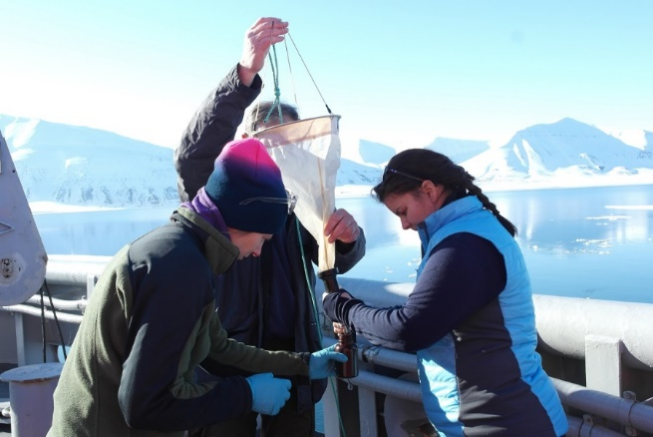

## Laboratory experiments

To test in a controlled setting how either algal communities or single key species will respond to future environmental conditions, we perform different experiments in the laboratory, simulating light stress, high CO2 levels or other aspects of future Arctic scenarios. Then we measure the responses of the algae and try to understand why some are better prepared to withstand the coming changes than others.

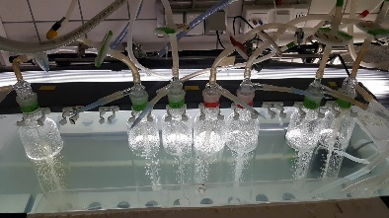

Example of experimental setup in the laboratory (left) and an algal cell (diatom) seen under the electronmicroscope (right)

## Modeling

In order to understand better how changes in sea currents, wind and temperature conditions affect the two fjord systems we study, one group of researchers in our project is developing a high-resolution 3D-model of the whole western Spitsbergen coast. To make sure that the model is capable of reproducing real scenarios, we compare it with historical data that we and our collaboration partners have collected from these fjords. Afterwards, we can test different kind of scenarios that we anticipate will occur in the future, and use the model to see how they will impact ice formation and bloom timing in the fjords we study.

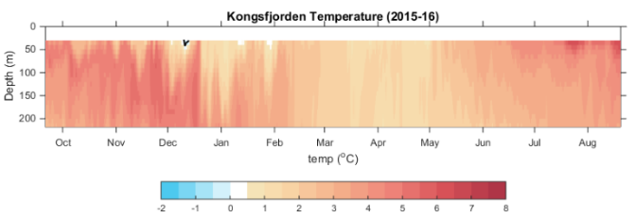

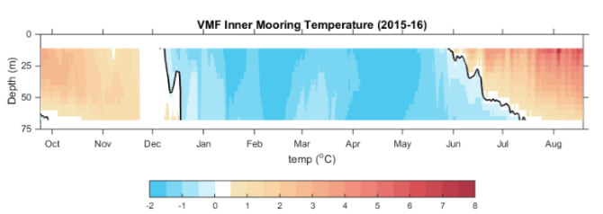

Fig. 4: Continuous temperature profiles measured in Kongsfjorden (upper panel) and Van Mijenfjorden (lower panel) 2015-2016. Water in Kongsfjorden was warmer than 0°C year round!

## What do we hope to learn?

This project will improve our understanding of how changes in the environment alter algal blooms in the Arctic. This will help us to:

* Improve models that predict future productivity in Arctic seas
* Predict potential consequences for the marine food web in the Arctic
* Increase our understanding about feedback mechanisms of algae onto their environment, in particular sea ice. This aspect has been so far neglected in most global models.

All this will contribute to create the knowledge base of a sustainable management approach for human activities in the future Arctic.

## Why is this such a 'hot topic' right now?

We researchers working in the Arctic, and in particular in the Svalbard region, have been witnessing temperature increases and changes of sea ice conditions during the past 10-20 years that exceed model predictions and expectations from most experts. In fact, the fjords in this region at 78-80°N change so fast that it is a major challenge to carry out research projects as planned.

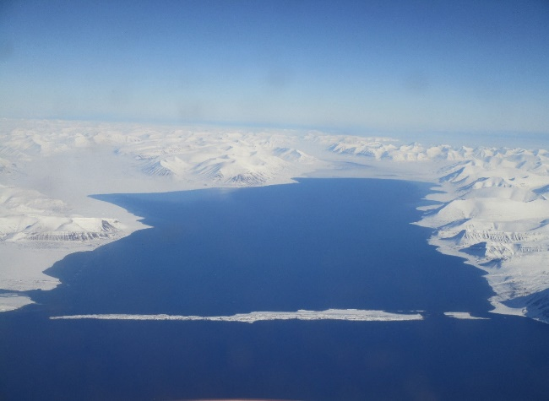

Van Mijenfjorden, 28. April 2016 20162016

Not much sea ice to study here any more …

## Project facts and collaborators

FAABulous was funded by the Norwegian Research Council under the OKOSYSTEM program in 2014 (project nr. 243702), and received 16.3 million NOK. It is led by Eva Leu (Akvaplan-niva AS), and runs from 2015 to 2019. Collaboration partners are UNIS, UiT The Arctic University of Norway, Nord University, NIVA, Alfred-Wegener-Institute (AWI), Max-Planck-Institute for Meteorology, Scottish Association of Marine Sciences (SAMS), and Institute of Oceanology, Polish Academy of Science (IOPAS).

For more information, see also: <http://mare-incognitum.no/index.php/faabulous>

Contact person: Eva Leu, [eva.leu@akvaplan.niva.no](mailto:eva.leu@akvaplan.niva.no)

 