Andreas Bäckman close to first STCC win at Ring Knutstorp
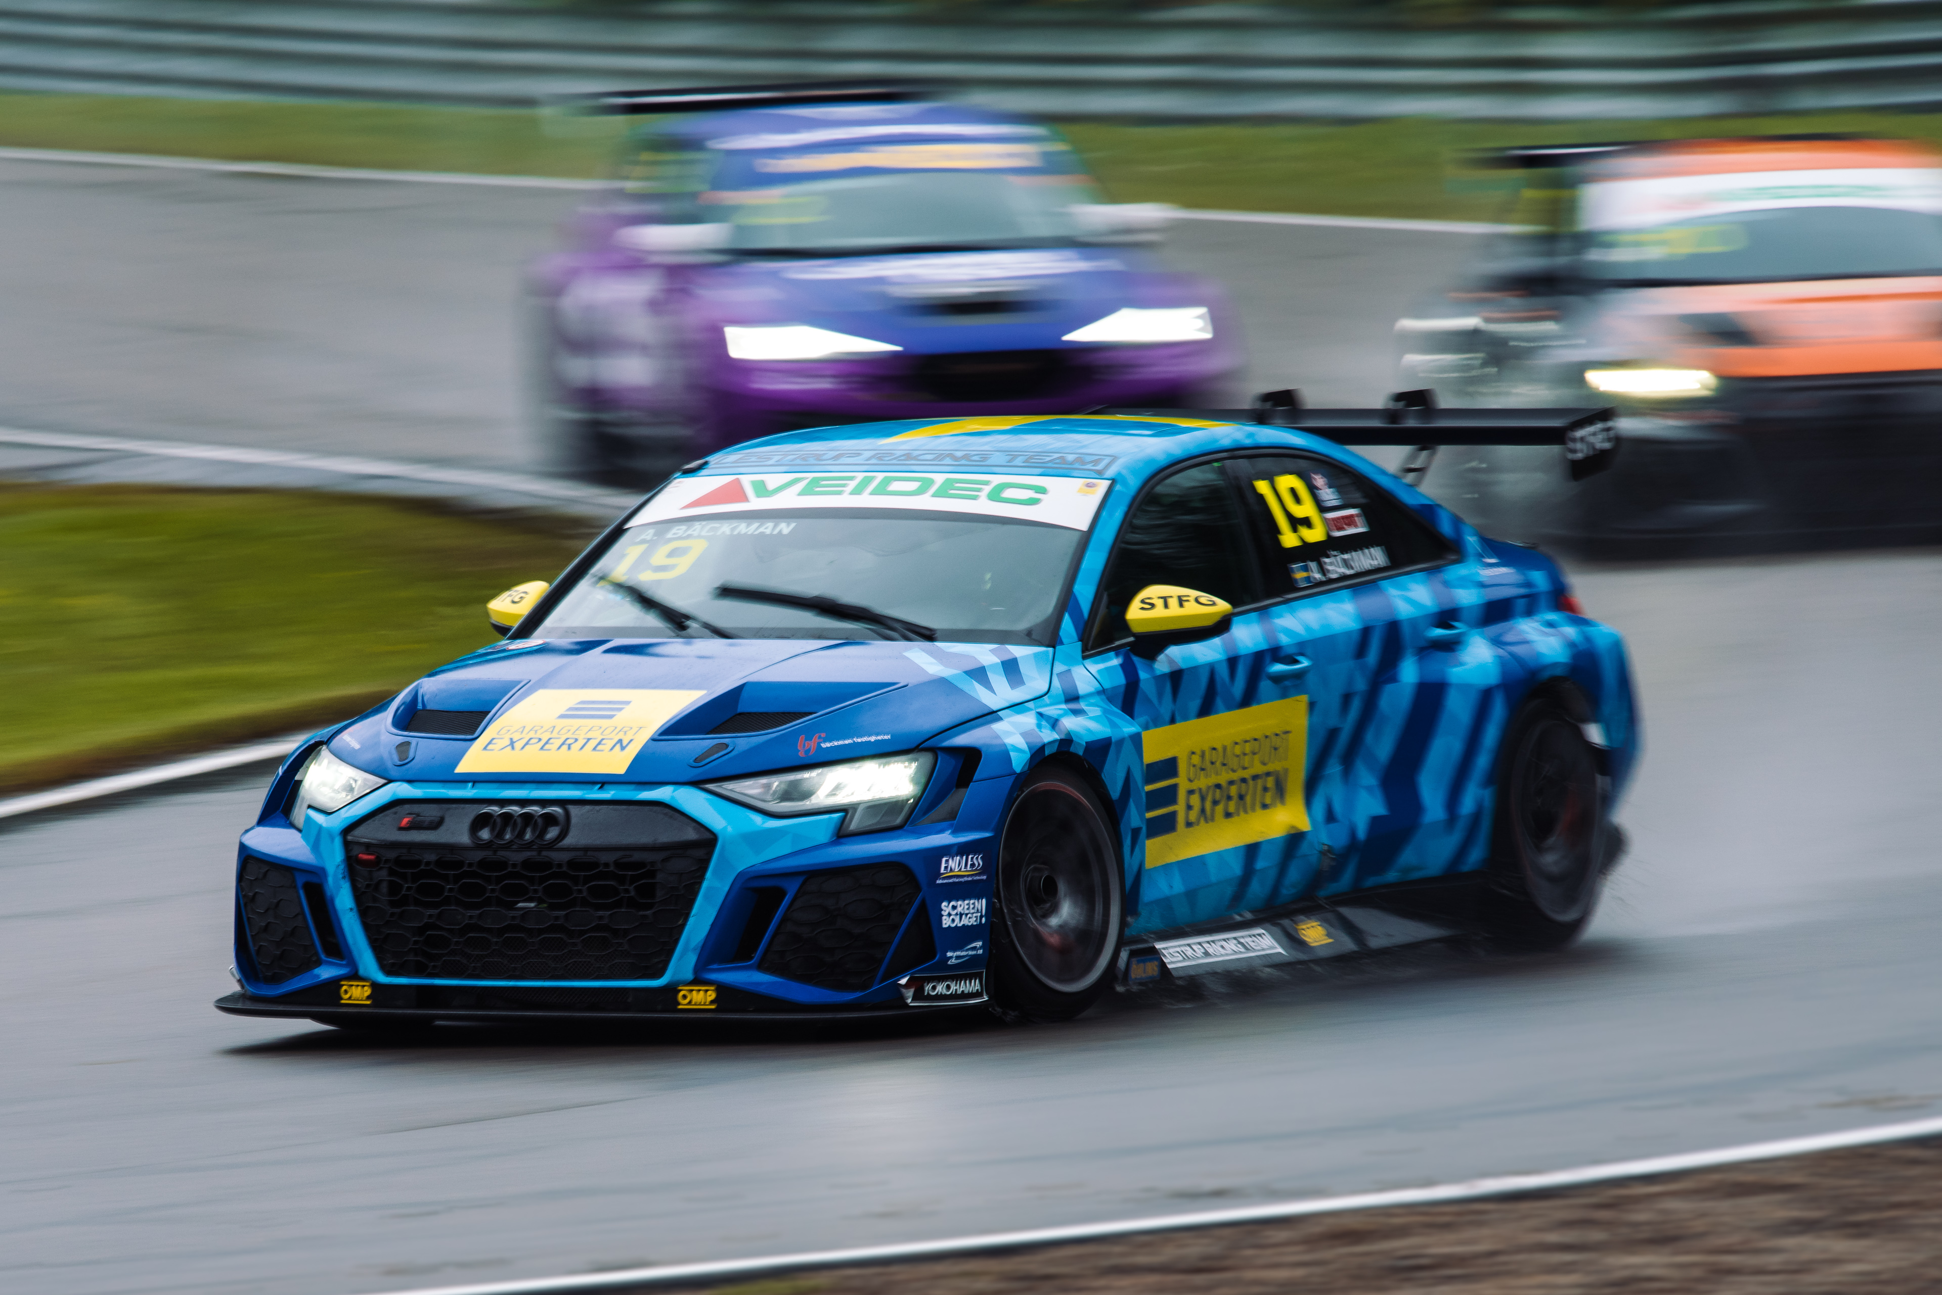
Andreas Bäckman (start number 19) drove all the way up to first place from fifth starting position in Race 3 in the first three laps at Ring Knutstorp, Sweden last Saturday.
Photo: Martin Öberg (Free rights to use the images)
This year's third STCC event was held last weekend, July 21st-23rd, at Ring Knutstorp. The race day was a bit up and down but by Race 3 it all came together as Andreas raced up to the lead before he made a mistake that lost him his first STCC win.
– It's a shame about the mistake in the end, the win was definitely within reach and I was the fastest on the track in the race, Andreas Bäckman says.
Last weekend, July 21st-23rd, it was time for the third round of STCC, STCC Newsrace, at Ring Knutstorp, and the Sweden National Team driver Andreas Bäckman was on the starting line, competing for Lestrup Racing Team in his Audi RS 3 LMS TCR car. Ring Knutstorp is a challenging track dating from the 1950s outside of Kågeröd, Sweden.
The weekend started well and Andreas was among the top in the practice sessions on Thursday and Friday. In the Qualifying on Friday afternoon he clocked the second fastest time in both Q1 and Q2 which meant second starting position for Race 1 and Race 2 on Saturday. On race day on Saturday, it started to rain, which meant that there were new conditions for both drivers and teams to adapt to. In the first two races, Andreas finished fourth.
- In Race 1 and Race 2 I lost positions in the starts and I didn't quite get the feeling in the car that I wanted. Together with the team we worked on during the day and by Race 3 both the starts and the car felt better, Andreas Bäckman says.
Good recovery in Race 3
In Race 3, the starting order of the top eight drivers from Race 2 was reversed, which meant a fifth starting position for Andreas. This time the start was much better and he went straight up to third place heading into the first corner, then he overtook another driver six corners later so that he was up to second place already after lap 1. Three laps later he was up to the lead after a hard fight for first place and Andreas was the fastest on the track and started to pull away from the drivers behind.
But unfortunately, with a few laps to go he makes a small mistake and drops down to fourth place.
- Unfortunately, the mistake that couldn't happen came, it was sad to lose the win like that as it felt like we had this win within reach. Disappointed and also feel sorry for the team as this was our race to win. I only have myself to blame and it can't be undone, so I have to learn from this and look forward, Andreas Bäckman says.
Despite the mistake, Andreas manages to re-focus and keep going. In the last couple of laps he managed to get back in the fight for the podium positions. He finally crossed the finish line in second place, clinching his second STCC podium of the season.
- The feeling in the car was good and I took the opportunities when they came, so I'm still happy that I managed to save the second position at the finish. Very mixed feelings after this day, but considering the circumstances in Race 3, it is very positive to take with you to the upcoming races. Many thanks to my team Lestrup Racing Team, already looking forward to the next STCC race at Gelleråsen Arena in one month, Andreas Bäckman says.

Next up for Andreas is the fourth round of the STCC championship in four weeks’ time, August 18th-20th, at Gelleråsen Arena, located near Karlskoga, Sweden.

Andreas’ results:
Official Test (Test 1): 4th place
Free Practice 1 (Test 2): 2nd place
Free Practice 2 (Test 3): 1st place
Qualifying (Q1): 2nd place
Qualifying (Q2): 2nd place
Race 1: 4th place
Race 2: 4th place
Race 3: 2nd place

STCC Championship Standings
STCC – TCR Scandinavia – Drivers’ Championship Standings – Overall (Top 3)
STCC 2022 (After 3 of 6 race weekends)
1: Robert Dahlgren (SWE), 136 p.
2: Oliver Söderström (SWE), 104 p.
3: Tobias Brink (SWE), 95 p.
–
4: Andreas Bäckman (SWE), 92 p.
See the full standings here
STCC – TCR Scandinavia – Teams’ Championship Standings – Overall (Top 3)
STCC 2022 (After 3 of 6 race weekends)
1: CUPRA Dealer Team - PWR Racing, 217 p.
2: Lestrup Racing Team, 196 p.
3: Brink Motorsport, 176 p.
See the full standings here

Did you miss this weekend’s STCC race?
Click here to see the replay from this weekend’s STCC race at STCC+

Follow the STCC season at:
Live-stream: plus.stcc.se
Other information: stcc.se
Facebook: facebook.com/STCCOfficial/
Twitter: twitter.com/stcc_official
Instagram: instagram.com/stcc_official/
YouTube: youtube.com/c/STCCTV

Free rights to use the images.

Download press-photos here:
http://bit.ly/jabaeckman-photos
https://www.mynewsdesk.com/se/ja-backman/images

