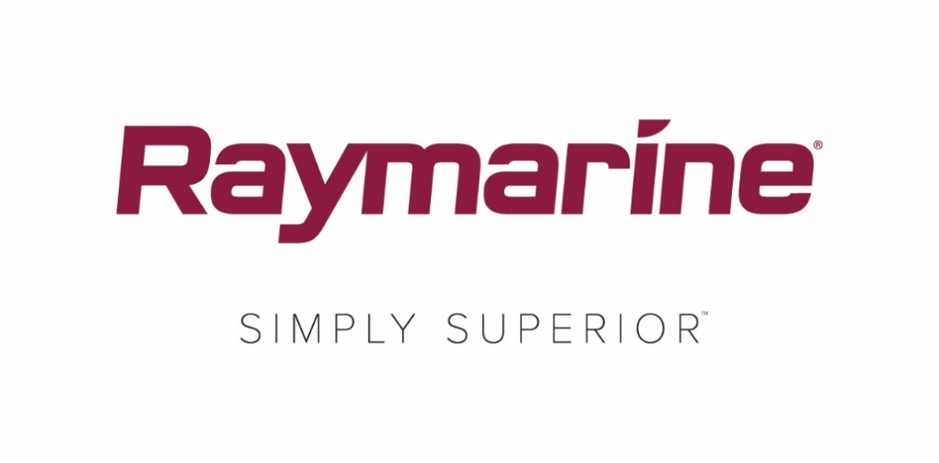
Raymarine Announced as Official Supplier to Alex Thomson Racing
Leading marine electronics brand supports Thomson’s bid
to be the first Briton to win the Vendée Globe

Fareham, United Kingdom – 7th August 2019 – Raymarine, a brand of FLIR Systems, has today announced its support as an Official Supplier to Alex Thomson Racing. The deal both demonstrates Raymarine’s deep commitment to UK sailing and consolidates its position as a premier choice for international racing campaigns.
Alex Thomson Racing has one clear aim: to be the first non-French team to win the round-the-world Vendée Globe race, to be held in 2020-2021. To be the best, they need the best, and their choice of Raymarine equipment for collision avoidance and digital switching is a ringing endorsement of Raymarine’s market-leading technology.
Scheduled for official launch in London on 19th September, ahead of the Transat Jacques Vabre in October, the innovative new IMOCA 60 yacht ‘HUGO BOSS’ first took to the water on 4th August. Designed by Alex Thomson Racing’s technical team together with the hugely successful naval architects VPLP, and built by Carrington Boats Ltd in Hythe, Hampshire, the new yacht brings together cutting-edge technology and performance in her design, construction and equipment.
Raymarine’s state-of-the-art Quantum Doppler radar is the perfect partner to support Alex Thomson Racing. Identifying marine traffic is crucial for skipper Alex Thomson when he races. Offering unrivalled range and resolution teamed with light weight and low power consumption, Raymarine’s Quantum Doppler radar is able to continuously work in the background as Alex competes.
Alex Thomson Racing’s new IMOCA race boat will also be fitted with a full Raymarine digital switching system. Both this and the Quantum Doppler radar are driven through Raymarine’s award-winning Axiom® multi-function displays.
About Alex Thomson
Alex Thomson is the youngest skipper ever to win a round-the-world yacht race. When he triumphed in the 1998/1999 Clipper Round-the-World Race he set a record which still stands today. Thomson also holds the British solo, unassisted round-the-world monohull record, which he set in 2017 when he finished the gruelling Vendée Globe race – ‘the Everest of sailing’ – in just 74 days, 19 hours, 35 minutes. Having achieved third and second place finishes in the last two editions of the Vendée, Thomson and his team – together with their long-standing sponsor, HUGO BOSS – now have their sights firmly set on becoming the first British team in history to win the iconic race. Raymarine are delighted to be supporting the team in that quest.
For more information, visit www.raymarine.eu and www.alexthomsonracing.com
####

Media contact:

Karen Bartlett
Saltwater Stone
+44 (0) 1202 669 244
k.bartlett@saltwater-stone.com

