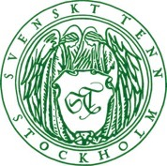
Press Release
Stockholm, February 9, 2017

Swedish Modern colouring book published by Thames & Hudson

Art book publishers Thames & Hudson now introduces Swedish Modern, an exclusive colouring book intended for adult design enthusiasts. The book contains images, sketches and texts documenting Josef Frank’s designs and Estrid Ericson’s interiors. It is now available at Svenskt Tenn and set for February 17 release at international bookstores and museum outlets.

”We are immensely proud and delighted over Thames & Hudson’s decision to feature Svenskt Tenn in a colouring book,” says Thommy Bindefeld, Marketing Director at Svenskt Tenn. “The book Swedish Modern lets you enjoy Svenskt Tenn interiors in a new, innovative fashion. Readers are also encouraged to use their imagination to add personal flavour to our classic shapes and designs.”
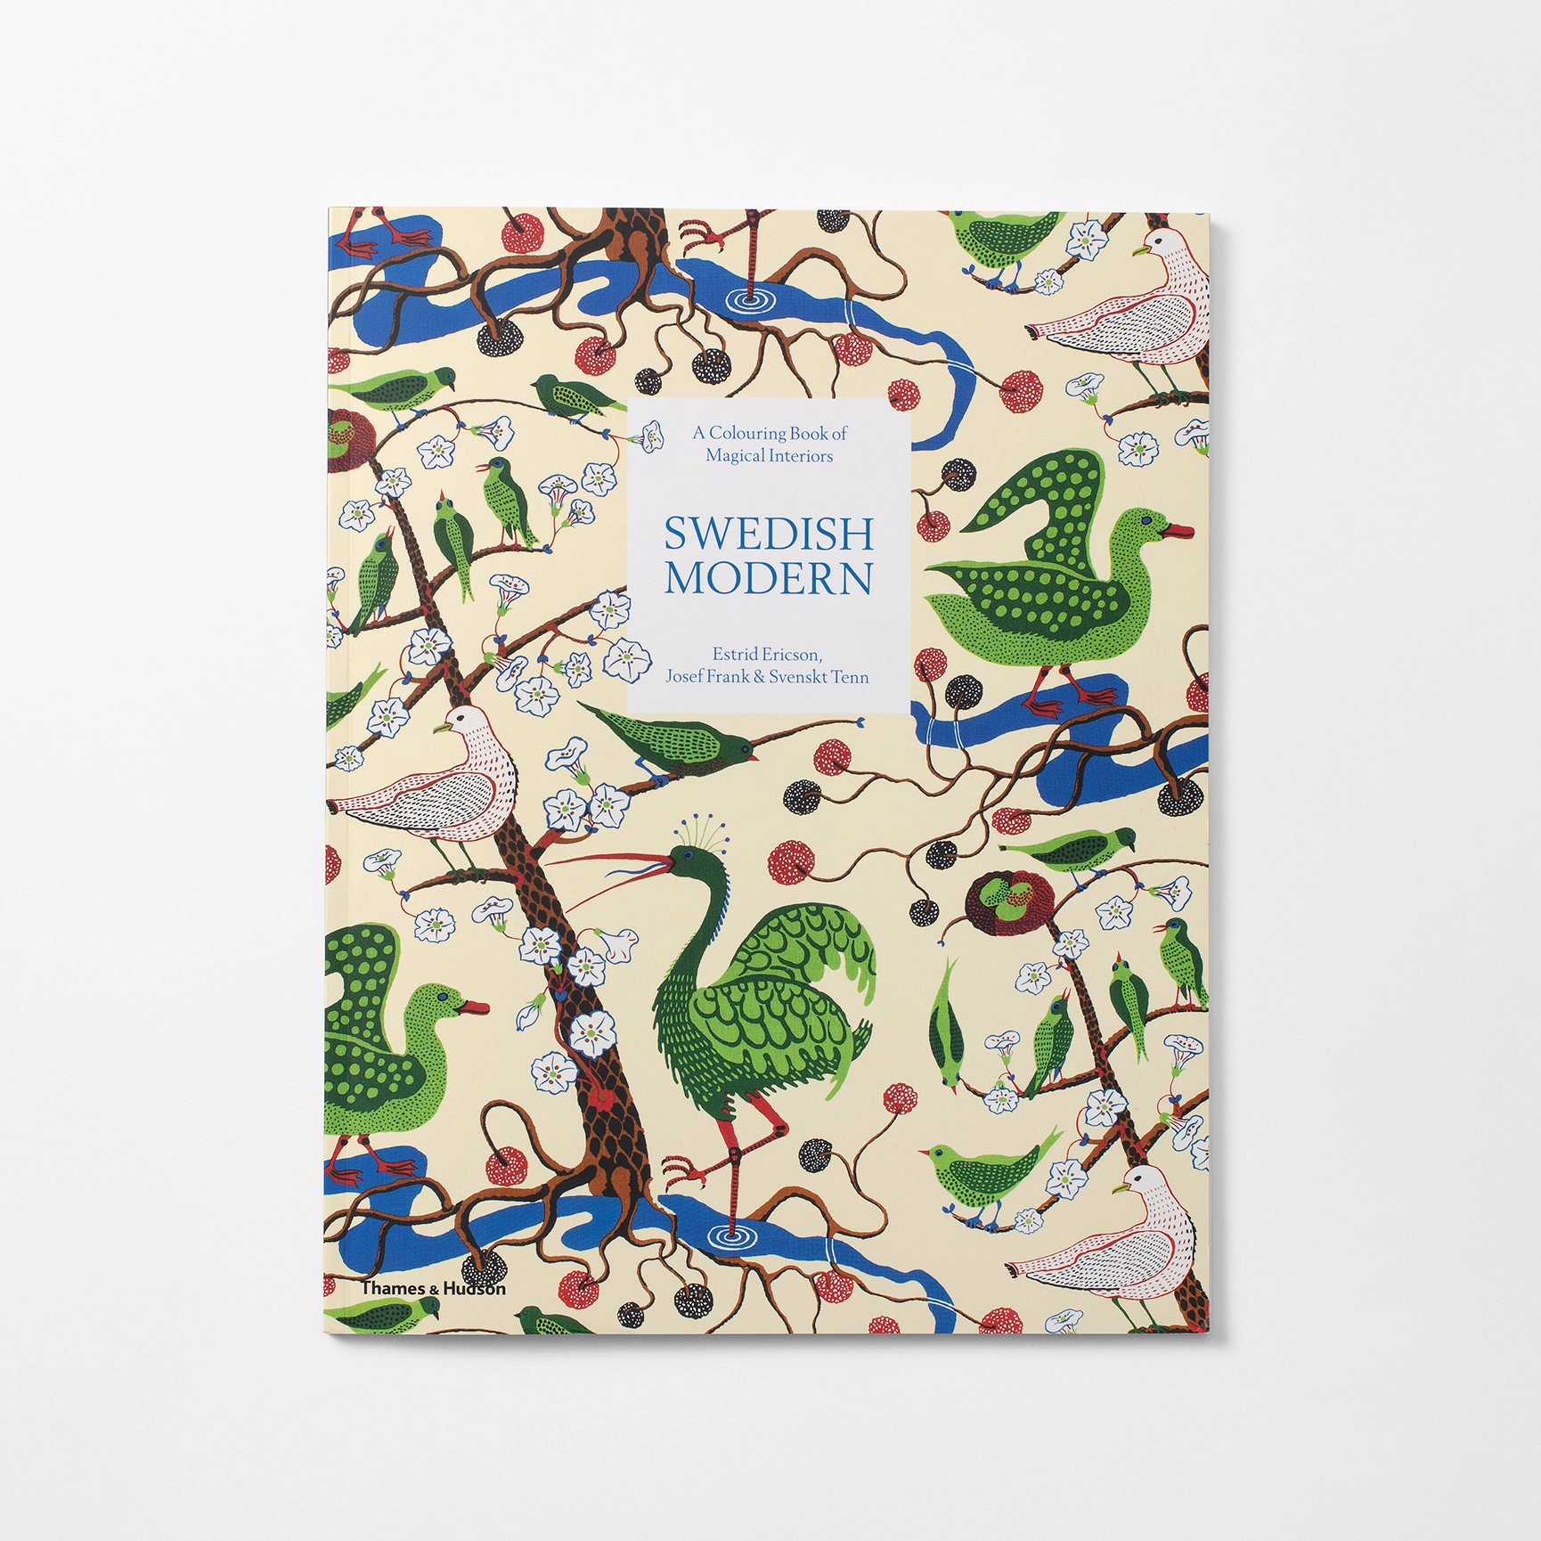
In 1934, Svenskt Tenn founder Estrid Ericson employed Josef Frank, and within a few years the famous professional pairing experienced their international breakthrough. Exhibiting at the World Fairs in Paris in 1937 and New York in 1939, they featured a contrasting selection of materials, colors and patterns that went sharply against the ideals of the day. The duo received great attention and became strongly associated with the Swedish Modern style. The eponymous colouring book now invites readers to learn more about the collaboration between Estrid Ericson and Josef Frank.

”To Estrid Ericsson and Josef Frank, it was essential to create timeless, amiable interiors characterised by humour and elegance, all of which is captured in the book,” says Thommy Bindefeld. ”It allows design enthusiasts to study the framework and basic elements of designs, and not only the completed works.”
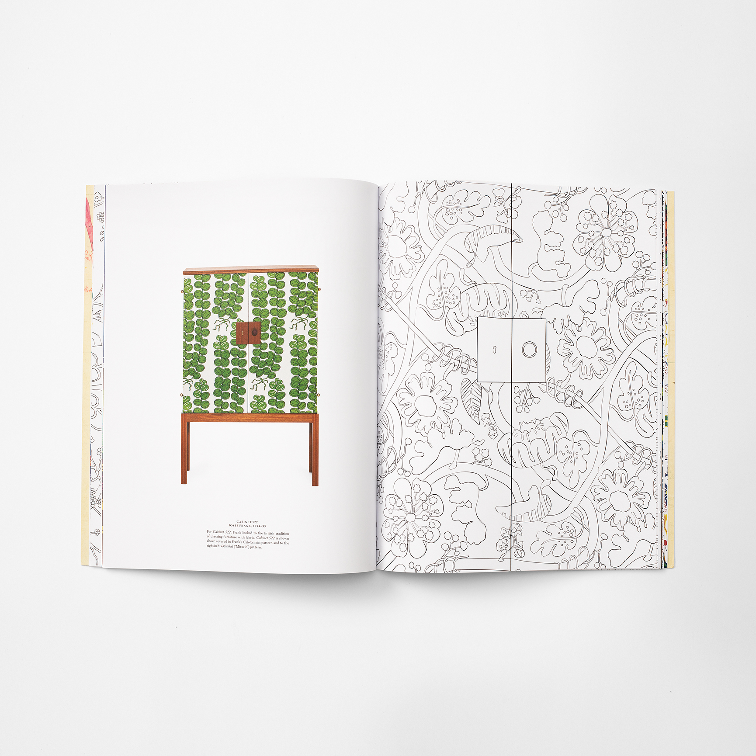
Swedish Modern is authored by Janet Colletti, who has covered and built her knowledge of the Swedish design scene and its driving forces over two decades as an industry writer. She has created the book together with Helene Boström, who is active in art book publishing as an editor, concept developer and consultant.

The book is priced at SEK 160 and is available from today Svenskt Tenn, online and at the store in Stockholm. From February 17, it will also be offered by international bookstores and museum outlets.

For further information, please contact:

Vicky Nordh, Marketing Assistant: +46 8-670 16 23 or vicky.nordh@svenskttenn.se

Thommy Bindefeld, Marketing Director: +46 8 670 16 02 or thommy.bindefeld@svenskttenn.se

Images can be downloaded from svenskttennpress.se. Username: Press. Password: Tenn

Svenskt Tenn is an interior design company with retail stores at Strandvägen in Stockholm and online. Since 1975, Svenskt Tenn is owned by the Kjell and Märta Beijer Foundation, which provides research grants within ecology, medicine and the preservation of Swedish interior design tradition.

