# Sustainable governance – setting direction and inspiring change in a city development corporation

Stefan Book (Ph.D)

CEO, Partner and Senior Management Consultant

Effort Consulting

Gamla Almedalsvägen 19, Hus C

412 63 Göteborg

Sweden

Magnus Marmgren

Partner, Senior Management Consultant and Ph.D Student

Effort Consulting

Gamla Almedalsvägen 19, Hus C

412 63 Göteborg

Sweden

Björn Gustafsson

Technical Manager and part of the top management team at Framtiden

Förvaltnings AB Framtiden

Box 111, 401 21 Göteborg

# Introduction

In the spring of 2013 a decision was taken on corporate level at Förvaltnings AB Framtiden (Framtiden), a group of seven companies managing 70600 apartments[1], fully owned by the City of Gothenburg, with the common vision to “build the sustainable society for the future”. The decision concerned the development of a sustainability framework for the group and the work has gained recognition among the top politicians in Gothenburg as well as industry representatives. At the moment a process is going on where a documented way of sustainability thinking is influencing corporate governance.

The central ideas of Corporate Governance evolve over time, and today CSR/Sustainability has become a major concern of many companies (Tricker, 2012). The Global Corporate Sustainability Report (2013) states that “the case for responsible business practices is strengthening, with a growing number of companies taking action… Turning a blind eye to sustainability issues is a ticking time bomb, and hiding missteps – no matter how deep down the supply chain – is no longer an option”. This is in line with Porter and Cramer (2006) showing the link between corporate responsibility and strategy.

The work at Framtiden is conducted as part of an action research approach aiming to develop both the corporation and knowledge. The purpose of this paper is to explore the process at Framtiden leading to a situation today where corporate governance is changing into a more conscious sustainability focus. The paper discusses central mechanisms that can influence the long term ability to govern the corporation in a sustainable way.

# Analytical framework

The analytical framework is founded on theories and experiences that can help in clarifying the interaction between ideas and behavior in organizations. The authors together have more than 50 years of working experience from a variety of contexts. According to Gummesson (1991) and Schön (1983) the productive learning and outcome of this research process should have excellent conditions for relevant knowledge development. We use the framework to organize and make sense of data and experiences from Framtiden in order to understand mechanisms influencing long term success (Weick, 1979, 1995). In line with Czarniawska and Joerges (1996) this is partly a matter of understanding the travels of ideas within and among organizations.

A central theme in the framework is based on Nonaka (1994) who pedagogically explain how productive learning takes place through dialogue between tacit and explicit knowledge. While individuals develop the knowledge that can produce better results, organizations play a critical role in articulating and stimulating relevant knowledge that can guide action and better results.

Figure 1 visualize a structure that guides our analysis. A conceptual paper describing this framework is in progress and will be finalized within our research. A central idea is to use it as a reflective tool rather than focusing on it. In focus are the patterns (Book, 2006) in the organization and the knowledge produced as we use it in action. One key aspect is the nature of learning within the organization which can be stimulated by conscious development of learning alliances between key persons (Frischer et al. 2000)

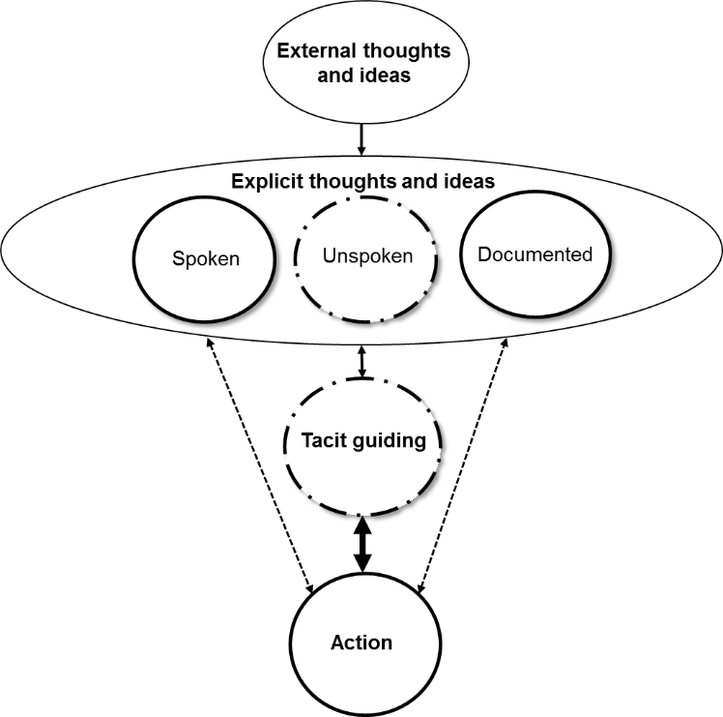

Figure 1: A structure facilitating productive learning, focusing explicit and tacit guiding knowledge and its relation to action producing results for stakeholders.

Tacit guiding is the generally subconscious “patterns” or “tracks” in our brains that actually guide action in a specific situation whether it is about riding a bike, operating a production line or running a complex project. Tacit guiding knowledge cannot be directly observed but inferred by looking at action or approached by interviewing[2]. This is in line with system 1 patterns of thinking (more intuitive) as described by Kahneman (2011) whereas the system 2 type of thinking (more conscious) takes place as part of explicit thoughts and ideas.

There are many different and often contradictory thoughts and ideas. Some are largely accepted by the organization/group in focus while others are not. An organization is also affected by external influences and success is dependent on the ability to adapt to the organizational pattern in the specific context (Book, 2006). The adaptation is partly dependent on the fit with existing thoughts and ideas (Marmgren, Clancy, Alänge, 2013) and the process of implementation (Lewin, 1948). At the same time the nature of solutions and innovation is dependent on how we see opportunities in the diversity of ideas and creative tension (Fonseca, 2002). Sustainability as concept can stimulate such innovation and drive success on several levels (Nidumolu et al., 2009)

# Setting Direction for Sustainable Governance

## Starting point

Framtiden was and is engaged in work intuitively associated with sustainability. It is within their assignment, as a municipally owned company, to do good and contribute to society. And employees are proud of the contributions to society that exist in practice in the daily work. What was missing however, was a clear integration of sustainability into a corporate governance model guiding action, hence a sustainable governance model setting direction for innovation and change. A vision had been set to “build the sustainable society for the future”, but there was a lack of guidance on how to actually fulfill this vision.

There were questions regarding the interpretation of CSR and sustainability in the context of Framtiden. The documented vision, owner directives for the mother and daughter companies, documented business plans and the city budget were not aligned in a clear and explicit direction for sustainable governance. A balanced scorecard logic existed but it mainly guided the organization of certain information rather than driving innovation. It did not guide behavior and action in a clear and intuitive way, given the purpose of the organization. Furthermore a reporting culture, with clear directives to report in different systems did not lead to feedback guiding action.

The work on corporate level was directed at coordination and reporting, but with no clear agenda or model on how to influence development. The will to do good was driving action in the whole organization and this was combined with a consciously invisible mother company. The daughter companies being closer to action directed their own work, with directions from their respective board of directors.

One company within the group had used GRI3 for Sustainability Reporting, and this had also been praised, but the contents of this report did not gain any momentum. In fact, the sense was that this was still another report following certain demands. The structure did not produce creative tensions driving innovation and improvement. Instead, it summarized what was already going on, within an external structure that was not natural to the company.

## Sustainability ideas inspiring change

A central idea was to build a strong belief and sense of sustainability in practice. The ambition was to build momentum around a sustainability idea that could stimulate the organization´s development with the focus on core issues. A threat against this ambition was that the corporate initiative would be seen as still another top-down reporting initiative creating conformity oriented ways of organizing. Another threat would be that this idea would challenge assumptions among professionals with an auditing and inspection focus. These threats further strengthened the importance of understanding the underlying patterns concerning Framtiden´s work and role in society.

The most important was to build from what already existed within the organization and not to rely on an externally set management model. External models and theories could serve as inspiration but not as the central guiding mechanism. The intention was instead to create a guide for development that Framtiden would be proud of. Something they “owned”. To manage this process we wanted to understand underlying patterns and adapt the work accordingly, which is in line with Book (2006). Central theoretical standpoints can still be used, but with respect for patterns that may influence the effects of the work. Another key was attract attention through visualization that could stimulate communication regarding what was going on in the corporation.

A central idea incorporated was that for an organization working sustainably, means that we take our responsibility and strive for long-term success by creating value for and with stakeholders* and balance their needs in the short and long term. This view had been developed over the years of practical work among the consulting firm facilitating the process.

* The nature and future generations are seen as stakeholders and someone must care for them

Another central idea was that sustainability is driven by learning through successive understanding of the organization seen as a system formed by several sub systems. And this systems relate to external levels of interrelated systems. This is in line with Brundtland (1987) pointing at several systems that need to function in order to reach a sustainable society. To stimulate successive improvements three central questions, in line with ISO 26000, were guiding the work:

1. Which principles should guide?
2. Who are our stakeholders?
3. What areas should be prioritized to satisfy the needs of our stakeholders?

## Now

Today there is a shared view of sustainability in Framtiden on corporate level, among board of directors and among CEOs in the daughter companies. A sustainability guide exists that can guide common thought and action. The guiding ideas facilitated the work on the first sustainability report developed on corporate level. The sustainability report is used for communicating, internally and to external stakeholders, what sustainability is at Framtiden, how they work, the results they have achieved and their aspirations. Central in the guide and report are eight defined focus areas (prioritized areas) that defines the type of results to strive for. In each area a number of aspects have been identified to clarify the meaning in practice. These areas are related to needs that the identified prioritized stakeholder groups have.

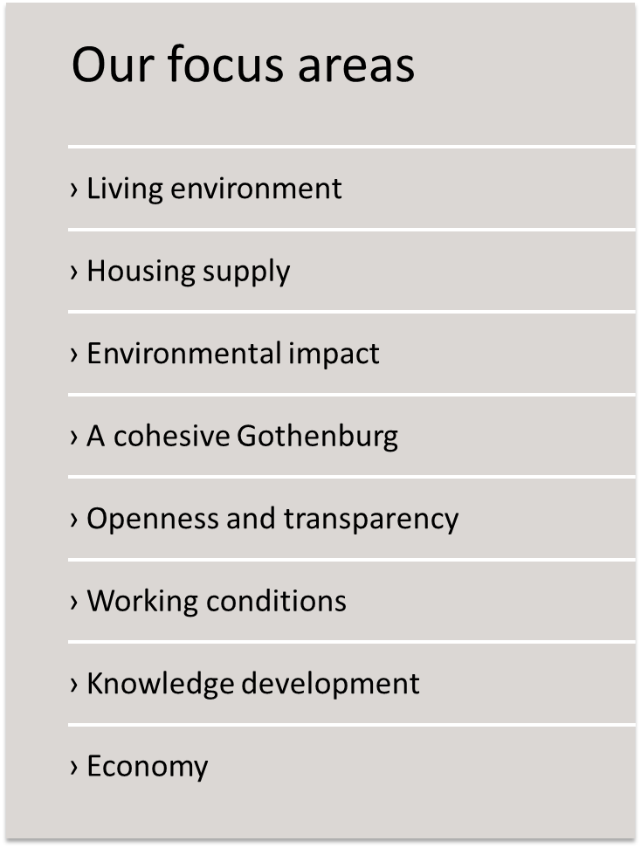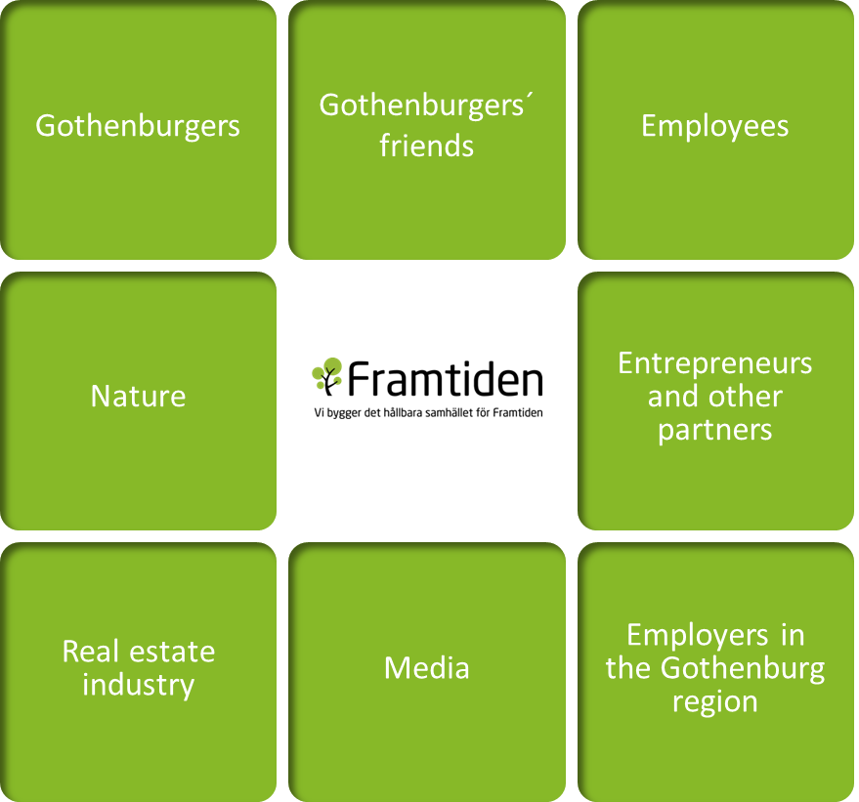

Figure 2: Prioritized focus areas and stakeholder groups

Representatives for the City of Gothenburg and people listening to the messages concerning sustainability at Framtiden are praising the work so far. Much work remains however, and the sustainability report clarifies that this is learning journey. The test comes when stakeholders are raising issues and questions. What is happening in action as a consequence of communication relating to the transparent sustainability work? A group of stakeholders – senior citizens – symbolize this moment of truth situation as they communicate certain issues and questions in a letter to Framtiden. They used the sustainability report to communicate regarding living options for senior citizens. Hence, the report has in this case facilitated stakeholder communication.

A central part of the strategy is to integrate sustainability into the tacit guiding knowledge that each person are carrying as they are fulfilling their role in the organization. So far, the creativity has mostly taken place on a governance level, but it is inspiring the daughter companies and other stakeholders’ communication. In fact one daughter company found their own way of addressing sustainability as a consequence of the work at the corporate level. The guiding sustainability model developed guided the daughter company to find a clearer role within the overall sustainability oriented mission.

New ideas regarding sustainable governance at Framtiden have been developed. These ideas are now also enacted in meetings and when writing key documents like the business plans. At a larger system level they have started to spread inside and outside the group, both through spoken communication and actions but also through key documents like the sustainability report and sustainability guide.

# Discussion

What are the central mechanisms, so far, influencing the long term ability to reach a natural and intuitive way of governing and driving a corporation in a sustainable way? The intention has been to build guiding ideas anchored in the core operations to gain ownership, rather than directing attention to external influences. Naturally, external influences are important over time and also during internal learning processes. Consultans are bringing in ideas from theories presented in the analytical framework and in the part on sustainability ideas inspiring change. The strategy is to build guiding ideas and document these, in an inspiring way, so that they can stimulate dialogue and further development. As these explicit thoughts and ideas are related to what is going on in action creative tension can drive innovation and development. A question is how the explicit ideas concerning sustainability are integrated in action relating to stakeholder needs.

The situation where senior citizens take contact is an opportunity for learning, in action, what the sustainability ideas means in action on corporate level. Many such situation will occur and their consequences in action (theory in use) will determine the learning journey ahead.

So far it is reasonable to believe that a few key persons taking part in the work so far has integrated the guiding ideas into the tacit guiding knowledge influencing behavior and action directly. Other persons are relating to the ideas, but not as part of their natural way of thinking. This, in line with Lewin (1948), takes more conscious actions to stimulate group processes and development of shared ideas as part of a conscious change process.

The transparency regarding the way of thinking that is promoted from corporate level has been greatly improved. In fact, regarding sustainability, the only guiding ide was related to the generic model of the triple bottom line: Economic, Environmental and Social dimensions of development and results. In practice, this structure of thought did not lead to an integration of sustainability, on the contrary it resulted in efforts to package what existed in an external and generic structure. This raise questions regarding the more normative suggested ways of addressing the challenges of sustainability.

One question has emerged during the work. The reporting culture and pride in doing good and contribute to society seem to be combined with a culture where outside scrutiny and feedback may be taken as criticism not leading to honest reflections that can guide actions to improve. One example is the scrutiny of stakeholders like media or representatives for those living in apartments. As long as the criticism or feedback is in line with the internal view there is no problem. When the views are not aligned however, it seems like the consequence are negative tensions instead of creative tensions driving innovation, in line with Fonseca (2002).

To stimulate a climate of creative tension that can drive innovation and development should be central. In the operations such tensions seem to exist between stakeholders and employees with a common interest to satisfy certain needs or desires. The question is how work on corporate level can benefit from similar creative tensions to promote a long term development of a sustainable governance. The intuitive answer could be to further clarify the processes and role of the persons working on corporate level to promote a sense of urgency relating to concrete needs that require action. The risk is that a perception of success and lack of action strikes back and creates major problems in line with Keating et al. (1999) discussing improvement paradoxes from reality.

# References

Argyris, C., Schön, D. A. (1996). Organizational Learning II. Reading, Massachusetts: Addison-Wesley Publishing Company.

Book, S. (2006). *Naturalizing Quality Management: A problem of organizing in processes of change*. Division of Quality Sciences, Chalmers University of Technology.

Brundtland, G. H. (1987). *Report of the World Commission on environment and development:" our common future."*. United Nations.

Czarniawska, B., Joerges, B. (1996). Travels of Ideas. In B. Czarniawska & G. Sevon (Eds.), Translating Organizational Change, Berlin, Walter de Gruyter, 13-47.

Fonseca, J. (2002). Complexity and Innovation in Organizations. London, Routledge.

Frischer, J., Alänge, S., & Scheinberg, S. (2000). The learning alliance: Relational aspects to the development of competence. In Work Values and Organizational Behavior Toward the New Millennium: Proceedings, from the 7th Bi-Annual ISSWOV conference in Jerusalem, June 25-28, 2000 (pp. 165-172).

Gummesson, E., (1991). Qualitative Methods in Management Research. Newbury Park, California, SAGE Publications (revised edition).

ISO, I. (2010). 26000 Guidance on Social Responsibility. The International Organization for Standardization, Geneva, Switzerland (November 2010).

Kahneman, D. (2011). *Thinking, fast and slow*. Macmillan.

Keating, E. et al. (1999). Overcoming the Improvement Paradox, European Management Journal. Vol. 2, No. 2, April, 120-134.

Lewin, K. (1948). Group Decision and social Change. In M. Gold (Ed.), The Complete Social Scientist (pp. 265-284). Washington, DC: American Psychology Association.

March. J.G. (1991, February). Exploration and Exploitation in Organizational Learning. Organization Science, Vol. 2, No. 1, pp. 71-87.

Nidumolu, R., Prahalad, C. K., & Rangaswami, M. R. (2009). Why sustainability is now the key driver of innovation. *Harvard business review*, *87*(9), 56-64.

Nonaka. I. (1994). A Dynamic Theory of Organizational Knowledge Creation. Organization Science, Vol. 5, No. 1, pp. 14-37.

Porter, M.E. & Kramer M.R. 2006. “Strategy & Society: The Link between Competitive Advantage and Corporate Social Responsibility”. Harvard Business Review, December, pp. 78–92.

Schön, D.A. (1983). The Reflective Practitioner: How professionals think in action. US, Basic Books.

Scott, W. R. (1998). Organizations: Rational, Natural, and Open Systems, fourth edition. New Jersey, Prentice Hall.

Tricker, B. 2012, Corporate Governance – Principles, Policies, and Practices, Oxford University Press, Oxford.

United Nations Global Compact (2013), Global Corporate Sustainability Report, UN Global Compact.

Weick, K. E. (1979). The Social Psychology of Organizing (second edition). New York, McGraw-Hill.

Weick, K. E. (1995). Sensemaking in Organizations. Thousand Oaks, California: Sage.

1. The largest municipality owned public housing company in Sweden,
2. This requires going beyond the first response to go in depth with the interviewee