Press release
16th of November 2018
Danish company achieves certification of sustainable handles manufactured in China
Design company furnipart has achieved internationally recognised certification with Cradle to Cradle certification of its aluminium handles, which are made for the kitchen and bathroom furniture industry. It is also noteworthy that the company has achieved this certification with production facilities that located in China – a country rarely associated with sustainability and the circular economy.
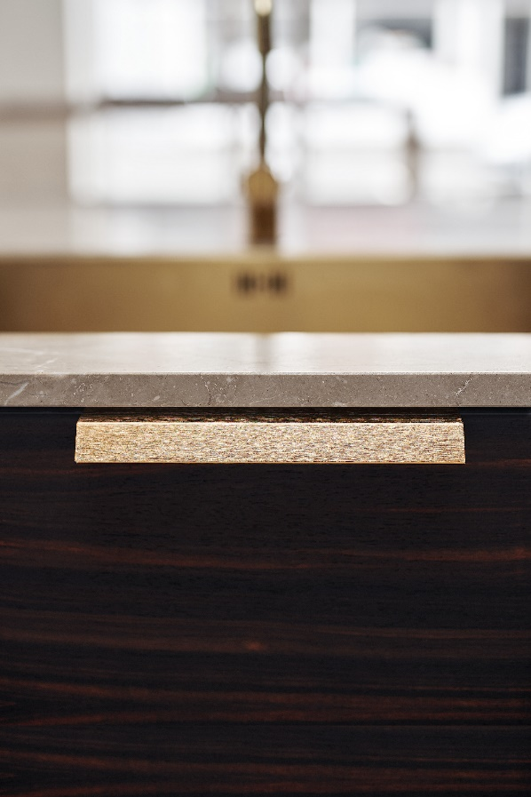
furnipart has worked concertedly for a year to achieve this certification, and the fact that it has been achieved with production in China makes CEO Rasmus Byriel even more satisfied:
The profile Bench from furnipart
“We chose to transition to a circular economy so that when it came to production methods, we could describe ours with a clear conscience. Having achieved certification of our production in China makes us very proud and it helps to break down the prevalent image of China as a manufacturing country.”
The work to achieve certification was carried out in collaboration with Vugge til Vugge ApS, an Accredited Danish Assessment Body, which is accredited by the Cradle to Cradle Products Innovation Institute. The company’s production is measured and assessed on the basis of criteria within the following five categories: material health, material reutilisation, renewable energy and carbon management, water stewardship and social fairness.
“We are transitioning to circular economy to create healthier production for the benefit of ourselves and future generations – it’s that simple. The concept of borrowing the Earth’s resources rather than consuming them appeals to the way we want to operate the business, and our certification is the first step in achieving healthier production,” says CEO Rasmus Byriel.
He points out that customers also include this on their own agendas.
“Our assessment showed that Cradle to Cradle certification was the best way to meet the increasing international demand for documented sustainability. It creates credibility about our brand, and it is good for our business,” says Rasmus Byriel.
The circular economy in Denmark
The Danish government’s strategy for transitioning the economy to a circular economy was published in September this year. Cradle to Cradle and the circular economy are two sides of the same coin, which means furnipart can use the new Cradle to Cradle certification to document that the company, like the Danish government, has a strategy for the circular economy.
The basis for transitioning to a circular economy is to create a healthier environment, but it will also mean healthier business. The government estimates an increase in net exports of 3–6 % in 2035 by transitioning to a circular economy.
The certification scheme Cradle to Cradle recognises human intention, but it also requires a plan for the continued improvement of the product, where progress is documented through re-certification every second year. Internationally, a Cradle to Cradle certified product is assigned value in sustainable building certification schemes such as BREEAM and LEED. For a company like furnipart, this is also significant, because the company supplies products to the building industry in Denmark and aboard.
Cradle to Cradle and Cradle to Cradle CertifiedTM
Cradle to Cradle is a design concept, where products are included in a healthy biological or technical circulation and creates value for people, the environment and the economy.
Based on the Cradle to Cradle concept, a product standard has been developed, called Cradle to Cradle Certified™ Product Standard. The standard is administered by Cradle to Cradle Products Innovation Institute, which is an independent non-profit organisation. Products can be certified in collaboration with assessor organisations that have been accredited by the institute, such as Vugge til Vugge ApS.
A Cradle to Cradle certificate is proof that a product is designed and manufactured in accordance with the concept’s principles.

Contact information:
CEO Rasmus Byriel – 0045 87 64 35 21 – rb@furnipart.com

