Epson launches new SureColor SC-P5000 printer

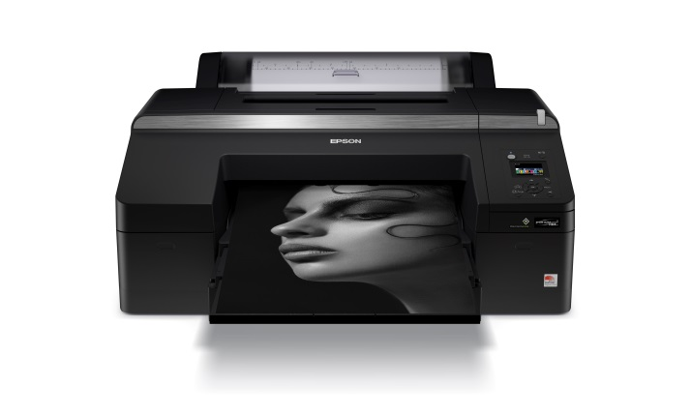

Epson SureColor SC-P5000 Printer

Malaysia, February 3rd, 2017 – Epson will be launching the new 17-inch SureColor SC-P5000 printer, designed to meet the needs of the proofing, fine art and photography applications. With the launch of the SC-P5000 printer, Epson now offers the full suite of print sizes from A4 to 64-inch, completing its line-up of the Epson P-series printers.

The SC-P5000 printer comes with the latest in ink technology, the new Ultrachrome HDX ink that brings an expanded colour gamut, delivering outstanding print quality and unparalleled colour matching capabilities for brilliantly detailed images.

The SC-P5000 with Ultrachrome HDX ink comes with violet HDX inkset to reproduce colours with near-perfect colour matching of 99% of Pantone Solid Coated Colour accuracy, suitable for colour proofing. Fine art photographers can use the SC-P5000 to reproduce their artwork with 98% of Pantone Solid Coated Colours.

The new Ultrachrome HDX ink delivers exceptional print quality to the prints, with a high print permanence rating for fine art photo prints and improved lightfastness for extremely long-lasting prints. It prints at a high-resolution of 2880 x 1440dpi, ensuring crisp and detailed results.

The SC-P5000 printer incorporates the Epson PrecisionCore printhead technology with Variable Size Dot Technology to produce outstanding performance and long-lasting quality output with ultra-precise control of dot size, shape and placement. The printhead comes with ink repelling coating for reduced nozzle clogging.

The SC-P5000 printer offers an enhanced body for reduced maintenance. It comes with new covers and seals to limit dust intrusion, and an improved automatic nozzle check. Epson’s new colour calibration software brings convenience and ease in set-up. The printer fits seamlessly into any proofing workflow and can be supplied with a SpectroProofer, which can handle colour proof checking.

“The SC-P5000 delivers precise colours that match exactly and that are easy to achieve with a printer that is highly reliable. Photographers, designers and artists can rest assured knowing that their artwork can be reproduced perfectly in the finish print to their demanding standards,” said Danny Lee, General Manager, Sales & Marketing, Epson Malaysia.

***

About Epson
Epson is a global technology leader dedicated to connecting people, things and information with its original efficient, compact and precision technologies. With a lineup that ranges from inkjet printers and digital printing systems to 3LCD projectors, smart glasses, sensing systems and industrial robots, the company is focused on driving innovations and exceeding customer expectations in inkjet, visual communications, wearables and robotics.
Led by the Japan-based Seiko Epson Corporation, the Epson Group comprises more than 73,000 employees in 91 companies around the world, and is proud of its contributions to the communities in which it operates and its ongoing efforts to reduce environmental impacts.
http://global.epson.com/

About Epson Southeast Asia
Since 1982, Epson has developed a strong presence across major markets in Southeast Asia. Led by the regional headquarters, Epson Singapore Pte Ltd., Epson Southeast Asia spans an extensive network of 10 countries, and is responsible for delivering and supporting Epson’s cutting-edge consumer and business digital imaging products to the customers of these markets through its comprehensive infrastructure of over 360 service outlets, 10 Epson solution centres and 8 manufacturing facilities. http://www.epson.com.sg

Media Enquiries:
Epson Malaysia Sdn Bhd  Chua Li Tinn  Manager – Marketing Communications  Tel: (03) 5628 8288 Ext 274  Email: ltchua@emsb.epson.com.my | SWOT Communications  Edina Manuel  Tel: 012 2500142  Email: edina@swotcommunications.com

