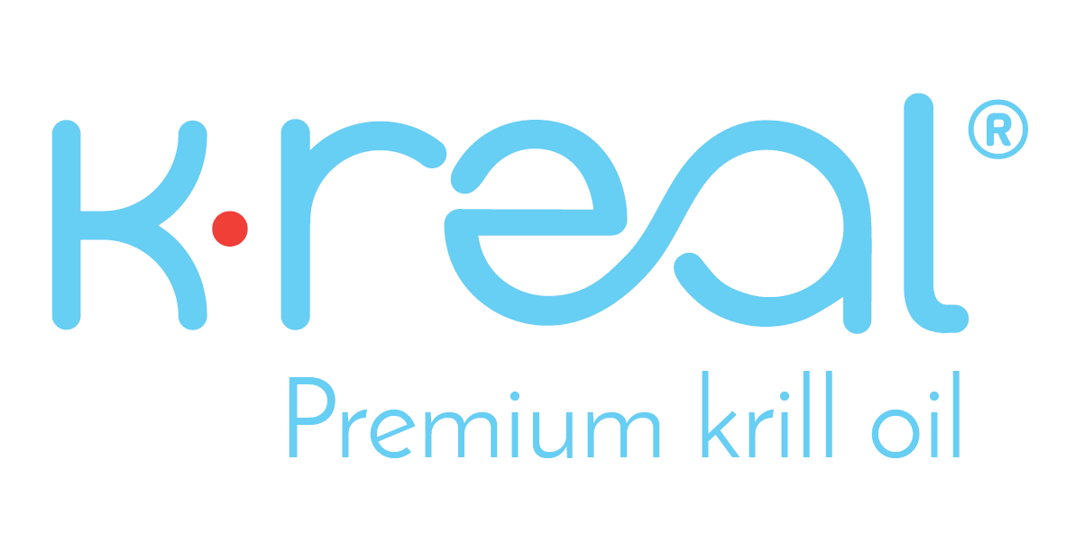
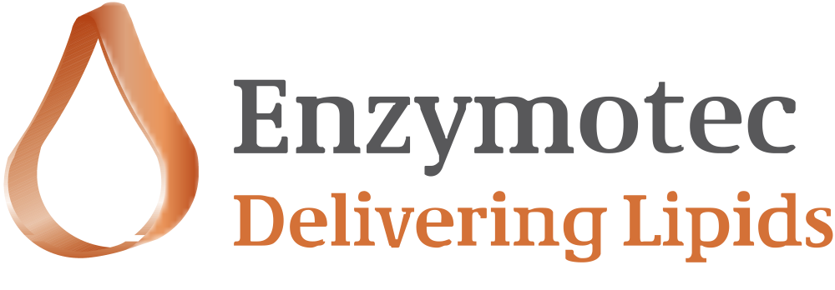

Enzymotec Launches Next Generation Krill Oil Product - K•REAL® Gold

MIGDAL HA'EMEQ, Israel, June 6th, 2017 (GLOBE NEWSWIRE) -- Enzymotec Ltd. (Nasdaq:ENZY)

Enzymotec, developer of innovative bio-active lipid-based nutritional ingredients and medical foods, today announced the launch of K•REAL® Gold, its next generation krill oil product. K•REAL® Gold is immediately available for purchase and represents the first launch in a line of new krill oil products that are under development.

K•REAL® Gold is highly concentrated in Omega-3 levels. It is rich in beneficial omega-3 fatty acids and Astaxanthin, produced using Enzymotec’s proprietary, cutting-edge MSO® 2.0 technology, which creates a high quality “T-free”^{1,2} and oxidation resistant^{1,3} product with an additional “low-sodium” offering in the European Union.

Avner Avissara, Vice President of Nutrition at Enzymotec, commented, “The introduction of K•REAL® Gold, using our cutting-edge MSO® 2.0 technology, enables Enzymotec to offer the market a unique product of unprecedented quality. This launch reaffirms Enzymotec’s commitment to delivering the highest quality krill products to remain competitive in a crowded krill oil market. We are excited to continue to pioneer products with exceptional freshness and superb oxidation resistance^{1,3}, as well as the assurance that our products are T-free^{1,2} and in the EU, low-sodium as well."

Notes to Editors

¹These statements have not been evaluated/ authorized by the Commission in accordance with Regulation (EC) 1924/2006 on nutrition and health claims made on foods.
²”T-free” refers to Trimethylamine N-oxide (TMAO) and Trimethylamine (TMA) free. Limit of detection of both TMAO and TMA is 1mgN/100g measured by Conway and Byrne’s micro-diffusion method (Conway & O’Malley, Microdiffusion Methods. Biochem, 36, 656-661(1942)).
³Relative to competing krill oil products. Based on results from in-vitro stomach model conducted by Enzymotec, where the levels of MDA of krill oils from various producers were tested.

Forward Looking Statements

This press release may contain forward-looking statements related to Enzymotec’s business strategy, outlook, objectives, plans, intentions or goals. The words "may," "will," "should," "plans," "explores," "expects," "anticipates," "continue," "estimate," "project," "intend," and similar expressions, identify forward-looking statements within the meaning of the Private Securities Litigation Reform Act of 1995, but their absence does not mean that the statement is not forward-looking. These statements are not guarantees of future performance and are subject to certain risks, uncertainties, and assumptions that are difficult to predict. Actual results could differ materially. Enzymotec expressly disclaims any obligation or undertaking to update or revise any forward-looking statement contained herein to reflect any change in the company's expectations with regard thereto or any change in events, conditions or circumstances upon which any statement is based.

About Enzymotec Ltd.

Enzymotec is a leading global supplier of specialty lipid-based products and solutions. The Company develops, manufactures and markets innovative bio-active lipid ingredients, as well as final products, based on sophisticated processes and technologies.

For more information about K•REAL® krill oil, visit http://www.krealkrill.com

For more information about Enzymotec, visit http://www.enzymotec.com

Contact:

The Ruth Group
Tram Bui / Alexander Lobo
(646) 536-7035 / 7037
tbui@theruthgroup.com
alobo@theruthgroup.com

Ingredient Communications
Richard Clarke
+44 1293 886291 (office) / +44 7766 256176 (mobile)
richard@ingredientcommunications.com
@ingredientcomms

