2025-06-24

**PRESS RELEASE**

Swedish-built instrument discovers new type of particle on the lunar surface

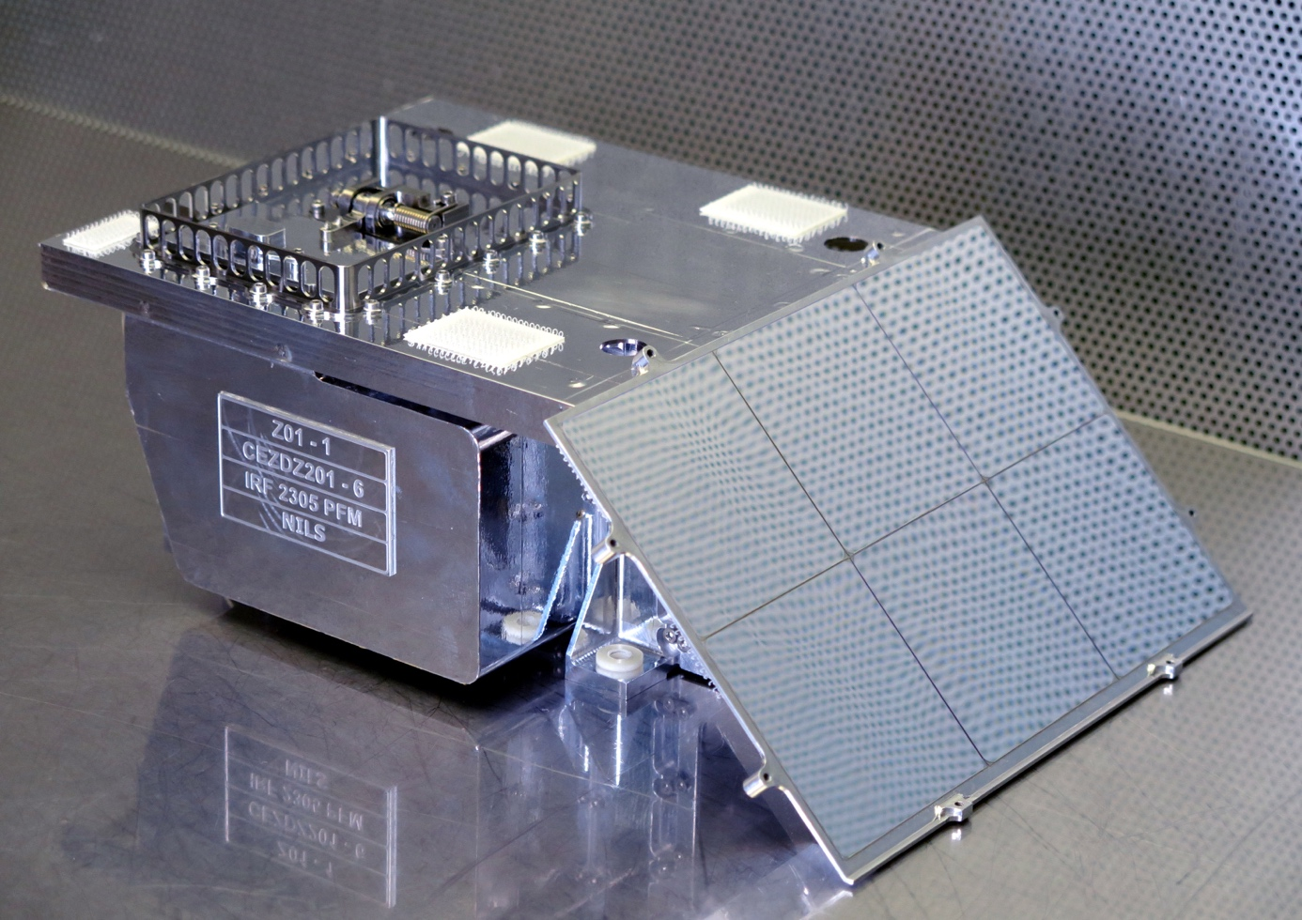

*Swedish scientists found negative ions on the Moon with NILS – a space instrument built at IRF. Cred: IRF*

**A space instrument, built by the Swedish Institute of Space Physics (IRF), has for the first time detected negative hydrogen ions on the surface of the Moon – a type of particle never seen there before. The discovery was recently published in the scientific journal *Nature Communications Earth and Environment*.**

When particles from the solar wind – mainly protons – hit the Moon’s surface, a reaction occurs that creates these negative hydrogen ions. This discovery is important because it opens up new ways to study how the Moon's surface becomes electrically charged and what it is made of.

The ions were detected by the NILS instrument (Negative Ions on the Lunar Surface), which landed on the Moon as part of China’s Chang’E-6 mission. NILS was developed by the Swedish Institute of Space Physics (IRF) on behalf of the European Space Agency (ESA) in collaboration with China's National Space Science Center, NSSC. NILS was the first ever sensor designed to measure negative ions beyond the Earth.

“*Finding negative ions on the Moon was an incredibly exciting achievement. The NILS instrument traveled a long way from Kiruna in Swedish Lapland to the far-side of the Moon to become one of the very few instruments to make direct measurements of ions on the lunar surface*,” says Romain Canu-Blot, one of the scientists behind the study.

“*This discovery shows that even small instruments can deliver excellent science*,” adds Martin Wieser, Principal Investigator for NILS.

IRF is a leading research institute studying and exploring the lunar environment. IRF's lunar research began from participation in a mission of discoveries Chandrayaan-1 carried out by the Indian Space Research Organization launched in 2008. In the coming years IRF will continue to play a key role in exploring the Moon.

With several upcoming missions and advanced instruments under development, IRF is at the forefront of unveiling the Moon’s mysteries — from its surface composition to how it interacts with the space environment. This ongoing research highlights Sweden’s strong and growing presence in international lunar science.

The article in Nature Communications Earth and Environment:

<https://www.nature.com/articles/s43247-025-02399-7>

Reference:   
Wieser, M., Zhang, A., Canu-Blot, R. *et al.* Direct observations of negative ions on the Lunar surface by Chang'E-6. *Commun Earth Environ* **6**, 451 (2025). <https://doi.org/10.1038/s43247-025-02399-7>

Contact:  
Dr. Martin Wieser, Scientist and Principal Investigator for NILS, Swedish Institute of Space Physics, [martin.wieser@irf.se](mailto:martin.wieser@irf.se), +46 70 277 1287