EMBARGOED UNTIL 28TH APRIL 2023

SUSANNE SUNDFØR RELEASES NEW ALBUM blómi
TODAY THROUGH BELLA UNION

SHARES fare thee well

WATCH THE VIDEO FOR alyosha

Photo credit: Janne Rugland
High res

“ blómi dares to dream and shuns convention. Sundfør has become to Norway what Björk is to Iceland.” - 4/5 MOJO

"It is a mesmerisingly beautiful album." - The Line Of Best Fit

Today, acclaimed artist Susanne Sundfør releases her stunning new album, blómi, through Warner Music Norway, and shares piano ballad fare thee well, a song about endings.

Susanne says of the album:

“I’ve dedicated this album to my family, in the sense that I'm presenting a better, more loving world. But it's not a parallel universe - it is here, and I want my daughter to always have that in her life. Whatever happens, she'll have that universe that I want her to see.”

Five years after Sundfør redefined her career with the folk-inspired, emotionally-effervescent album Music for People In Trouble, the Norwegian musician, artist and producer delves even deeper into her personal mythology on the soul-bearing blómi.

Earlier this year, Sundfør shared two new songs from the album alyosha and leikara ljóð. The video for alyosha features footage from Sundfør’s wedding day, painting an honest and beautiful portrait of love, and directed by Margreth Olin, Norwegian award winning film director known for her thought provoking documentaries.

Meaning “to be in bloom'' in Norse, blómi takes very unique aspects of Susanne’s life story, like the academic work of her grandfather who is a linguist specialising in Semitic languages, and her own life-changing experiences as a new mother, to weave together a colourful tapestry unlike anything she has released to date.

Sundfør wrote blómi, above all, as a love letter to her young daughter, a missive to a precious new life entering an unstable world. In the title track, which is anchored around a lush, driving piano arrangement and skin-tingling saxophones, Susanne imparts all her wisdom to her daughter, urging her to take her words with her through life. Pairing her lyrics with hints of Norse language and mythology, Susanne harks to indigenous Nordic cultures who built matrilineal societies and worshipped divine feminine deities. These roots, this passing from mother to child, is at the core of the music on blómi.

While Susanne’s previous albums, such as Ten Love Songs and The Brothel (which topped the Norwegian charts) established her as a singular voice in Norway’s modern musical history, blómi is a decidedly bold evolutionary jump.

With its 10 expertly crafted tracks of exquisite songwriting, blómi represents a complex and rewarding new chapter in a visionary artist’s established career.

blómi tracklisting:
- orð vǫlu
- ashera's song
- blómi
- rūnā
- fare thee well
- leikara Ijóð
- alyosha
- ṣānnu yārru lī
- náttsǫngr
- orð hjartans

Pre order blómi
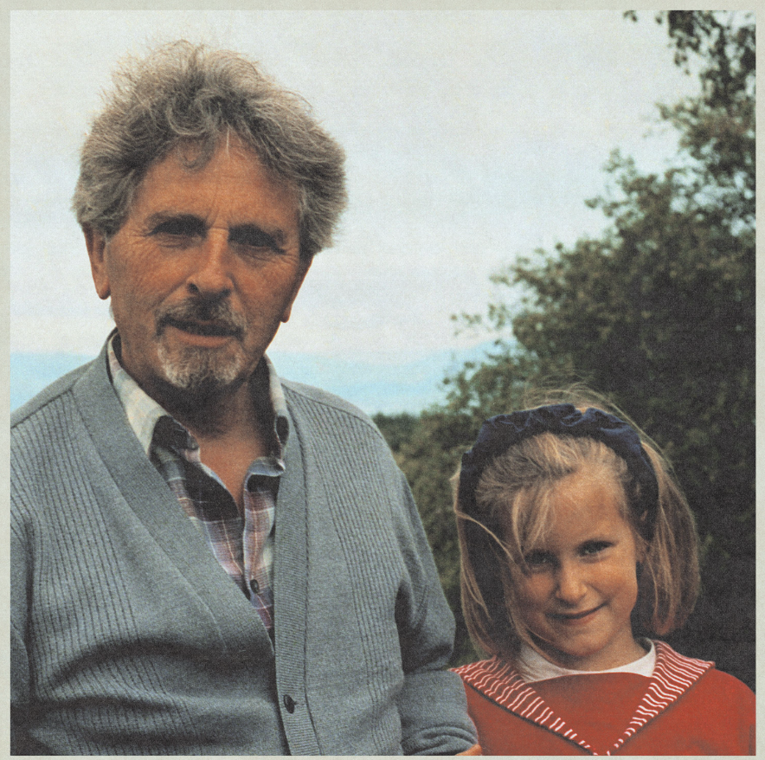
Blómi artwork here

Live dates:

May 29 - Nattjazz, Bergen, NO
May 30 - Nattjazz, Bergen, NO
June 9 - Lyse netter, Moss, NO (Duo)
June 16 - Verven Festival, Horten, NO
July 13 - Ravndalen Live, Kristiansand, NO
July 21 - Bukta Festival, Tromsø, NO
July 29 - Kubafestivalen, Svolvær, NO
July 31 - Olavsfestdagene, Trondheim, NO
August 10 - Øya Festival, Oslo, NO
August 11 - Stavanger, Fiskepiren NO

Instagram | Twitter | Facebook | Web

