**A Love Affair With Danger**

**Bill Hastings has been in Norway about 20 times. He was first hired by The Norwegian University College of Dance in 1991 to do Dancin’ Man for their 25th anniversary. Now, he’s back at The Norwegian University College of Dance to rehearse The Rich Man’s Frug for the 50th anniversary.**

**Can you tell me about your career as a dancer?**

*- I went to college on a full music scholarship. I was a self-taught percussionist who dreamed of playing in a classical orchestra; however, I graduated with a degree in theatre. While in college, a friend of mine came to me and said there was an audition for a local production of the musical “Paint your Wagon”. He encouraged me to audition, and so I did. Quite surprisingly I was hired for the job. A whole new world opened to me. The combination of music, theatre and dance was thrilling. I was hooked. A lifelong career as dancer, choreographer and teacher was to follow. About the same time, I saw a film of Martha Graham’s Seraphic Dialogue; and I thought, I want to do THAT - the beautiful, powerful movement; the iconic design; and, the theatrical artfulness. However, it was the bright lights of musical theatre that ultimately won me over.*

**You seem like you like what you are doing. Is that right?**

*- I love what I’m doing; but, it also frightens me. It demands much from the heart, the spirit, the intellect and the body (as with most athletes, age is a constant sparring partner). For me it’s a love affair with danger; the possibility of failure is always present.*

*- There is an old saying in the theatre, you are only as good as your last show. The rousing ovation shares the stage with possible humiliation. Failure, like success, is always just a step away.*

**Can you say something about the process, and how you work with the students?**

*- When I rehearse a piece or teach a dance, I’m layering; starting from the outside edges of the movement to eventually dig further and further into the detailed, inner layer. For NUCD, I’m re-creating another choreographer’s work. Presently, I have a notebook in which I write all the choreographic detail and design to make sure I’m honoring the original work. I really want to do this re-creation well; I prepared for several weeks before arriving in Oslo. Once here, I had to change the spacing of the piece as the stage here is smaller; but, that’s part of the job; you must be willing to adapt at a moments notice.*

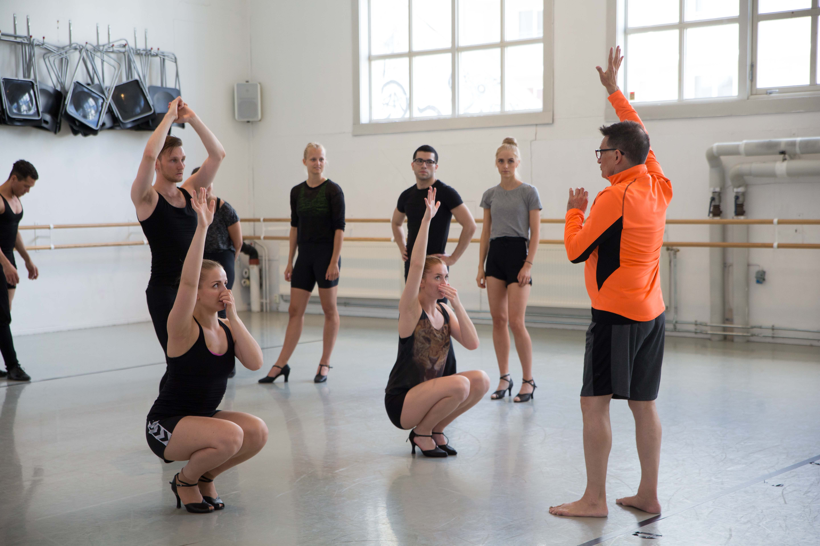

Bill Hastings at NUCD, teaching The Rich Man’s Frug, 2016. Photo: Camilla Storvollen.

*- What I love so much about the teaching part, is I get the chance to see the student/dancer develop from day to day. They all come from different backgrounds, and the way they dance and express themselves physically depends upon a lot of things; from how they hear music; how they see abstract design; and, also, what kind of experiences life has thrown at them. As dancers, we all want to do the right thing; but, sometimes we over think and subsequently over work. It’s also my job to help them relax, so they become more integrated with the movement and can subsequently enjoy their experience on stage.*

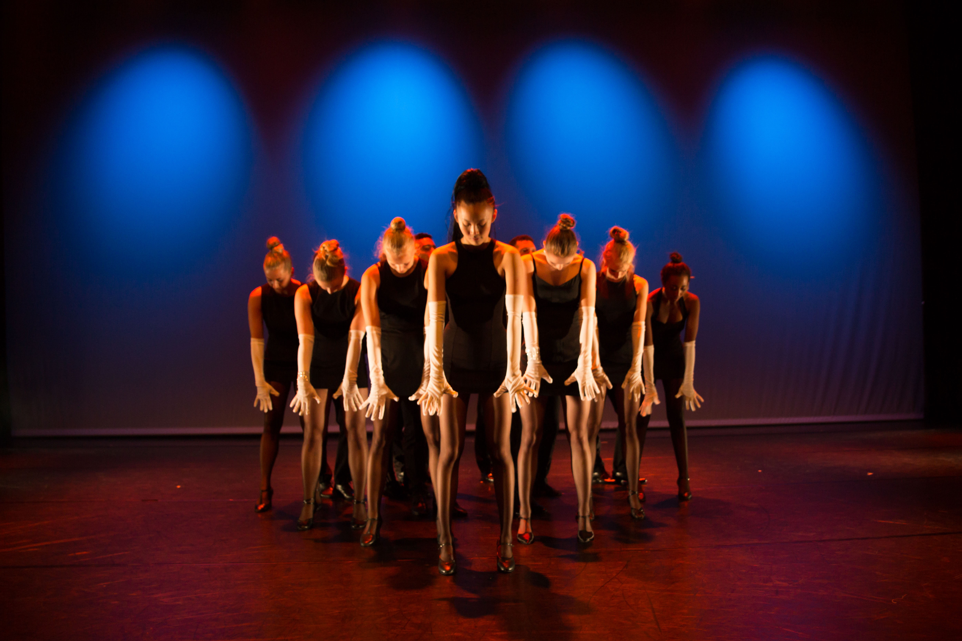

The Rich Man’s Frug, from the rehearsal at Riksscenen. Photo: Camilla Storvollen.

**Can you say something about jazz dance and style, in terms of technique?**

* *An important aspect of jazz dance is that it is not locked into one expression. It has many influences, and as such varies greatly in style, technique, body language and rhythmic interpretation. Initially it was an improvisational expression reflecting the music, spirit, and cultural environment of the time. There are very few consistent jazz dance techniques out there. Unlike ballet, jazz dance techniques are forever fluid, mirroring the times as well as changing performance sensibilities.*

**Can you say something about Bob Fosse’s style and work?**

* *In 1980, I auditioned for Bob Fosse’s Broadway musical Dancin’. I danced two years in that show, the last year of which I served as it’s dance captain. People would ask me, “how can you dance eight times a week for two years in the same show, don’t you get bored?” And I respond; “Each show teaches me something. Mr. Fosses choreography was always teaching me something.” I was always concerned that I wouldn’t dance well enough. You can perhaps address Bob Fosse’s choreographic expression in two eras. Some might say his early career was his “ice cream period”; it was bright, happy, very ‘musical theater’. The style was pulled from ballet; contemporary jazz styles; arguably the jazz expressions of Jack Cole; and, certainly his own wonderfully vivid imagination. He was responding to the time in which he lived - the 40s, 50s and 60s. Eventually, his dance expression began to change. People said that his choreographies became darker, more sexual, more cynical, even whimsical. You certainly can see this in the piece I’m rehearsing with the students now, The Rich Man’s Frug from his show Sweet Charity.*

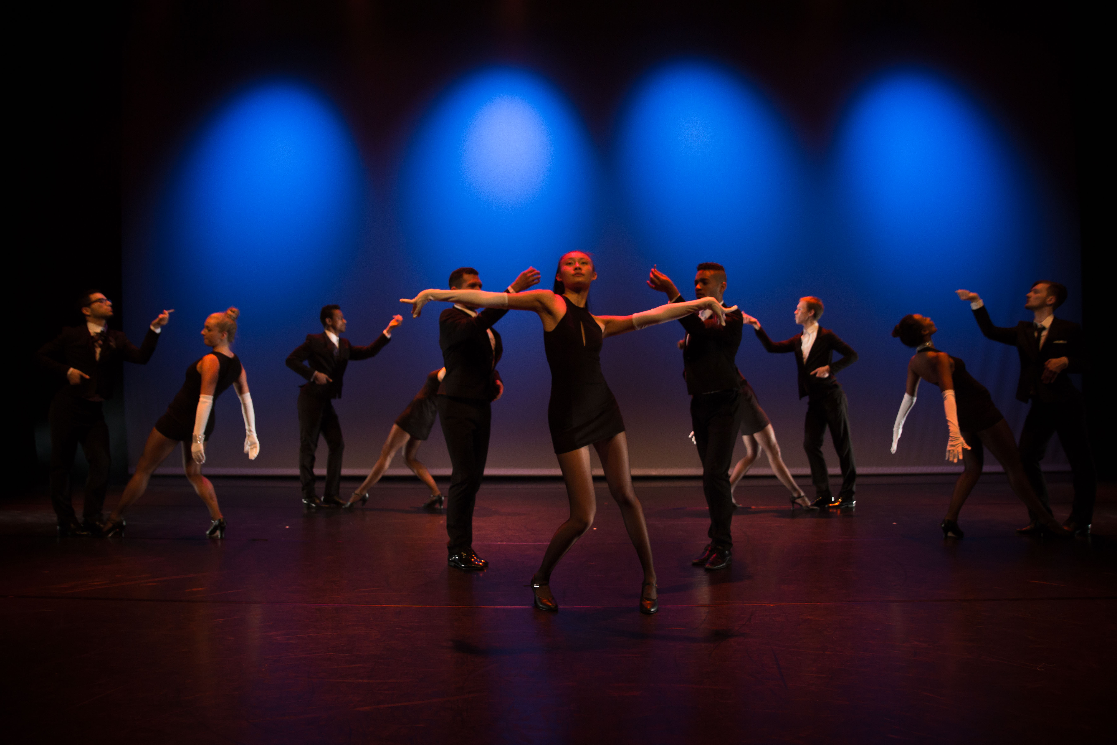

The Rich Man’s Frug, from the rehearsal at Riksscenen. Photo: Camilla Storvollen.

* *The second era, which some call his darker period, was the time I was privileged to work with him. As well as performing in Dancin’, I had the pleasure of dancing in Mr. Fosse’s Broadway and national tour companies of Sweet Charity, in 1986. In the 90s, I was fortunate enough to assist Chet Walker and Gwen Verdon in their creation of the Tony Award-winning Broadway show, Fosse.*
* *Mr. Fosses work is a style, a point of view, not a technique. However, it is very site specific. You always know where a movement comes from; where it was initiated in the body; and, what imagery supports it. You became a dancer who acts. Mr. Fosse was not only a brilliant choreographer, he was a consummate director, guiding his actors and dancers through the beautiful world of theatre. I’m privileged and honored to pass on not only some of Mr. Fosse’s steps; but, also a bit of his imagery which bring his work to life.*

Interviewed by [Camilla Storvollen](http://ndh.no/ansatte/639) for The Norwegian University College of Dance, june 2016.