Press release
The Non-Violence Project Foundation (NVPF) May 28th2020, Geneva

MAKE A BID TO STEM VIOLENCE

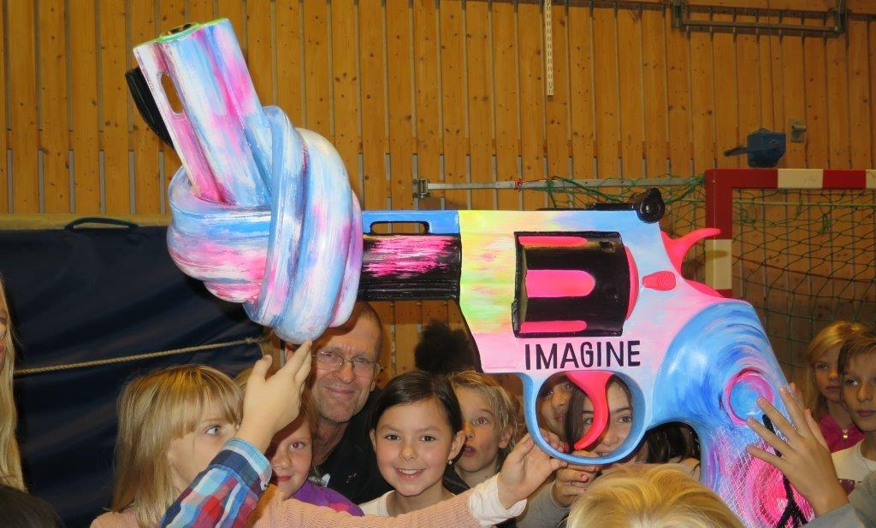
#Make a bid to support the work of the Foundation to reduce all sorts of violence in the world
As Covid19 and confinement have now become a reality on many parts of our planet, another collateral effect has unfortunately surged: the increase of domestic violence. Hotlines are lightening up and, in some countries, domestic abuse has raised up to 40 %.
NVPF has been fighting violence for 27 years now and has decided to stand up specifically against domestic violence and children abuse. We are therefore launching a fundraising campaign as our actions are more needed than ever. Within this fundraising campaign, an online auction, AUCTIONNONVIOLENCE, has been organized with the partnership with CB-Events Geneva. It offers the opportunity to buy some unique items and support a great cause!

Some rare lots will be available to bidders: limited editions of the Knotted Gun sculpture, some Beatles original records of 1966, a private concert of a famous pianist, some beautiful pieces of art just to name a few.
100% of the funds raised will go to The Non-Violence Project Foundation (NVPF) to pursue its work against violence through its educational programs.
“The Non- Violence Project Foundation’s global objective is challenging as we want to raise 100,000 Swiss Francs but the people we want to help fully deserve we do our utmost. In 2019 we were able to train more than 23,000 people around the world with great results as shown by our Evaluation Report. Nonetheless, to pursue and develop our educational programs, we need support through sponsorships or donations. The funds raised through this auction will be a major contribution to our work to stem violence.” says Blaise Oberson, CEO of NVPF.
NVPF is a non-profit educational organization based in Geneva, Switzerland, established in 1993 and operating in 11 countries out of four continents. The Foundation owns and cherishes the rights to The Knotted Gun, the sculpture created by Carl Fredrik Reuterswärd in tribute to his friend John Lennon. A universal symbol of non-violence, with its original placed outside the UN headquarters in New York.
NVPF ‘s mission is to INSPIRE, MOTIVATE and ENGAGE people to understand how to resolve conflicts peacefully. Since 1993, the Foundation has trained more than 8 million people, including students, teachers, trainers and sports coaches. From 2018 to 2019 NVPF trained more than 115,000 students, 4000 teachers and 7500 volunteers. The Foundation has received numerous awards such as the Bill Clinton Daily Light Award and the Barack Obama Foundation Award for its educational activities and programs.
-----
For more information: www.nonviolence.com
Contacts
Blaise Oberson, CEO; blaise@nonviolence.com
Jan Hellman, Co-Founder; jan@nonviolence.com

