NEC Display Solutions uppdaterar integrerade PCs med tredje generationens Intel Core™-processorer

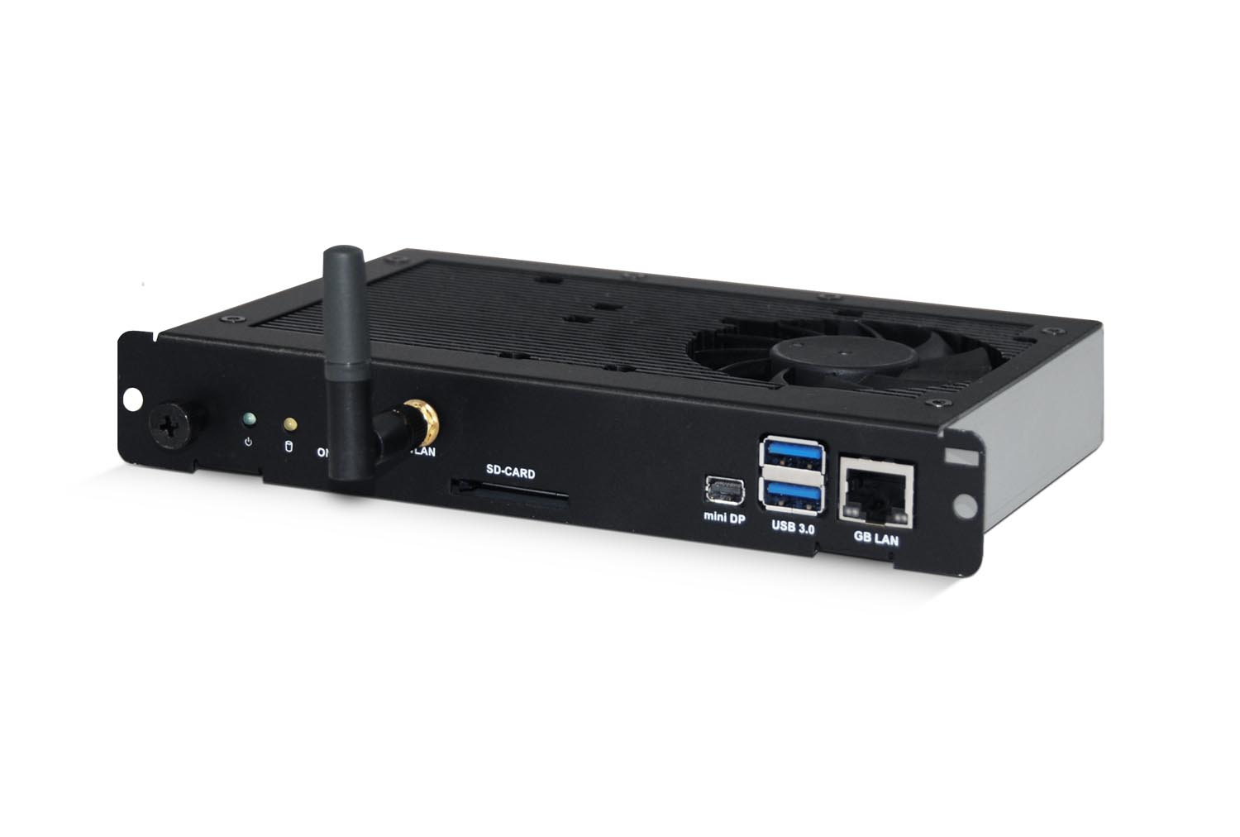

NEC Display Solutions lanserar tre nya inbyggnadsdatorer som gör att kompatibla storformatsskärmar och projektorer kan visa innehåll utan behov av varken extern dator, kablar, montering eller extra strömförsörjning. Modellerna bygger på Open Pluggable Specification (OPS), en standard som utvecklats i en strategisk allians mellan NEC och Intel Corporation. Lösningen är kompatibel med NECs storformatsskärmar med utbyggnadsmoduler STv2 eller Dual Slot, samt även för installationsprojektorer i PX- och PH-serien.

De nya modellerna är indelade i tre kategorier:

- Flaggskeppsmodellen med tredje generationens Intel ® Core i7-processor som levererar förstklassig prestanda för de mest krävande tillämpningar, så som multitouch-funktioner och 3D-applikationer.

- En version med Intel ® Core i5-processor som bygger på Intels 22nm-teknik och som lämpar sig för HD-media och interaktivt bildmaterial.

- En version med Intel ® AtomTM-processor avsedd för att visa statisk information, exempelvis information på flygplatser och enklare digital skyltning.

För mer information, kontakta:
Henrik Breda, Nordisk försäljnings- och marknadschef på NEC Display Solutions
Telefon:+47 92 25 50 58, E-post: henrik.breda@emea.nec.com

Ann Kjellser, PR Manager EMEA, NEC Display Solutions Europe
Telefon +46(0)72 162 8719, E-post: ann.kjellser@emea.nec.com

Läs det engelska pressmeddelandet i sin helhet nedan.

NEC Display Solutions updates Slot-In PC module range based on 3rd Generation Intel® CoreTM processors

Wireless Option Board system offers improved performance at reduced costs

NEC Display Solutions Europe has unveiled a trio of additions to its range of Slot-In PCs, which allow compatible public displays and projectors to display the latest content without the need for an external PC, cabling, mounting and power supply.

All three of the new models are based on the Open Pluggable Specification (OPS), a specification designed in a strategic alliance between NEC and Intel Corporation to be compatible with NEC Public Displays with a STv2 or DualSlot, as well as NEC PX Series and PH Series installation projectors.

The flagship module boasts a 3rd Generation Intel® CoreTM i7 processor, which not only delivers top-of-the-line performance ideal for the most demanding tasks. This makes it perfect for high performance applications such as Hiperwall, multi-touch and 3D installations in places such as high-level retail signage environments, as well as control rooms in utility and transportation organisations.
Demanding users can opt for the Intel® CoreTM i5 processor version, also built on Intel's 22nm technology. This powerful CPU, combined with 4GB of RAM and Intel® HD graphics, ensures that this new module delivers 26 per cent more processing power and 45 per cent more graphics performance than its predecessor. This makes it perfect for the rigorous demands of public displays streaming high definition and interactive content.

For those users with less demanding requirements and smaller budgets, the second module incorporates and Intel® AtomTM processor 2 x 1.6GHz OPS and integrated graphics. This makes it the perfect solution for displaying static content such as flight information in airports and light retail signage.

Compared to their predecessors, all the modules also boast improved graphics power for full HD crisp playback, and a wide range of connectivity options, including two USB ports (USB 2.0 for the Intel Atom processor based version and USB 3.0 for the Intel Core i5 and i7 processor modules) and an SD Card slot, as well as wired and wireless network connectivity. Furthermore, these models are also highly configurable in terms of memory, storage and pre-loaded operating system, adding even greater flexibility to match every usage scenario.

As well as providing a superior graphics power and versatility, they offer excellent total cost of ownership thanks to low power consumption. In particular, the Intel Atom processor dual core model draws a maximum of just 11 watts, 40 per cent less than its predecessor.

"NEC offers a variety of Slot-In PC systems for use with our public display screens and projectors that provide an easy upgrade path and improved cost of ownership as you can upgrade your OPS device or upgrade your display individually during the ordinary lifecycle,” said Thomas Walter, Product Manager Public Display Solutions at NEC Display Solutions Europe. "With research from specialist research and knowledge-based consulting firm, FutureSource, predicting that Embedded Media Player sales are going to soar over the next four years, this is the perfect time to be ensuring that we have an up-to-date, and compelling, proposition for users, no matter what their requirements."

"The Open Pluggable Specification provides the industry with a standardized media player input to increase flexibility for users of any digital signage application as well as simplify the upgrade process," said Jose Avalos, Director of Retail and Digital Signage, Intel Corporation. "Using 3rd Generation Intel® CoreTM processors for the computing element of the OPS enables stunning high-definition visuals and reduces the overall total cost of ownership."

Availability, price and warranty
The Intel Atom processor and Intel Core i7 processor NEC Slot-In PCs are both available from October 2012 onwards, and the Intel Core i5 processor based version due to be launched around Mid-October. The flagship Intel Atom processor 2, Intel Core i5 i7 processor modules are expected to have a recommended retail price of €690, €1,350 and €1,600 respectively. All versions come with a three-year warranty.

NEC Display Solutions Europe GmbH has its European headquarters in Munich, Germany and is responsible for all business activities in EMEA. NEC Display Solutions benefits from the technological know-how and technologies of the NEC Corporation and, with its own Research and Development, is one of the world's leading manufacturers offering the widest product range of display solutions in the market. The display product portfolio ranges from entry-level to professional and speciality desktop LCDs, via large-size Public Displays for Digital and Retail Signage. The Projector range offers products for all needs, from portable devices via business projectors to products for permanent operation (such as PoS applications) and digital cinema projectors. Bernd Eberhardt is President and CEO of NEC Display Solutions Europe.

Further information can be found online at: www.nec-display-solutions.com

Follow us on our social media channels: Facebook, YouTube, Twitter and LinkedIn.

NEC Corporation is a leader in the integration of IT and network technologies that benefit businesses and people around the world. By providing a combination of products and solutions that cross utilize the company’s experience and global resources, NEC’s advanced technologies meet the complex and ever-changing needs of its customers. NEC brings more than 100 years of expertise in technological innovation to empower people, businesses and society.

For more information, visit NEC at: www.nec.com

NEC is a registered trademark of NEC Corporation. All Rights Reserved. Other product or service marks mentioned herein are the trademarks of their respective owners. ©2012 NEC Corporation.

Intel, Intel Atom and Intel Core are registered trademarks of Intel Corporation in the United States and other countries.

