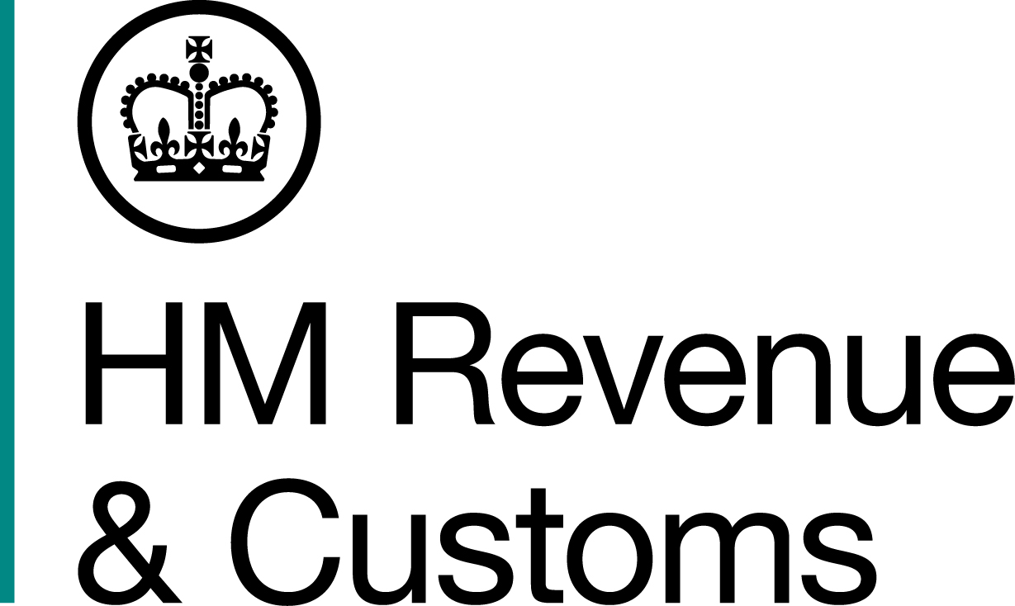
News Release

 | For the attention of News and Business Desks |  | No of pages: 5
 | Date: | 25 February 2019 | Ref: | SE 02/19

Two jailed for £60m fraudulent HIV cure tax fraud

Two fraudsters, who attempted to steal more than £60 million through a fraudulent tax avoidance scheme claiming to invest in HIV research and conservation, have been jailed for a total of 14 and a half years.

Ethical Trading and Marketing Ltd company director Antony Blakey, 68, and finance director, John Banyard, 70, enticed wealthy people to invest in the scheme with the promise of avoiding tax by supporting tree planting in the Amazon and research into a HIV cure.

The pair were aided by world renowned conservation scientist Professor Ian Swingland, 72, who joined the fraud to help create the fake documents and add credibility to the scheme.

An investigation by HM Revenue and Customs (HMRC) found the men created false documents to fraudulently claim expenses. They submitted fake scientific reports to HMRC and photos to support their claims but there was no evidence any of this had actually taken place.

The men sold this scheme as a marketed investment opportunity when in fact it was fraud masquerading as avoidance.

Investors were able to claim tax rebates on the losses that the businesses apparently generated, or lower their tax bills, by offsetting losses against £160 million of income, attempting to avoid £60 million in tax. The majority of repayments claimed were withheld by HMRC.

Details of the convictions and sentences can only now be revealed after reporting restrictions were lifted today (25 February 2019).

Simon York, Director of Fraud Investigation Service, HMRC, said:

“This was a calculated and cynical crime carried out by men who had no shame in using a worthy cause like HIV research to mask their criminality. In doing so, they attempted to steal millions of pounds from the taxpaying public - money that ultimately pays for vital public services like the NHS.

“Promoting tax avoidance schemes is bad enough and we’re making it a priority to go after those who market them, but for these men that was just a first step in establishing an elaborate criminal operation that included offshore accounts, fake transactions and blatant lies.

“To those who would follow in their footsteps, I would say this case sends a clear message that no matter how well you think you’ve covered your tracks, no one is beyond our reach and you will face justice.”

During the investigation, HMRC worked with a number of foreign jurisdictions including Germany, Mauritius, Brazil, the Netherlands, France, Cyprus and the United States and found the fraudsters used offshore companies in Mauritius and the Seychelles to cover their tracks.

Kristin Jones, Head of Specialist Fraud Division at the CPS said:

“These two men flagrantly stole millions from the public purse, under the guise of investing in research and conservation. Our Specialist Fraud Division, along with HMRC, has made sure that they will no longer be able to profit from their dishonesty.

“The CPS will continue to work with our partners to ensure that fraudsters are prosecuted to the full extent of the law.”

Upon sentencing the three men for the fraud based on tax avoidance in March 2017, His Honour Judge Pegden QC, said:

“The offences required significant planning and the fraudulent activity was over a sustained period. You were all involved in different ways in dishonest tax schemes.

“Antony Blakey, you lay at the very heart of these schemes, playing a part in devising them and ensuring their sale, and then lying to Her Majesty’s Revenue and Customs over a prolonged period.”

The men were found guilty on 3 March 2017 after a trial at Southwark Crown Court that began in September 2016. Antony Blakey was jailed for seven and a half years on 10 March 2017; revised to nine years at the Court of Appeal on 25 May 2017. John Banyard was jailed for four and a half years; revised to five and a half years at the Court of Appeal, on the same dates. Professor Ian Swingland received a two year sentence, suspended for 18 months.

HMRC is pursuing confiscation against the fraudsters to recover criminal proceeds and also pursuing those who invested in this now failed avoidance scheme to recover taxes due.

On 3 November 2017, Antony Blakey pleaded guilty to evading Income Tax of £441,000 through the use of offshore companies and bank accounts. Today (25 February 2019) John Banyard pleaded guilty to Income Tax evasion of £207,000.

Martin King, 56, a financial planner who hid his true income by arranging payment of work he did with Blakey through an offshore company, pleaded guilty the fraudulent evasion of £235,000 Income Tax on the same day.

All three men had used companies registered in the Seychelles and bank accounts in Cyprus to hide their personal income and evade tax. John Banyard also pleaded guilty to facilitating the Income Tax fraud by Blakey and King.

Notes for Editors

      - There is no suggestion that the investors knew the scheme was a sham, or knew that their money was not being spent on research and development and carbon trading business activity.
      - HMRC found very little evidence of the £160 million the fraudsters claimed to have invested in Brazil between March 2005 and March 2009. HMRC found no evidence on real funding for HIV research.
      - Antony Clive Blakey (25/02/1951) a serving prisoner, previously of South Terrace, Littlehampton, West Sussex.
- Blakey was found guilty on 3 March 2017 of two counts of cheating the public revenue, contrary to common law, and one count of conspiring to commit fraud by false representation. Company Director of Ethical Trading and Marketing Ltd, he took the lead role in the fraudulent ‘avoidance’ scheme.
- Blakey was jailed for seven and a half years on 10 March 2017 at Southwark Crown Court; revised to nine years at the Court of Appeal on 25 May 2017. He was sentenced to nine years, and five years, for the two counts of cheating the public revenue, and to five years for conspiracy to commit fraud. All to run concurrently.
- Blakey was jailed for eight months in January 2015 for Contempt of Court in relation to this HMRC investigation, after he breached a Financial Restraint Order by failing to keep the Crown Prosecution Service notified of any bank accounts he opened.
- Antony Clive Blakey pleaded guilty to the fraudulent evasion of Income Tax on 3 November 2017 at Southwark Crown Court. He received a three year jail term for this offence, to run concurrently with the nine years he is already serving, at the same court on 10 November 2017.
      - John Alexander Banyard (01/01/1949) a serving prisoner, previously of Dickins Way, Horsham, West Sussex, was Finance Director and accountant for Ethical Trading and Marketing Ltd.
- He was found guilty on 3 March 2017 of two counts of cheating the public revenue, contrary to common law. Banyard was jailed for four and a half years on 10 March 2017 at Southwark Crown Court; revised to five and a half years at the Court of Appeal on 25 May 2017. He received a concurrent sentence of three years for the second count of cheating the public revenue.
- John Alexander Banyard pleaded guilty to the fraudulent evasion of Income Tax and facilitating the Income Tax fraud on 25 February 2019 at Southwark Crown Court. He received a 21 months sentence for each offence, to be served concurrent, on the same day.
      - Professor Ian Richard Swingland (02/11/1946) of Alexander Close, Sandwich, Kent was found guilty on 3 March 2017 of one count of conspiring to commit fraud by false representation. He is a scientist and professor of conservation biology and helped bring credibility to the scheme. He helped source material for inclusion in false documents. Professor Swingland received a two year sentence, suspended for 18 months at Southwark Crown Court on 10 March 2017.
      - In 2007, Professor Swingland had been awarded the Order of the British Empire for services to conservation, following his conviction in 2017, this was cancelled on the recommendation of the Cabinet Office Forfeiture Committee.
      - Martin Adrian King (22/05/62) a financial planner of Oakfield Gardens, Beckenham, Greater London pleaded guilty to the fraudulent evasion of Income Tax on 25 February at Southwark Crown Court. He was handed an 18 month sentence, suspended for 2 years, on the same day.
      - Two men were acquitted of all charges in the September 2016 to March 2017 trial.
      - Blakey and Banyard had previously worked together to promote film finance as a way of reducing tax bills.
      - HMRC is working with the tax profession to tackle those who promote tax avoidance schemes. Promoters of Tax Avoidance Schemes legislation, introduced in Parliament in 2014, is aimed at tackling those who push the boundaries of the rules, and carries consequences for those who fail to change their behaviour.
      - Reporting restrictions were lifted on 25 February 2019 which means the September 2016 to March 2017 fraud trial, and the personal tax evasion investigation can now be reported.
      - Follow HMRC Press Office on Twitter @HMRCpressoffice

Issued by HM Revenue & Customs Press Office

Press enquiries only please contact:

Jemma Smith
Tel: 03000 520 184 / 07741 615 662
Email: jemma.smith@hmrc.gov.uk

Paul Conroy
Tel: 07469 022 985
Email: paul.conroy1@hmrc.gov.uk

Out of hours
Tel: 07860 359544
Website www.gov.uk/hmrc

