HIMOINSA Provides Power in the Fight Against Covid19 in Spain
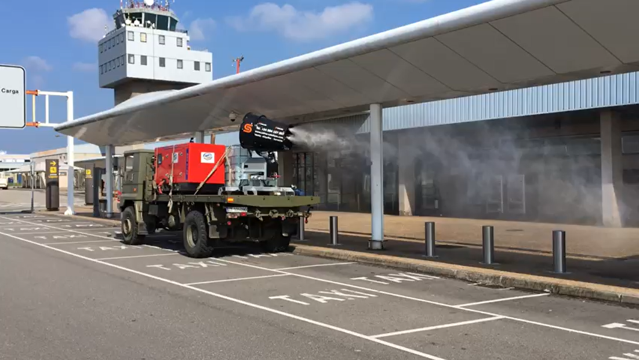
A HIMOINSA generator mounted on an army truck powers disinfection efforts at Asturias International Airport.
Asturias, Spain (September 8th, 2020) – Generators from Yanmar subsidiary HIMOINSA have been used in disinfection activities to combat the coronavirus pandemic. HIMOINSA distributor, Dos Vías Alquiler de Maquinaria located in Asturias, a region in the north of the country, supplied mobile equipment to assist with fumigation of various public facilities to combat the pandemic.
Dos Vías Alquiler de Maquinaria worked in cooperation with the ‘Principe de Asturias’ Military Regiment towards disinfection and fumigation of public spaces, civil structures and transport. Disinfection spraying was carried out by the army in an attempt to alleviate the COVID-19 pandemic that has affected Spain since March.
Pedro Suárez, manager of Dos Vías Alquiler de Maquinaria explains: “The army requested help to install mobile equipment for a sprayer on military trucks. For such a delicate job, 20 Kva of power was required and, most importantly, reliable, robust and silent machines, with enough autonomy to work more than 12 hours a day at full capacity”. The work began on March 27, and was carried out at the Asturias International Airport which serves the citizens of the region, especially the three main population centers of Gijón, Avilés and the regional capital of Oviedo. In addition, essential public spaces such as government buildings were disinfected, along with the seaport, administrative centers, and key transport facilities.

Dos Vías Maquinaria is a consolidated distributor of HIMOINSA in Spain. “The generator supplied for this work is part of a renewal of the machinery park that we carried out months ago. It´s a silent generator - a soundproofed version with a Yanmar engine. These offer the best noise levels and performance,” explains Pedro Suárez. “Another important aspect when choosing this genset for this project was the generator size and ensuring it complied with regulations regarding work in public places with the presence of citizens, both in terms of emission of pollutants and sound levels.”Both HIMOINSA and its partner Dos Vías Alquiler de Maquinaria stand ready to assist in further activities in support of the people of Asturias Principality.
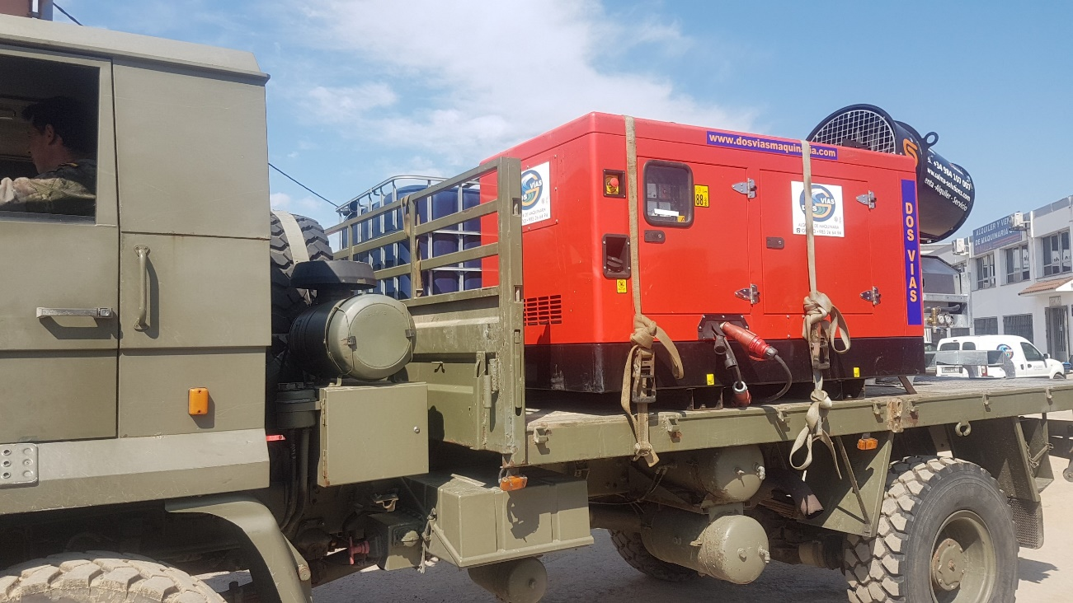
The HIMOINSA generator powers a mobile spraying unit for COVID-19 disinfection.

About HIMOINSA
A Yanmar Group Company, HIMOINSA is a global corporation that develops, manufactures and distributes power generation equipment, from diesel and gas generator sets to lighting towers.
HIMOINSA manufactures all generator sets components and works with the top engine and alternator brands, applying its engineering know-how to adapt the product design to the specific needs of each project, offering technical consultancy, feasibility studies and certifications. This ability to make products to measure gives the company enormous flexibility in tailoring products to suit customer needs for a global market.
Constantly expanding and developing new products, HIMOINSA currently has eight factories and eleven subsidiaries around the world.
​Visit the website for more information: ​https://www.himoinsa.com/

