FOR IMMEDIATE RELEASE

Intellian launches C700 Iridium Certus®
maritime terminal

State-of-the-art 12-patch phased array antenna technology enables the most powerful performance and feature-rich all-in-one terminal ever
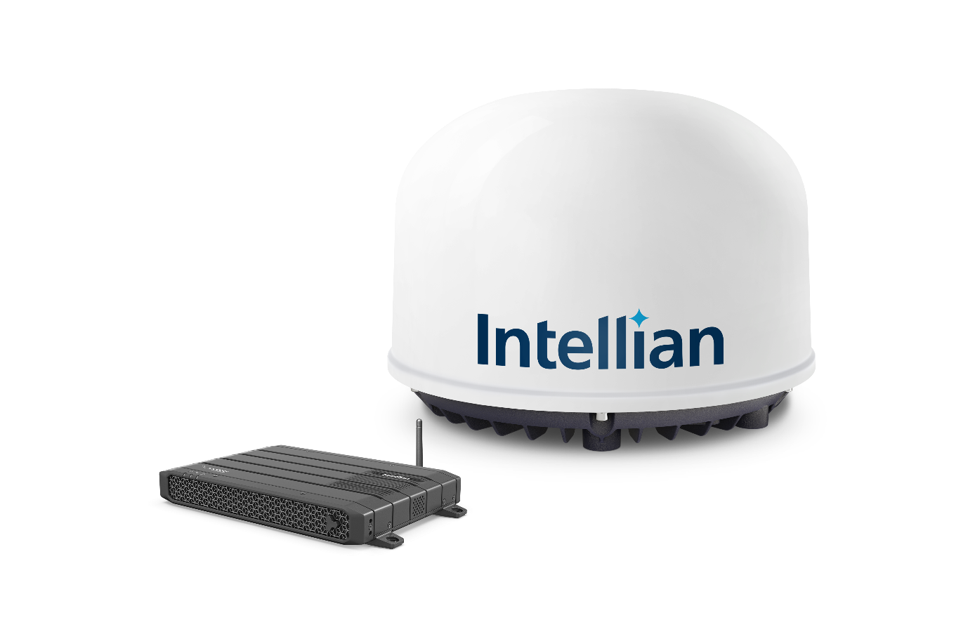Intellian’s 12-patch C700 Iridium Certus® antenna delivers best in class performance

27 October 2020 – Intellian’s eagerly-awaited C700 Iridium Certus® maritime terminal has now been launched and is expected to quickly secure a reputation as the most powerful and technically advanced Iridium Certus® terminal on the market.
With its best-in-class RF performance, the C700 can deliver out-of-the-box uplink speeds of 352kbps and downlink speeds of 704kbps by default, with equally impressive low-elevation-angle RF efficiency thanks to its unique 12-patch phased array antenna technology. It will support three high-quality, low-latency phone lines simultaneously; and as a solid-state antenna with no moving parts inside, the C700 is especially robust, requiring no scheduled maintenance over its lifetime.
The advanced performance of the C700 provides customers across all markets with the flexibility to deploy it as the primary communication antenna or as a companion to a VSAT system for seamless redundancy. For primary communications, the Below Deck Unit (BDU) incorporates key features which make it ready to deploy without additional cost, including firewall, IP PBX, WAN port and built-in Wi-Fi. Hardware and software functions such as these, incorporated into the system, make the C700 the most powerful, feature-rich L-band solution on the market, delivering best in class performance and functionality. The innate stability and reliable connectivity afforded by the C700 also make it an ideal platform for future safety services, including the Global Maritime Distress and Safety System (GMDSS).
The C700 delivers installation efficiency both through the product design and the commissioning process. The BDU, weighing approximately 1.2kg, is available as a standalone bulkhead mount system or a 19” all-in-one rack-mount version. With its small, lightweight and space-saving form factor, the C700 can be carried on board by just one technician or crew member for rapid and low-cost installation. Once the C700 is installed, the built-in, user-friendly AptusLX software enhances the commissioning and setup experience of customers and partners.
Wouter Deknopper, Vice President and General Manager of Maritime, Iridium, observes: “Many vessel owners and operators may decide against VSAT for budgetary reasons, lack of deck space or the absence of adequate coverage on their voyage routes, so Iridium Certus is ideal as a primary means of communication, supported by the ease of upgrading to the C700 from an existing system.
“Iridium Certus also excels as a VSAT companion, combining the benefits of LEO with GEO, and L-band with Ku-band. VSAT can suffer from certain degradations and also isn’t global. That’s where you need a strong hybrid system, and Intellian of course is a highly respected manufacturer of maritime VSAT antennas and the new C700, so it is in a strong position to offer a very competitive turnkey hybrid package on the market. The flexibility of the airtime packages Iridium and our partners offer for Intellian customers is also an essential consideration in such uncertain times for the shipping industry and beyond.”
L-band is particularly resistant to rain fade and other forms of atmospheric interference, and the C700’s 12-element antenna arrangement is designed to supply rapid and efficient tracking performance, leading to optimal high-speed data and voice connections. Troels Christensen, Product Manager, EMEA, Intellian, explains: “The signal stability is exceptional even on fast boats or smaller vessels in rough seas, where you may experience heavy pitch and roll.”
An attractive proposition for crew communications with its multiple high-quality voice lines, the C700 is also protected with Intellian’s international support and service network infrastructure, and comes with a three-year warranty for parts and labor. “The fact that it can be retrofitted by reusing a vessel’s old mast mount, cables and power supply saves additional time and money,” adds Mr. Christensen. “There’s no need for extra boxes, there are no hidden costs, and Iridium Certus provides truly global coverage, even at the poles, so the C700 is an L-band innovation that pays ample dividends not just for smaller vessels, but right across the board.”
Eric Sung, CEO, Intellian Technologies, concludes: “We’re delighted to partner with Iridium and believe our C700 is a great addition to our innovative maritime product portfolio. The new C700 antenna is a great choice for multiple customer segments, delivering an affordable solution which leads the market in speed and functionality.”
-Ends-

For further enquiries, please contact:
Paul Comyns / VP of Marketing
Intellian Technologies USA
T + 1 949 727 4498 ext. 1301
Paul.Comyns@intelliantech.com

David Pugh
Saltwater Stone
T +44 1202 669 244
d.pugh@saltwater-stone.com
Sadie Brown / Marketing Manager
Intellian Ltd
T +44 2380 019 021 ext. 1612
Sadie.Brown@intelliantech.com
About Intellian Technologies
Intellian is a leading global technology and solutions provider for satellite communications, empowering connectivity for the maritime, government, military, energy, cruise and enterprise sectors. Founded in 2004, Intellian is renowned for its innovative design, future-proofed technologies and outstanding customer support, which combined with continued investment in its partners, logistics network, quality control and low environmental impact production facilities make it a trusted enabler within the satellite communications industry. Its bold, pioneering solutions include the award-winning v240MT – the world’s first tri-band, multi-orbit antenna system – and the future-proof NX series antennas, optimized for high performance and low cost of ownership.
Intellian has a global presence with over 400 employees, 12 regional facilities and five logistics centers on three continents. The Intellian 24/7 global support desk provides dedicated assistance to 550 service provider partners and their customers in mission-critical environments. Intellian Technologies Inc. is listed on the Korean Stock Exchange, KOSDAQ (189300:KS).

