**The Bäckman’s takes on Portugal**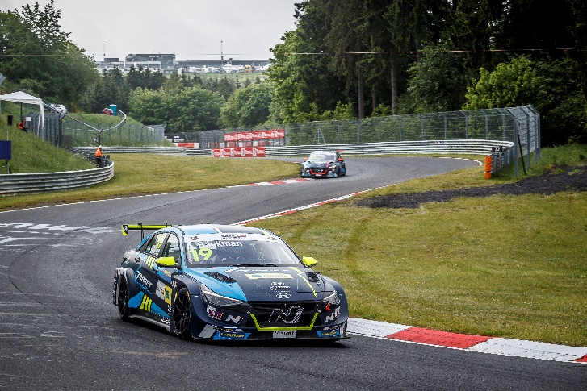Andreas and Jessica Bäckman are ready for the second round of WTCR this weekend in Portugal.  
Photo: FIA WTCR (Free rights to use the image)

**The siblings Andreas and Jessica Bäckman competes this weekend in the second round of WTCR - FIA World Touring Car Cup in Estoril, Portugal. After a tough debut at Nürburgring, the Sweden National Team drivers are looking forward to a new weekend with new opportunities.  
- Exciting with another new track to learn, it will be important to get up to speed as quickly as possible, Andreas Bäckman says.**

This weekend, June 26th-27th, the second round of the FIA WTCR series will be held at the classic Estoril track in Portugal. It will be the siblings Andreas and Jessica Bäckman's second race weekend in WTCR, and they will compete for the Italian team Target Competition in their Hyundai Elantra N TCR cars.

- Exciting with another new track to learn, it will be important to get up to speed as quickly as possible. The last race for me came to a sad end with a crash already at the start, so I look forward to getting back on the track and competing again. I also think that this track will suit us a little better than the Nürburgring, **Andreas Bäckman** says.

**WTCR Race of Portugal - Circuito do Estoril**Circuito do Estoril, also known as the Autódromo Fernanda Pires da Silva, is a racetrack located outside Estoril in Portugal and is approximately 30 km from the capital Lisbon. The Portuguese Grand Prix in Formula 1 was run on this track between 1984-1996 and the track length is 4,182 km. Other well-known series such as MotoGP, WTCC and DTM have also run on the track over the years.

June 26th-27th, it is time for WTCR to run on the track in the WTCR Race of Portugal 2021 and it will also be the WTCR series first visit to the track.

- I feel very ready and looking forward to a new race weekend. It seems to be a technical track based on what I have seen and run on the simulator with both fast and slow parts. I believe and hope this track will suit us well, so I look forward to the weekend, **Jessica Bäckman** says.

**WTCR is broadcasted LIVE on Eurosport**Throughout this season, all competitions will be broadcasted LIVE on both Eurosport on TV and can also be streamed via Eurosport Player. The two free practice sessions are also broadcasted LIVE on WTCR's [Facebook](https://www.facebook.com/WorldTouringCarCup)- and [YouTube](https://www.youtube.com/FIAWTCR) pages.

**Timetable for this weekend (WTCR Round 2):**(all times are in CEST/Swedish time)

**Saturday June 26th:**10:00 Free Practice 1 (Broadcasted LIVE on Eurosport Player & on FIA WTCR on [Facebook](https://www.facebook.com/WorldTouringCarCup) and [YouTube](https://www.youtube.com/FIAWTCR))  
13:00 Free Practice 2 (Broadcasted LIVE on Eurosport Player & on FIA WTCR on [Facebook](https://www.facebook.com/WorldTouringCarCup) and [YouTube](https://www.youtube.com/FIAWTCR))  
16:00 Qualifying (Broadcasted LIVE on Eurosport Player)

**Sunday June 27th:**13:15 Race 1 (Broadcasted LIVE on Eurosport 2 & Eurosport Player)  
16:15 Race 2 (Broadcasted LIVE on Eurosport 2 & Eurosport Player)

**The FIA WTCR app**In the FIA WTCR app, you can follow the competitions with live timing, and there is also more information such as results and the championship standings. Here you will also find the latest news and photos. The FIA WTCR app is available on both [App Store](https://apps.apple.com/se/app/fia-wtcr/id358795125) and [Google Play](https://play.google.com/store/apps/details?id=com.eurosport.events.wtcc&hl=sv&gl=US).

**About the track (Circuito do Estoril):**

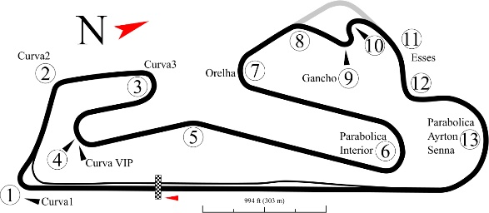

**Location:** Estoril, Portugal

**Length:** 4,182 km

**Corners:** 13

**Race length:** Race 1: 13 laps (54,366 km) and Race 2: 15 laps (62,730 km)

**Track record (TCR):** 1:48.518 / average speed 138.735 kph, Mat’o Homola (SEAT León TCR) 2016

**WTCR Series Standings**

**FIA World Touring Car Cup for Drivers WTCR – Overall (Top 3)**FIA WTCR 2021 (After 1 of 8 race weekends)

1: Jean-Karl Vernay (FRA), 39 p.

2: Tiago Monteiro (PRT), 33 p.

3: Nestor Girolami (ARG), 33 p.

–

**17: Jessica Bäckman (SWE), 2 p.**

**22: Andreas Bäckman (SWE), 0 p.**

[See the full standings here](https://www.fiawtcr.com/standings/)

**WTCR Trophy – Overall (Top 3)**FIA WTCR 2021 (After 1 of 8 race weekends)

1: Gilles Magnus (BEL), 20 p.

2: Tom Coronel (NLD), 19 p.

3: Bence Boldizs (HUN), 10 p.

–

**4: Jessica Bäckman (SWE), 4 p.**

**5: Andreas Bäckman (SWE), 3 p.**

[See the full standings here](https://www.fiawtcr.com/standings/)

**FIA World Touring Car Cup for Junior Drivers – Overall (Top 3)**FIA WTCR 2021 (After 1 of 8 race weekends)

1: Luca Engstler (DEU), 55 p.

2: Gilles Magnus (BEL), 53 p.

3: Bence Boldizs (HUN), 36 p.

–

**4: Jessica Bäckman (SWE), 32 p.**

[See the full standings here](https://www.fiawtcr.com/standings/)

**WTCR – FIA World Touring Car Cup for Teams – Overall (Top 3)**FIA WTCR 2021 (After 1 of 8 race weekends)

1: Engstler Hyundai N Liqui Moly Racing Team, 63 p.

2: ALL-INKL.COM Muennich Motorsport, 56 p.

3: ALL-INKL.DE Muennich Motorsport, 50 p.

–

**10: Target Competition, 2 p.**

[See the full standings here](https://www.fiawtcr.com/standings/)

​ ***Free rights to use the images.***

***Download press-photos here:***[***http://bit.ly/jabaeckman-photos***](http://bit.ly/jabaeckman-photos)[***https://www.mynewsdesk.com/se/ja-backman/images***](https://www.mynewsdesk.com/se/ja-backman/images)

