Press release
For immediate release

New PV generation and consumption monitoring system from geo
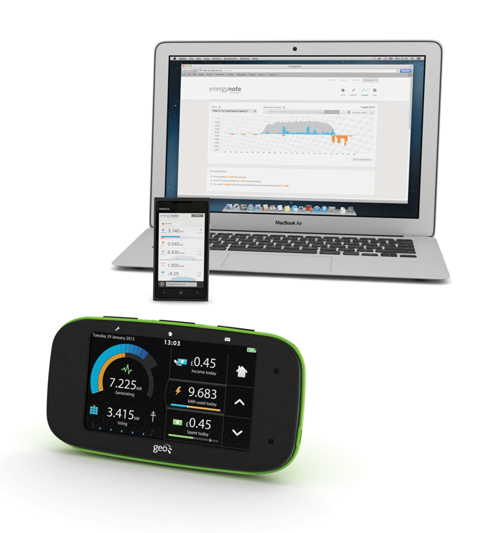
(Cambridge, UK) – Green Energy Options (geo), well known for its Solo PV solar monitoring display, is releasing an advanced touchscreen display with personalised online service, energynote®. The Chorus PV allows homeowners with PV panels to see both generation levels and electricity use on one display and become more efficient with how they use their generated electricity. The same information is also available online on smartphones and laptops.
The Chorus PV is designed for both new and retrofit installations. Homeowners can get a full overview of how efficiently they are using their system and, because the display is so easy to set up, installers and consumers can have the system up and running in no time. The Chorus PV speaks wirelessly to the generation meter and the consumption meter using a combination of LED readers and a current clamp.
The Chorus PV is an intelligent, touchscreen display and a vast amount of information can be found just by touching and reading the different screens. With the geo web pack consumers also get their own personalised online account on energynote, which collects energy information and presents it in easy-to-read snippets as well as in-depth statistics for spotting trends and patterns.
The system educates solar panel owners on how to use their generated electricity most efficiently. Through the web service, energynote, households can look at when they are using electricity and compare it with their generated electricity. The trick is to match the two together, which is where the Chorus PV comes into its own.

Patrick Caiger-Smith, Chief Executive Officer at geo, says: “As a solar panel owner myself it’s been fascinating seeing how much we can learn from the Chorus PV. I thought we knew all the answers already but by checking with the display how much surplus power we’re generating we’ve managed to shift a lot of appliance use to the sunny part of the day with the confidence that it’s not also importing electricity at a high tariff rate. This is impossible to establish without a clever system like the Chorus. As a result, almost every day we earn more from the feed in tariff than we spend on electricity. It’s great to be able to announce that the Chorus PV and energynote online service goes on sale at the end of April through our distribution network and on Amazon.”
The Chorus PV features:
- Understand generation and consumption of electricity relative to each other
- See generation/consumption & import/export of electricity
- Use with any PV array of any size
- At-a-glance analysis of earnings - feed-in tariff, deeming and saving
- Track generation against use to try to match the two
- Keep an eye on your electricity consumption against a target
- Access to our web service energynote for deeper analysis
- Remote access view of PV performance on a smartphone
- Add temperature sensors (up to three) to measure a second room, different floor or outside temperatures
- Wireless sensors – no need to run extra cabling
--ENDS--
Notes for Editors
A product sample is available on request.
Interviews can be arranged with Patrick Caiger-Smith.
About Green Energy Options (geo)
Energy expert geo designs and produces in-home energy displays, online energy services and mobile applications that make energy engaging. We enable energy suppliers, meter manufacturers and installers to strengthen relationships with their customers by putting them in control of their energy consumption, their home appliances and their energy budget in a visual, informative and engaging way. Our products and services work together with pre-smart and smart meters and microgeneration to enable the energy-efficient home.

Media enquiries: Christine Rush, geo, +44 1223 851 390, christine@greenenergyoptions.co.uk

