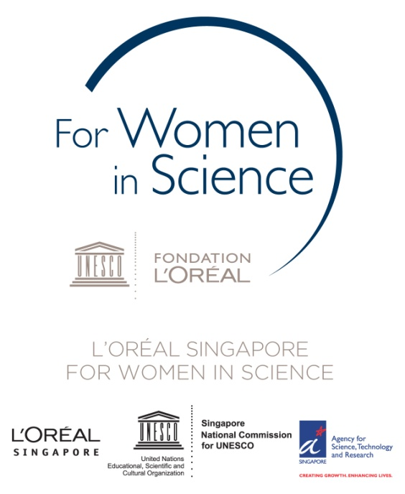

MEDIA RELASE

**L’Oréal Singapore awards the 2014 For Women In Science**

**National Fellowships**

*Two women scientists, Dr. Guo Huili and Associate Professor Ho Ghim Wei, have been named the 2014 L’Oréal Singapore For Women In Science National Fellows. Each receives a grant of S$30,000.*

3 December 2014 – SINGAPORE – From a record pool of 50 applications, L’Oréal Singapore has awarded two fellowships to Guo Huili and Ho Ghim Wei in favour of the 2014 *L’Oréal Singapore For Women In Science National Fellowship* programme.

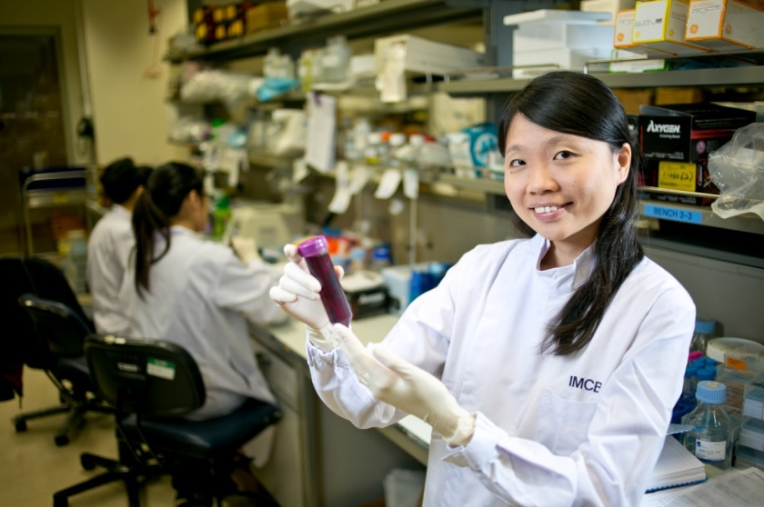Organized with the support of the Singapore National Commission for UNESCO and the Agency for Science, Technology and Research (A*STAR), the fellowship programme recognizes talented women engaged in science research. The programme also aims to encourage women to pursue careers in science; as well as to promote participation in Singapore’s research and development sector to women.

Each year, a fellowship is awarded for a researcher’s work in Life Sciences and another for Material Sciences. For the first time in 2014, the Material Science category broadened its definition to include Physical & Engineering Sciences. For the first time, the applications received this year were equally distributed between the categories; typically they lean towards the Life Sciences.

Dr. Guo Huili was awarded the *2014* *L’Oréal Singapore For Women In Science National Fellowship* for Life Science

The 2014 Life Science Fellowship was awarded to **Guo Huili** (郭慧丽), 31, Junior Investigator, Institute of Molecular and Cell Biology, A*STAR, Adjunct Assistant Professor, Department of Biological Sciences, National University of Singapore and Adjunct Assistant Professor, Lee Kong Chian School of Medicine, Nanyang Technological University-Imperial College. Dr. Guo received the fellowship for her research into “Understanding the Impact of Translation on Human Health”.

Dr. Guo’s lab investigates how the control of translation impacts human health and disease. Translation, the process by which information encoded in messenger RNAs is turned into functional proteins, is carried out by cellular machines known as ribosomes. This is a very basic mechanism that impacts multiple processes in the cell. Dr. Guo uses a range of molecular biology and genomics techniques, including ribosome profiling, to probe areas of the translation field that have hitherto been neglected, in order to gain new molecular insights and identify novel therapeutic approaches.

She says, “Every day, I try to come up with unconventional ways to solve puzzles of cellular translation. It would give me immense satisfaction to see these research findings translate into clinical applications.”

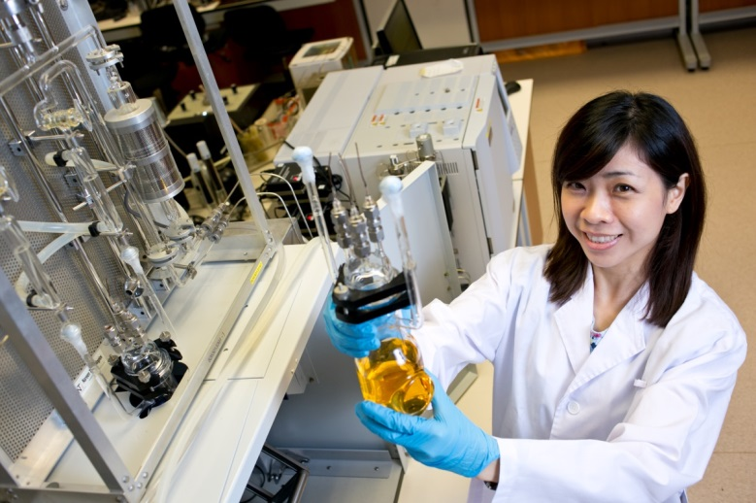The 2014 Physical & Engineering Science fellowship was awarded to **Ho Ghim Wei (**何锦韦), 39, Associate Professor, Engineering Science, Electrical & Computer Engineering at the National University of Singapore for her work in Functional Nanomaterials for Photocatalysis Solar Hydrogen Production.

Professor Ho Ghim Wei was awarded the *2014* *L’Oréal Singapore For Women In Science National Fellowship* for Physical & Engineering Science

Associate Professor Ho’s research focuses on the development of nanostructured materials for photocatalytic applications. The synergistic combinations of low cost aqueous synthesis, band gap engineering and materials functionalization have been employed to rationally design advanced photocatalyst for energy generation and pollutant degradation applications.

Associate Professor Ho said “Through my innovation and impact, in both education and research in nanomaterial science and engineering, I hope to contribute to advances in health and environmental benefits and bring about greater recognition of the under-represented women in this field.”

Remarking on L’Oréal Singapore’s participation in the fellowship programme, Christopher Neo, Managing Director of L’Oréal Singapore said “We want to give science back its power of fascination. Give it the image of an attractive and fascinating discipline, especially for young women. The For Women in Science fellows must share the enthusiasm that drives them. Be role models, guides and mentors. Pass on the torch.”

As part of the endowment each fellow receives a grant of SG$30,000, along with the prestige of being a L’Oréal For Women In Science Fellow. L’Oréal Singapore has awarded the fellowships consecutively for the past 6 years; and 14 women scientists have received the honour. The funds can be applied in whichever way the awardees choose.

The fellows are selected by an esteemed jury led by Professor Andy Hor, Executive Director, Institute of Materials Research & Engineering of A*STAR.

– ENDS –

IMAGES

High resolution images of the fellows are available for download at [[this link](https://www.dropbox.com/sh/nnvmxv8a61m8bph/AADtkg507j7nj57w_bmE2gkLa?dl=0)](https://drive.google.com/folderview?id=0BzSSxaVFrKAoclNFMjJvcVZoNDg&usp=sharing).

NOTES TO EDITORS

1. **Runners Up: The 2014 Life Science Finalists**
2. **Christine Cheung (张慧雯, 30) Junior Investigator, Institute of Molecular and Cell Biology, A*STAR**

*Research Topic:* Towards Personalised Management of Blood Vessel Diseases

*Research Summary:* Heart disease, stroke and dementia contribute to significant public health burden in our rapidly ageing populations. Blood vessel pathology is the primary cause of these debilitating conditions. Dr. Cheung's research aims to investigate cerebro- and cardiovascular health and diseases as influenced by genetics and metabolic risk factors. She has pioneered methods to re-create patients’ blood vessel subtypes from their own stem cells. This could capture their genetic susceptibilities to vascular dysfunctions. By understanding the disease-causing pathways arising from their individual predispositions, it would lead to better genetic screening and more effective treatments for patients.

1. **Yvonne Tay (郑美娴, 32), Junior Principal Investigator, Cancer Science Institute of Singapore, Assistant Professor, Department of Biochemistry, National University of Singapore**

*Research Topic*: Non-coding Regulatory Networks in Cancer

*Research Summary*: In addition to genomic alterations, aberrant changes in RNA regulation represent another mechanism to disrupt the function of critical oncogenes or tumor suppressors and contribute to tumorigenesis. MicroRNAs are short non-coding RNAs which regulate gene expression and have been functionally linked to multiple human cancers. Work by Dr. Tay’s group and others have demonstrated that RNA transcripts co-regulate each other by competing for shared microRNAs. Now, Dr. Tay’s lab will focus on investigating the role that these RNA:RNA regulatory interactions play in tumorigenesis. This work will lead to the discovery of novel oncogenes and/or tumor suppressors, which in turn may provide potential diagnostic or therapeutic targets.

“Biomedical research in Singapore has really flourished in the last decade, and I am very honored to be able to contribute to the vibrant research scene here, as well as do my part to inspire the next generation of young female Singaporean scientists.”

1. **Runners Up: The 2014 Physical & Engineering Science Finalists**
2. **Ling Xing Yi (林歆怡, 35), Assistant Professor, Chemistry and Biological Chemistry Division, School of Physical and Mathematical Science, Nanyang Technological University**

*Research Topic*: Development of Sensitive Environmental Toxin Sensor Using Superomniphobic Surface-enhanced Raman Scattering (SERS) Platforms

*Research Summary*: The contamination of water and soil by environmental toxins is a severe challenge faced by every country. Dr Ling’s lab has introduced an ultrasensitive environmental sensing platform for quick on-site detection using superomniphobic SERS platforms. Her research is divided into (1) the development of SERS platforms using shape-controlled metallic nanoparticles; (2) tuning the SERS platform into anti-wetting superomniphobic properties such that both organic and aqueous analyte molecules can be confined into a tiny area to further enhance the SERS sensitivity, and (3) the development of portable opto-sensors for on-site SERS detection. These SERS platforms are designed to achieve detection of environmental pollutants at trace level.

1. **Lee Pooi See (李佩诗, 39), Associate Professor, School of Materials Science and Engineering, Nanyang Technological University**

*Research Topic*: Nanomaterials and Renewable Materials for Energy and Electronics

*Research Summary*: Associate Professor Lee has developed high energy capacitors, energy saving electrochromic coatings, novel transparent conductors, flexible and stretchable devices. She is interested in synthesizing innovative nanomaterials, and harnessing its multi-functionality through understanding the structural-property characteristics. Associate Professor Lee is particularly keen in translating research from laboratory to solve real world problems.

1. **The jury members for 2014 included:**

Professor Andy Hor, Jury President

Executive Director, Institute of Materials Research & Engineering, A*STAR

Associate Professor Gan Chee Lip, Jury Member

Director, Temasek Laboratories@NTU

Associate Professor, School of Material Science and Engineering, Nanyang Technological University

Assistant Professor Melissa Fullwood, Jury Member

2009 L’Oréal Singapore For Women in Science Life Science Fellow,

Junior Principal Investigator, Cancer Science Institute Singapore,

Assistant Professor, Yale-NUS,

Joint Principal Investigator, Institute for Molecular and Cell Biology, A*STAR

Mark Phong, Jury Member

Head, L’Oréal Singapore Research & Innovation Center

Associate Professor Christina Chai, Jury Member

Assistant Dean, Faculty of Science, NUS,

Principal Scientist, Institute of Chemical and Engineering Sciences, A*STAR

1. **Science Needs Women**
   * YouTube Video: *Science needs women* <http://www.youtube.com/watch?v=fL6aCNXvYCo>
2. **16 Years of Supporting Women in Science**
   * Created in 1998, the L’Oréal-UNESCO For Women in Science Fellowships were established by the L’Oréal Corporate Foundation as the first international awards dedicated to women scientists around the world. 16 years later, the programme continues to be a benchmark of international scientific excellence and an invaluable source of motivation, support, as well as inspiration for women in the fields of science. Since it was founded in 1998, the program has honoured 82 Award Laureates (including two who went on to win the Nobel Prize), and supported more than 1,920 Fellows - women who are making contributions in every field of research. By the end of 2014, a total of 2,000 women scientists from more than 100 countries will have benefitted from the program.
3. **L’ORÉAL**

L’Oréal has devoted itself to beauty for over 105 years. With its unique portfolio of 28 international, diverse and complementary brands, the Group generated sales amounting to 23 billion euros in 2013 and employs 77,500 people worldwide. As the world’s leading beauty company, L’Oréal is present across all distribution networks: mass market, department stores, pharmacies and drugstores, hair salons, travel retail and branded retail.

Research and innovation, and a dedicated research team of 4,000 people, are at the core of L’Oréal’s strategy, working to meet beauty aspirations all over the world and attract one billion new consumers in the years to come. L’Oréal’s new sustainability commitment for 2020 “Sharing Beauty With All” sets out ambitious sustainable development objectives across the Group’s value chain. www.loreal.com

1. **Singapore National Commission for UNESCO**

The Singapore National Commission for UNESCO is responsible for planning and coordinating Singapore’s programmes and activities in UNESCO. Chaired by Mr Lawrence Wong, Acting Minister for Culture, Community and Youth and Senior Minister of State, Ministry of Communications and Information, Singapore, the Singapore National Commission is supported by three Sub-Commissions focusing on Education, Science and Culture & Information. More information can be found at [www.unesco.sg](http://www.unesco.sg).

1. **Agency for Science, Technology and Research (A*STAR)**

The Agency for Science, Technology and Research (A*STAR) is Singapore's lead public sector agency that fosters world-class scientific research and talent to drive economic growth and transform Singapore into a vibrant knowledge-based and innovation driven economy. In line with its mission-oriented mandate, A*STAR spearheads research and development in fields that are essential to growing Singapore’s manufacturing sector and catalysing new growth industries. A*STAR supports these economic clusters by providing intellectual, human and industrial capital to its partners in industry. A*STAR oversees 20 biomedical sciences and physical sciences and engineering research entities, located in Biopolis and Fusionopolis as well as their vicinity. These two R&D hubs house a bustling and diverse community of local and international research scientists and engineers from A*STAR’s research entities as well as a growing number of corporate laboratories.

This release is distributed by PINPOINT Public Relations on behalf of L’Oréal Singapore.

MEDIA CONTACTS

L’Oréal Singapore

Tracy Khoo

[tkhoo@sg.loreal.com](mailto:SCHIA@sg.loreal.com)

+65 9691 4800

Illka Gobius

PINPOINT Public Relations

[illka.gobius@pinpoint-pr.net](mailto:illka.gobius@pinpoint-pr.net)

+65 9769 8370