NOA Relaxation – focus in Benelux
NOA Relaxation, a low calorie beverage with natural herbs that help coping with stress and maintain focus, is now available to people in Holland, Belgium and Luxemburg.
The beverage market is shifting towards more healthy alternatives. Consumers want drinks that are not full of sugar and doing nothing good for you. We see traditional drink categories struggling and functional drinks growing. The more developed the market the more we see this shift happening.
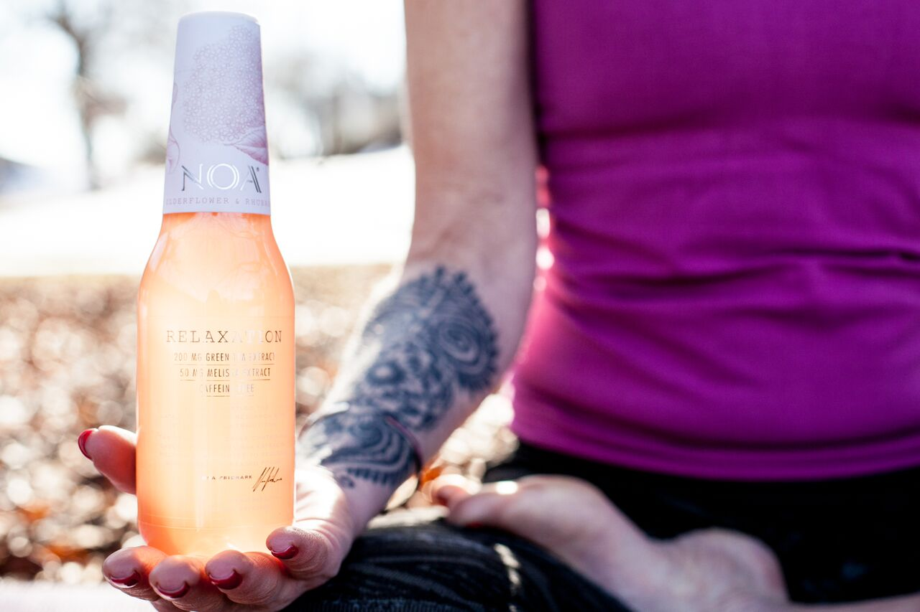
Photographer: Linda Dahlqvist
According to Foodbusinessnews.net we will see continued changes for better for you alternatives, that communicate a story around the brand. It will be more focus on energy, nutrition and satiety and of course less calories (http://www.foodbusinessnews.net/articles/news_home/Consumer_Trends/2016/01/Beverage_trends_2016)
“NOA Relaxation is perfect for those seeking a healthy, yet tasty, alternative. We believe it offers something new to the growing trend towards healthier beverage. Our Nordic flavours are very appreciated around the world and we are certain they will be so in Benelux as well. NOA Relaxation is of course free from caffeine, preservatives and GMOs” says Nina Gillsvik, Chief Marketing Officer, NOA Relaxation.
NOA will be sold by leading beverage distributors: 2foods in the Netherlands and D-Drink in Belgium. Both have extensive experience of premium, functional beverages.
NOA Relaxation takes its flavour inspirations from the Scandinavian nature, including Elderflower & Rhubarb, Blueberry & Birch Sap, and Wild Apple & Gooseberry.
NOA Relaxation is an award-winning beverage with natural herbs that contributes to reduced stress and increased focus (Green tea extract with L-theanine, Lemon balm). NOA Relaxation is the result of the latest research and millennia-old traditions. The company was founded by Mr Noa Fridmark in late 2013, with the product launching in Sweden and Norway in late 2014. Since then, NOA Relaxation has won a number of international awards, including ”Best Premium Beverage” in November 2014 at WBIA – the world’s largest beverage awards. An international panel of industry experts deemed the complete branding concept and packaging to be the best in the world. NOA Relaxation has attracted strong international media attention, with 100+ newspaper articles and more than 300 bloggers writing about the company and its products.
For more information and images please contact: (Nina Gillsvik, CMO, NOA Relaxation, nina.gillsvik@noapotions.se, +46705587293

