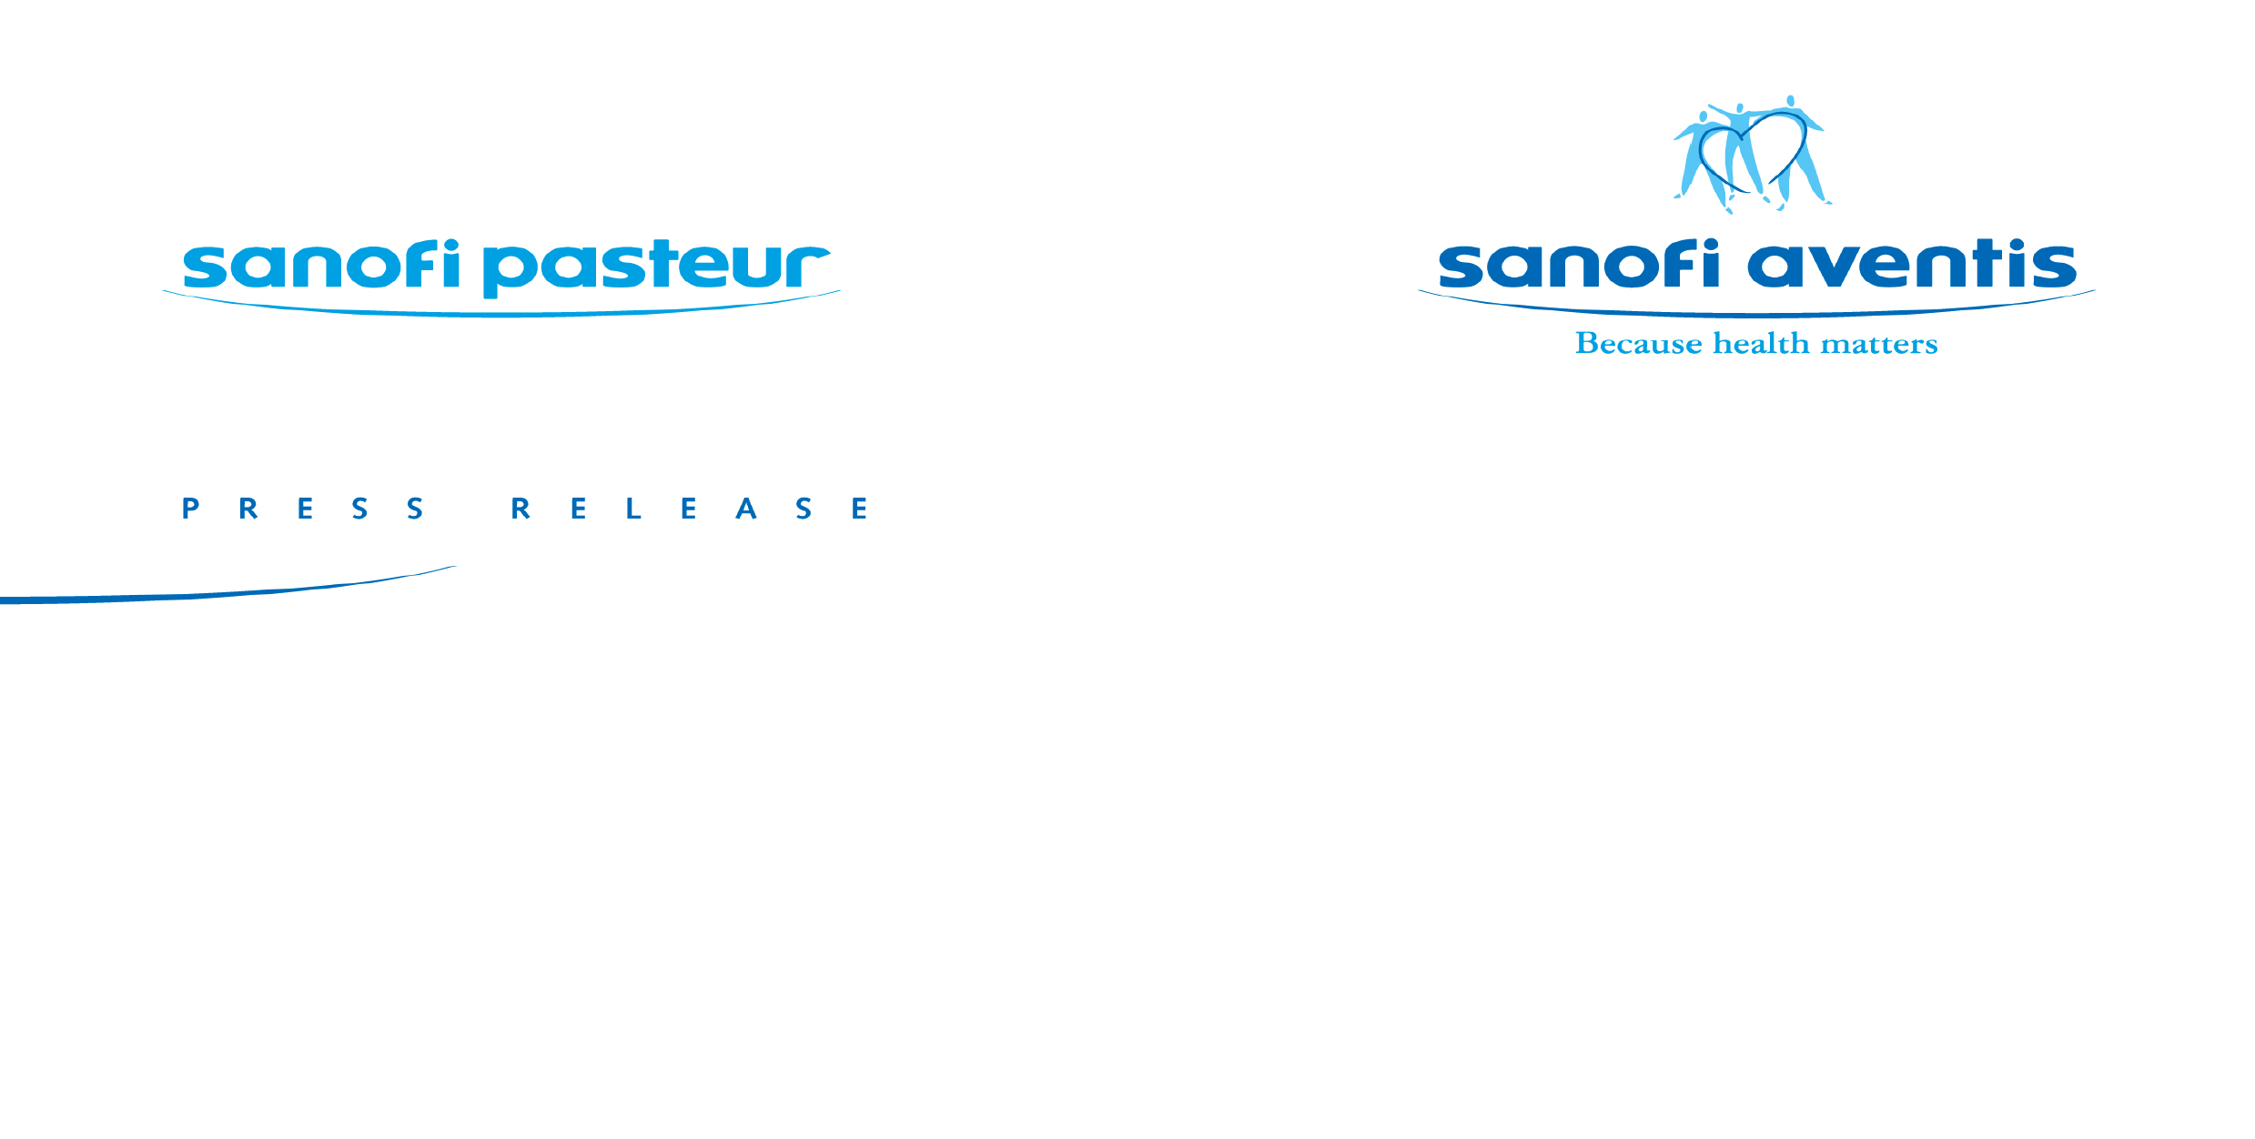
14

FDA Advisory Committee Recommends Licensure of New
Pediatric Combination Vaccine

- If approved, Pentacel vaccine would be the first pediatric combination vaccine in the U.S. to immunize against diphtheria, tetanus, pertussis, polio,
and Haemophilus influenzae type b (Hib) -

Bethesda, Md. – January 25, 2007 – Sanofi pasteur, the vaccines business of the sanofi-aventis Group (NYSE: SNY; EURONEXT: SAN), is pleased that the members of an advisory committee to the U.S. Food and Drug Administration (FDA) voted nearly unanimously today that the company’s pentavalent combination vaccine for use in pediatric patients is both safe and efficacious. Pentacel® (DTaP-IPV-Hib) vaccine1 protects against diphtheria, tetanus, pertussis, polio, and Haemophilus influenzae type b (Hib).

According to the current Recommended Childhood and Adolescent Immunization Schedule from the Advisory Committee on Immunization Practices (ACIP) of the U.S. Centers for Disease Control and Prevention (CDC), up to 23 injections are needed through 18 months of age. The use of Pentacel vaccine could reduce that number of shots by seven.

The regulatory submission of Pentacel vaccine is based on results of clinical studies involving more than 5,000 children in multi-center trials2 conducted in the U.S. and Canada. Pentacel vaccine is licensed for pediatric use in nine countries, including Canada, where it has been used universally in infants and young children since 1998 for the prevention of diphtheria, tetanus, pertussis, polio and Hib. Over 12.5 million doses of Pentacel® have been distributed in Canada.

Pentacel vaccine is the first DTaP-based combination vaccine candidate for use in infants in the U.S. that includes both polio and Hib vaccine components. The diphtheria, tetanus, and pertussis components in Pentacel vaccine are based on the formulation in DAPTACEL®-- Diphtheria and Tetanus Toxoids and Acellular Pertussis Vaccine Adsorbed (DTaP vaccine)-- which was introduced by sanofi pasteur in the U.S. in 2002. In clinical trials, Pentacel vaccine was administered as a four-dose series--at 2, 4, 6, and 15-18 months of age--concomitantly with other recommended childhood vaccines.

-more-

The true name for Pentacel® vaccine is: Diphtheria and Tetanus Toxoids and Acellular Pertussis Adsorbed, Inactivated Poliovirus and Haemophilus b Conjugate (Tetanus Toxoid Conjugate) Vaccine Combined
2 Herz A, Black S, Shinefield H, Noriega F, Greenberg, D. Safety of DTaP-IPV//PRP-T (PENTACEL) administered at 2, 4, 6, and 15 to 18 months of age. Annual meeting of the Pediatric Academic Societies 2005

Sanofi pasteur’s U.S. operations in Swiftwater, PA has long been committed to providing vaccines to prevent childhood diseases. In 1987, it licensed the first Haemophilus influenzae type b (Hib) conjugate vaccine. And in 1996, it was the first company to license a diphtheria, tetanus, and acellular pertussis vaccine for use in infants--Tripedia®, Diphtheria and Tetanus Toxoids and Acellular Pertussis Vaccine Adsorbed. In 2005, sanofi pasteur continued its tradition of innovation by introducing Menactra®, Meningococcal (Groups A, C, Y and W-135) Polysaccharide Diphtheria Toxoid Conjugate Vaccine to protect against meningococcal disease in adolescents and adults, 11-55 years of age, and ADACEL®, Tetanus Toxoid, Reduced Diphtheria Toxoid and Acellular Pertussis Vaccine Adsorbed as a booster dose for protection against tetanus, diphtheria and pertussis in both adolescents and adults 11-64 years of age.

About Diphtheria
Diphtheria is a disease caused by a bacterium, Corynebacterium diphtheriae, that usually affects the tonsils, throat, nose and/or skin. It is passed from person to person by droplet transmission, usually by breathing in diphtheria bacteria after an infected person has coughed or sneezed. Although diphtheria disease is rare in the U.S., it appears that C diphtheriae continues to circulate in areas of the country with previously endemic diphtheria. Diphtheria also occurs in many other parts of the world.

About Tetanus
Tetanus is a severe, frequently fatal disease caused by an exotoxin produced by Clostridium tetani, a bacterium that is found in the environment. Tetanus is not transmitted from person to person. Rather, Clostridium tetani enters the body through an open wound, including lacerations, abrasions and puncture wounds. The toxin causes neuromuscular dysfunction, with rigidity and spasms of skeletal muscles. The muscle spasms usually start in the jaw (which is why the disease is sometimes called “lockjaw”) and neck and may spread to many other muscles, leading to generalized paralysis.

About Pertussis
Pertussis, a highly contagious disease of the respiratory tract, is caused by exposure to bacteria (Bordetella pertussis) found in the mouth, nose and throat of an infected person. Pertussis is primarily spread by direct contact with discharge from the nose or throat of infected individuals. Classic--or severe pertussis--as defined by the World Health Organization, consists of at least 21 days of cough illness (with the cough coming in spasms or paroxysms), associated whoops or post-cough vomiting, and laboratory confirmation. Despite widespread vaccination, reports of pertussis outbreaks continue to in the U.S. At particular risk are newborns and babies who have not yet been fully vaccinated against pertussis, iii who are more likely to have severe pertussis, and who face the possibility of serious complications and death. Over the last decade, 80% of pertussis deaths have occurred in infants under 6 months of age.³

About Polio
Poliomyelitis (polio) is a highly infectious disease caused by a virus that invades the nervous system and can cause severe paralysis. The virus enters the body through the mouth and multiplies in the intestine. Initial symptoms are fever, fatigue, headache, vomiting, stiffness in the neck, and pain in the limbs. One in 200 infections leads to irreversible paralysis (usually in the legs). Among those paralyzed, 5-10% dies when their breathing muscles become immobilized. Polio mainly affects children under five years of age. Naturally occurring polio
- more-

3 Vitek CR, Pascual FR, Baugham, AL, Murphy TV. Increase in deaths from pertussis from young infants in the United States in the 1990s. Pediar Infect Dis J. 2003:22:628:634.6

was eliminated in the U.S. in 1979 and in the Western Hemisphere by 1991; however, worldwide efforts are continuing towards eradication of this contagious and devastating disease.

About Hib
Haemophilus influenzae type b (Hib) disease is caused by a bacterium that enters the body through the nose or throat and then can spread to cause meningitis (an infection of the coverings of the brain and spinal cord), blood stream infection, pneumonia, infection of the epiglottis, and other serious infections. Hib disease can cause mental retardation in young children and be a life-threatening infection. The Hib bacterium is still circulating in the U.S. today.4 Ongoing vaccination is critical in preventing a resurgence of Hib, which was the leading cause of bacterial meningitis in children under five years of age before vaccines were introduced.

About sanofi-aventis
Sanofi-aventis is one of the world’s leading pharmaceutical companies. Backed by a world-class R&D organization, sanofi-aventis is developing leading positions in seven major therapeutic areas: cardiovascular, thrombosis, oncology, metabolic diseases, central nervous system, internal medicine and vaccines. Sanofi-aventis is listed in Paris (EURONEXT: SAN) and in New York (NYSE: SNY).

Sanofi pasteur, the vaccines business of the sanofi-aventis Group, sold more than a billion doses of vaccine in 2005, making it possible to protect more than 500 million people across the globe. The company offers the broadest range of vaccines, providing protection against 20 bacterial and viral diseases. For more information, please visit: www.sanofipasteur.com

Forward Looking Statements
This press release contains forward-looking statements as defined in the Private Securities Litigation Reform Act of 1995. Forward-looking statements are statements that are not historical facts. These statements include financial projections and estimates and their underlying assumptions, statements regarding plans, objectives and expectations with respect to future events, operations, products and services, and statements regarding future performance. Forward-looking statements are generally identified by the words “expect,” “anticipates,” “believes,” “intends,” “estimates,” “plans” and similar expressions. Although sanofi-aventis’ management believes that the expectations reflected in such forward-looking statements are reasonable, investors are cautioned that forward-looking information and statements are subject to various risks and uncertainties, many of which are difficult to predict and generally beyond the control of sanofi-aventis, that could cause actual results and developments to differ materially from those expressed in, or implied or projected by, the forward-looking information and statements. These risks and uncertainties include those discussed or identified in the public filings with the SEC and the AMF made by sanofi-aventis, including those listed under “Risk Factors” and “Cautionary Statement Regarding Forward-Looking Statements” in sanofi-aventis’ annual report on Form 20-F for the year ended December 31, 2005. Other than as required by applicable law, sanofi-aventis does not undertake any obligation to update or revise any forward-looking information or statements.

⁴ Donnelly, M.J, Herold, B.C., Jenkins, S.G., Daum, R.S. Obstacles to the elimination of Haemophilus influenzae type b disease: Three illustrative cases. Pediatrics. Vol. 112, No. 6, December 2003, pp. 1465-1466

Pascal Barollier | Len Lavenda
International Media Relations | U.S. Media Relations
Tel: + 33-(0)4-37-37-51-41 | Tel: +1-570-839-4446
pascal.barollier@sanofipasteur.com | len.lavenda@sanofipasteur.com

