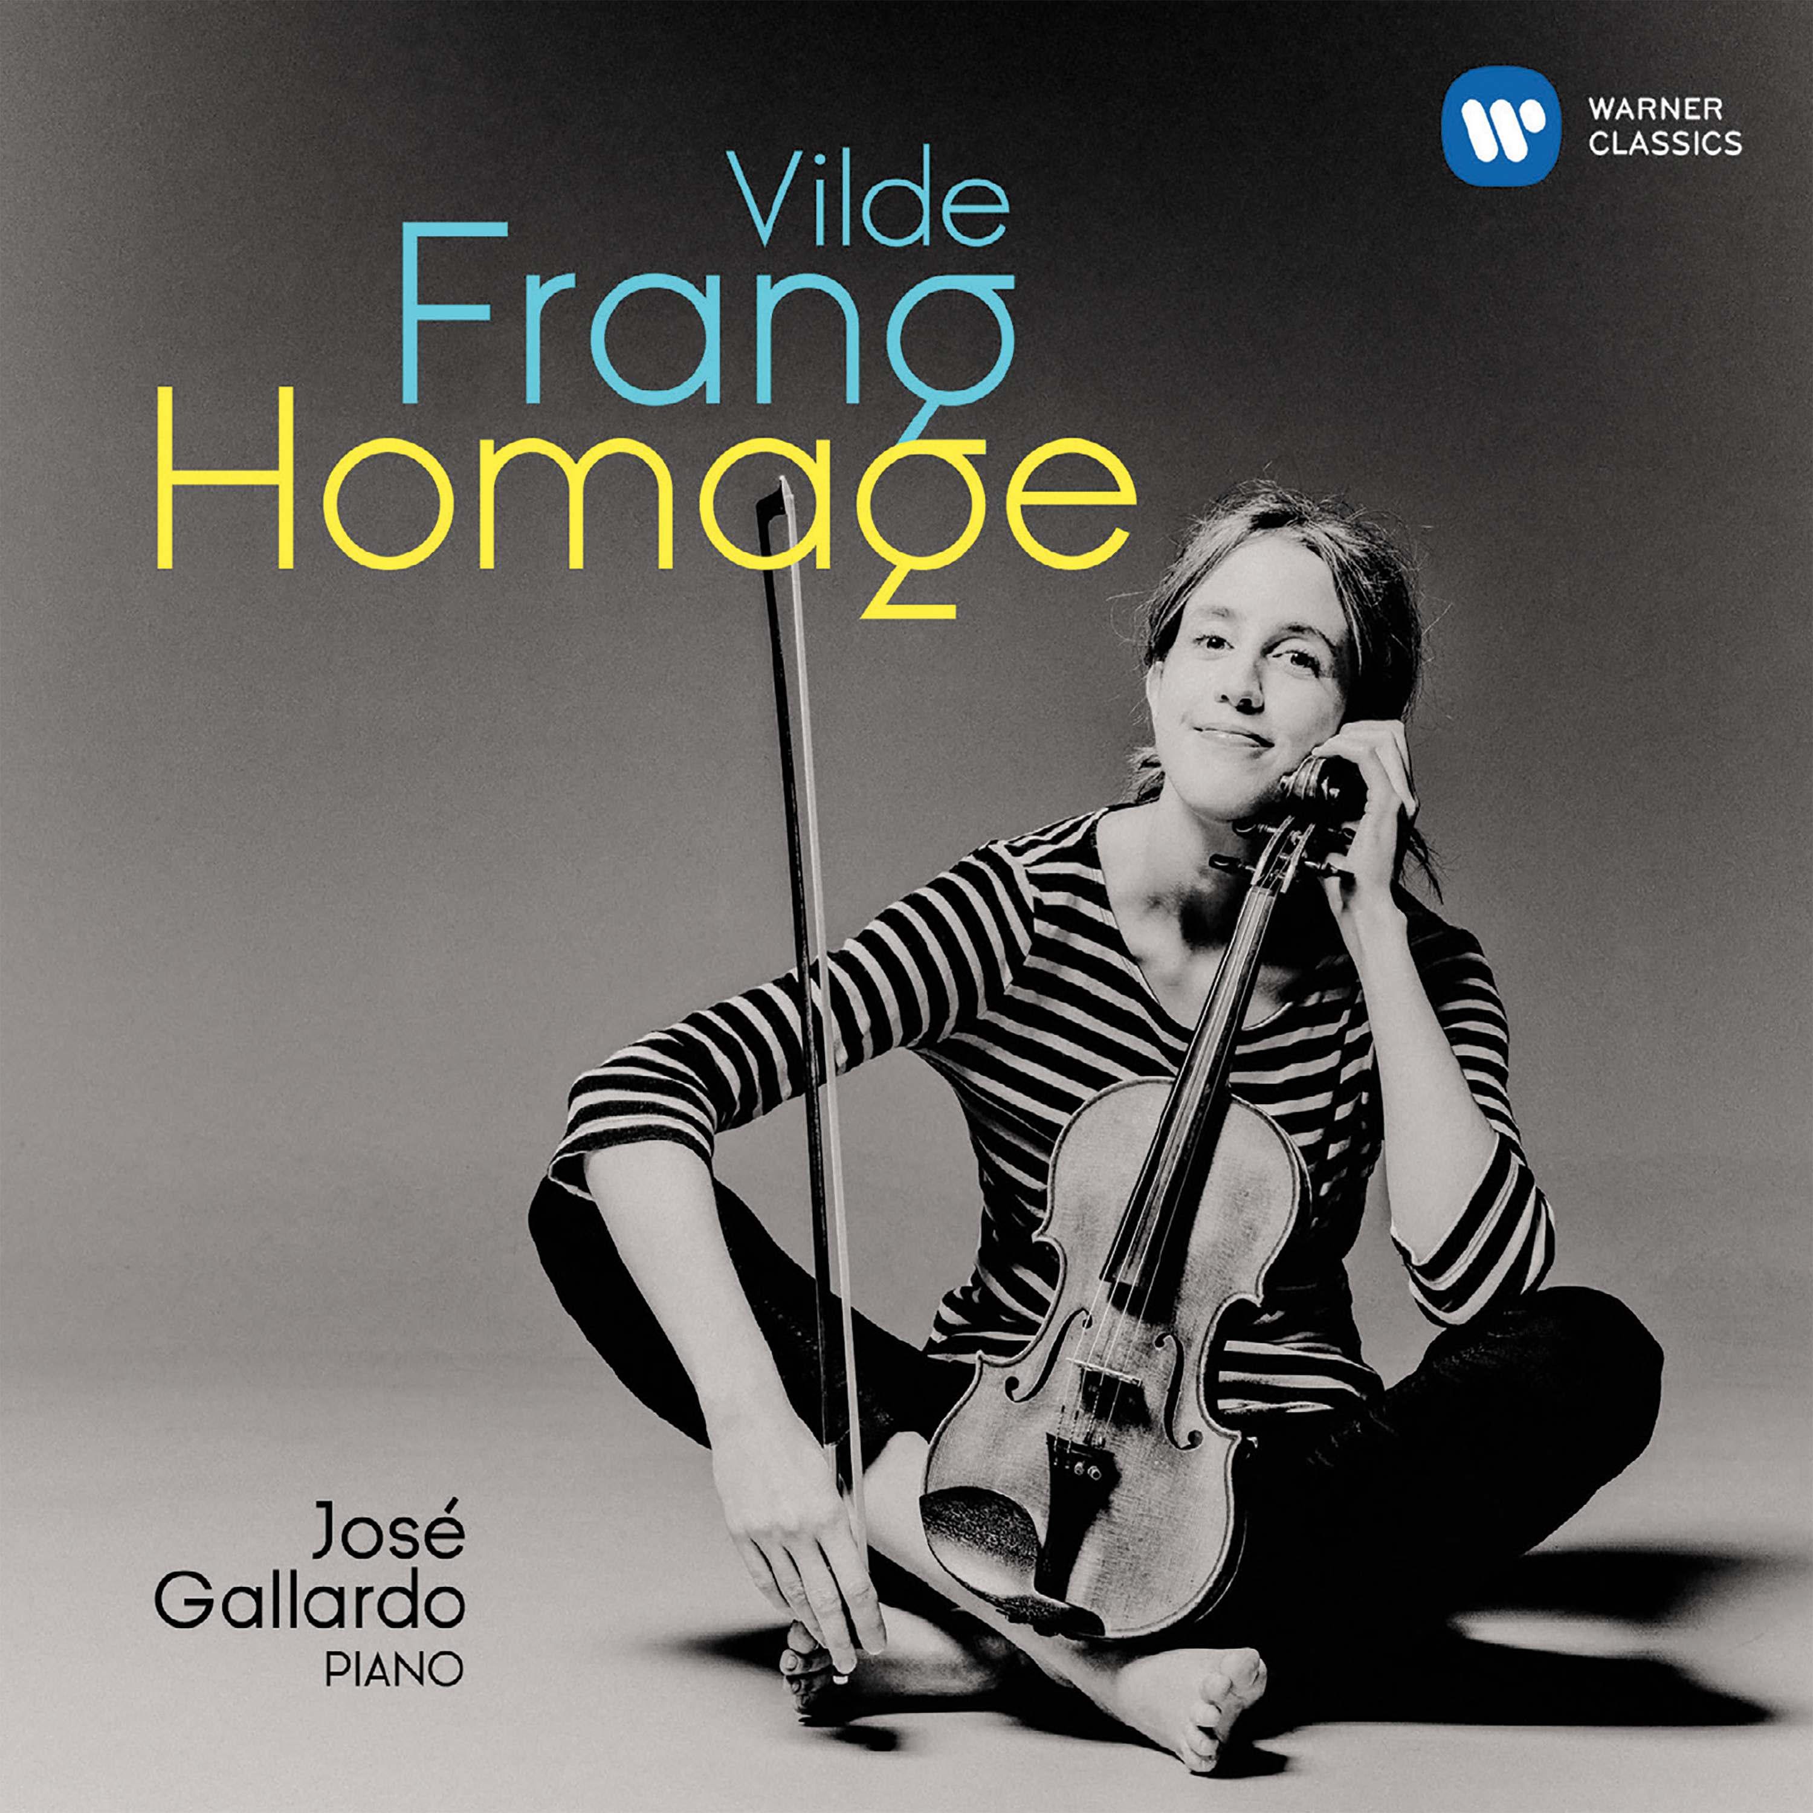

Homage
Vilde Frang
José Gallardo
International release date: 17th November 2017
CD: 0190295805326 - Standard Download: 0190295805319
Mastered for iTunes: 0190295805302 - HD Download: 0190295805296

There is a subtle link between Vilde Frang’s new recital, Homage, and her previous Warner Classics release, the Gramophone Award-winning recording of the Korngold and Britten violin concertos. Five of the album’s 17 short pieces are in arrangements or transcriptions by Jascha Heifetz. Often described as the greatest violinist of the 20th century, he gave the premiere of the Korngold concerto in St Louis in 1947. Compositions or arrangements by other players who exemplify the so-called Golden Age of the Violin also feature amongst the tracks: Fritz Kreisler, Leopold Auer and Joseph Szigeti. Joining them from an earlier era is the 19th century virtuoso, Henryk Wieniawski.

Vilde Frang has conceived the album as something of a homage to her illustrious predecessors. Born in 1986, she is clearly very much a violinist of today, and – as a Norwegian trained in Germany – she did not grow up in the Central and Eastern-European tradition of Heifetz, Kreisler, Auer and Szigeti. That being said, she brings her own, distinctively captivating magic to her instrument. As Gramophone wrote of her performance of the Korngold concerto, a work that has its roots in the composer’s glorious late-Romantic scores for Hollywood: “Frang has a winning way with the rubato that makes the melodies yearn and smile, but there’s a fragile thread of silver woven through her passagework that bounces off the glinting accompaniment of the Frankfurt RSO as an opalescent gown catches the light in a mirrored ballroom. Fresh thought illuminates each phrase and she has the technique to bring off every idea, from the wild caprice of the first movement’s dash to the double-bar, to a coquettish (or demure?) restraint in the finale’s big tune.”

Not all the composers on the album are better known as violinists. They include Schubert, Schumann, Mendelssohn, Dvořák, Debussy, Albéniz, Scriabin and Prokofiev, and a significant proportion of the tracks (some of them very famous indeed) were originally conceived for piano, orchestra or even voice.

While this album is called Homage, it is worth remembering that, in the first half of the 20th century, players like Kreisler and Heifetz would often present a sequence of short pieces – lyrical or brilliant, tender or dramatic, but always enchanting – as an integral part of their programme. Though that is no longer customary practice for instrumentalists, it echoes the way singers assemble a recital as a matter of course. Vilde Frang’s partner for the album, the Argentinian-born, German-trained pianist José Gallardo, is renowned for his skills as a chamber musician, so a stimulating dialogue is guaranteed.

Many of the numbers have belonged to Vilde Frang’s performing repertoire for years. Her affection for them is evident as she brings her characteristic flair and sensitivity to their interpretation. With Homage, she once again bears out the words of BBC Music Magazine: "Frang has the knack of breathing life into every note, whether by variations in phrasing, attack, tone or dynamic.” That is an art that surely belongs to its own Golden Age.

TRACKLIST
Homage
[1] La Capricciosa
Franz Ries
[2] Widmung (Myrthen, Op.25)
Robert Schumann arr. Auer
[3] Mazurka No.1 Op.19 (Obertass)
Henryk Wieniawski
[4] Melodie
Christoph Willibald Gluck trans. Kreisler
[5] Ballet music from Rosamunde
Franz Schubert trans. Kreisler
[6] Tango
Poldowski
[7] La plus que lente – Valse
Claude Debussy Trans. Léon Roques
[8] Caprice Es-dur. Alla Saltarella
Henryk Wieniawski trans.‎Kreisler
[9] Etude Op.8 No.10
Aleksandr Scriabin Trans. J. Szigeti
[10] Rondino – On a Theme by Beethoven
Fritz Kreisler
[11] Gypsy Caprice
Fritz Kreisler
[12] Slavonic Dance in E Minor Op 46, No2
Antonín Dvořák trans. Kreisler
[13] Masks (from Romeo and Juliet)
Sergei Prokofiev trans Jascha Heifetz
[14] Song without words Op.62 No.1
Felix Mendelssohn trans. Kreisler
[15] Sevilla (Suite Española Op.47)
Isaac Albéniz arr. Jascha Heifetz
[16] Estrellita (My Little Star) Mexican Serenade
Manuel Ponce trans. Jascha Heifetz
[17] Calabrese Op.34
Antonio Bazzini trans. Jascha Heifetz

Vilde Frang violin
José Gallardo piano

