PRESS RELEASE

FRICTION AND RESONANCE

For the first time in Sweden, Beatrice Brovia and Nicolas Cheng present, their work at Konsthantverkarna, Friction, Resonance, April 1 – 26 2017.
Metro: Slussen in Stockholm.

Beatrice Brovia and Nicolas Cheng are jewellers and craft artists based in Stockholm. While maintaining an individual practice, since 2011, they have also been working together on the ongoing collaboration Conversation Piece – a way to make together with, but also to challenge one another, to pose questions through craft and decorative objects.

In the exhibition at Konsthantverkarna, for the first time in Sweden, a selection of works is presented from both their individual practices and Conversation Piece, as in a game of references and contrasts.

The viewer is invited into a space at once familiar and offbeat, where the works and objects we encounter, despite their subtle appearance, are imbued with complex material narratives and fabulations. www.conversationpiece.co

Conversation Piece is a collaborative practice founded in 2011 by Beatrice Brovia and Nicolas Cheng, jewellers and cross-disciplinary artists based in Stockholm, Sweden. Conversation Piece has a strong focus on material culture and craft discourse and its projects are developed across scales and medias – from self-organised exhibitions, installations and objects to conceptually-driven jewellery; jewellery often represents the lenses through which the process of making is perceived and experienced. Different chapters are developed through time, which are often revisited.

Since 2011, work from Conversation Piece has been regularly included in international publications and exhibited at venues such as, among others, Triennale Design Museum in Milano (IT), Saint-Etienne Design Biennale (FR), Schmuck 2016 - IHM Munich (DE), Z33 - House for Contemporary Art in Hasselt (BE), Cheongju Craft Biennale (KR), KORU 5 (FI), Stedelijk Museum‘s Hertogenbosch (NL) and Gallery F15 in Moss (NO).

Work from Conversation Piece is represented in the permanent collections of Pinakothek der Moderne in Munich, Germany, and of Stedelijk Museum 's Hertogenbosch, the Netherlands.

Beatrice and Nicolas have been regularly lecturing about their work and holding workshops at, among other institutions, Akademie der Bilden Künste Nürnberg / DE, Sint Lucas Antwerpen / BE, Zimmerhof Symposium 2015 / DE, HDK - Academy of Design and Crafts, University of Gothenburg / SE, Asia Society Hong Kong / HK and Akademie der Bildenen Künste Munich / DE.

Artist Talk: April 6th, 6.15 PM.
Make your reservation to: info@konsthantverkarna.se

For more information:
Åsa Lindgren, Manager,
asa.lindgren@konsthantverkarna.se, 08-611 03 70

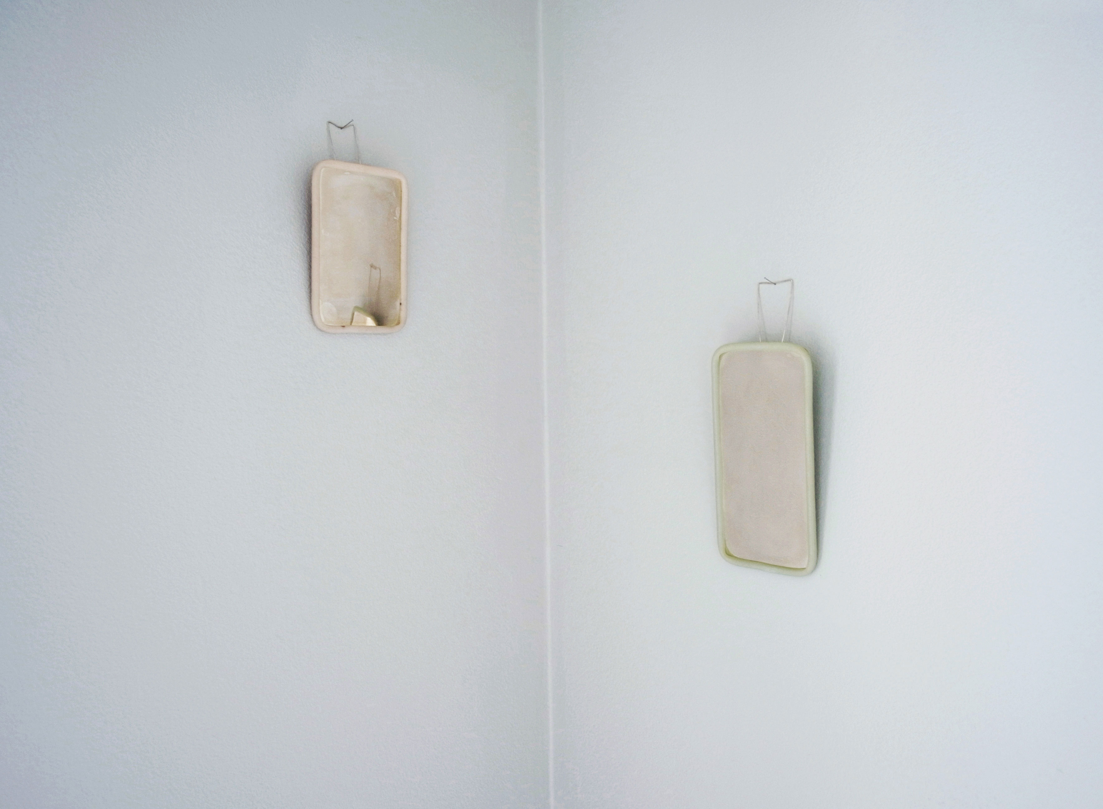

Vanity mirror.

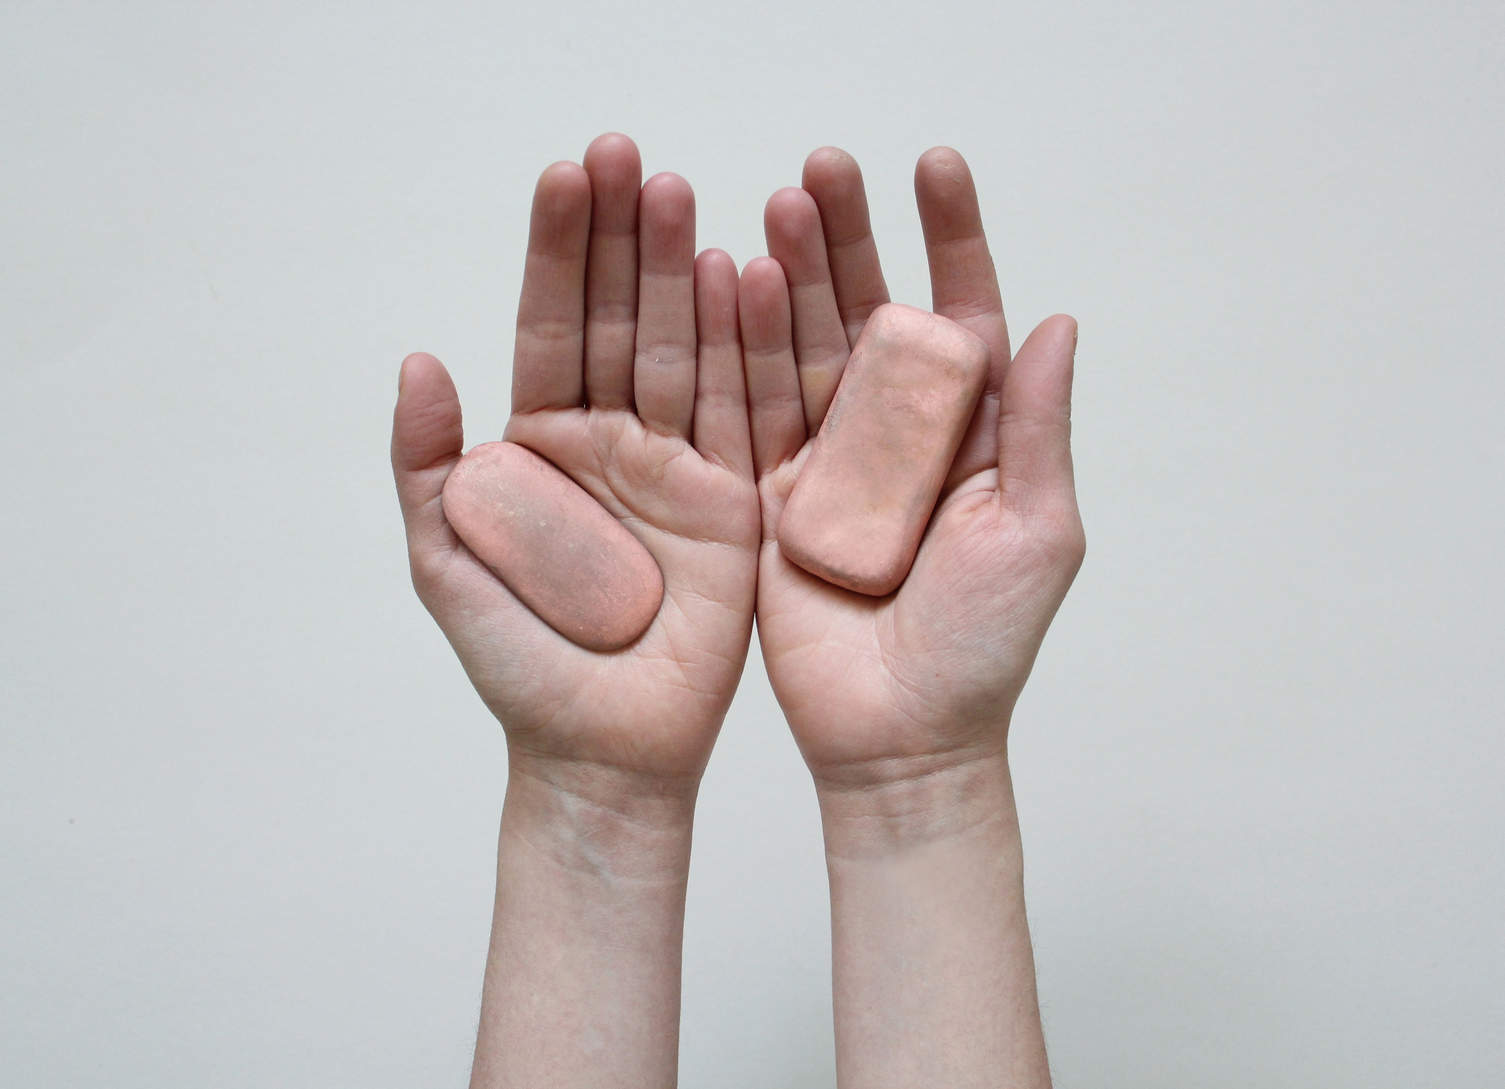
Soap Handle.

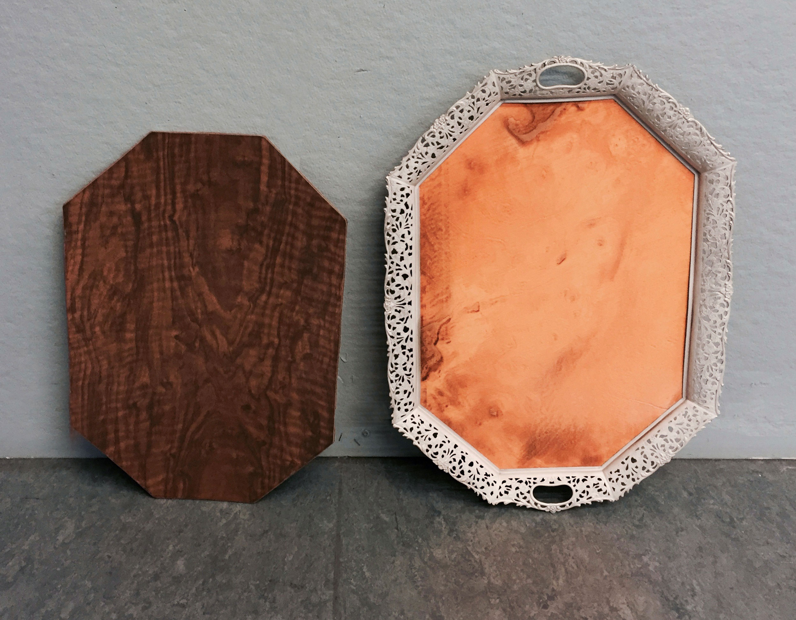
Friction, by Nicolas Cheng.

