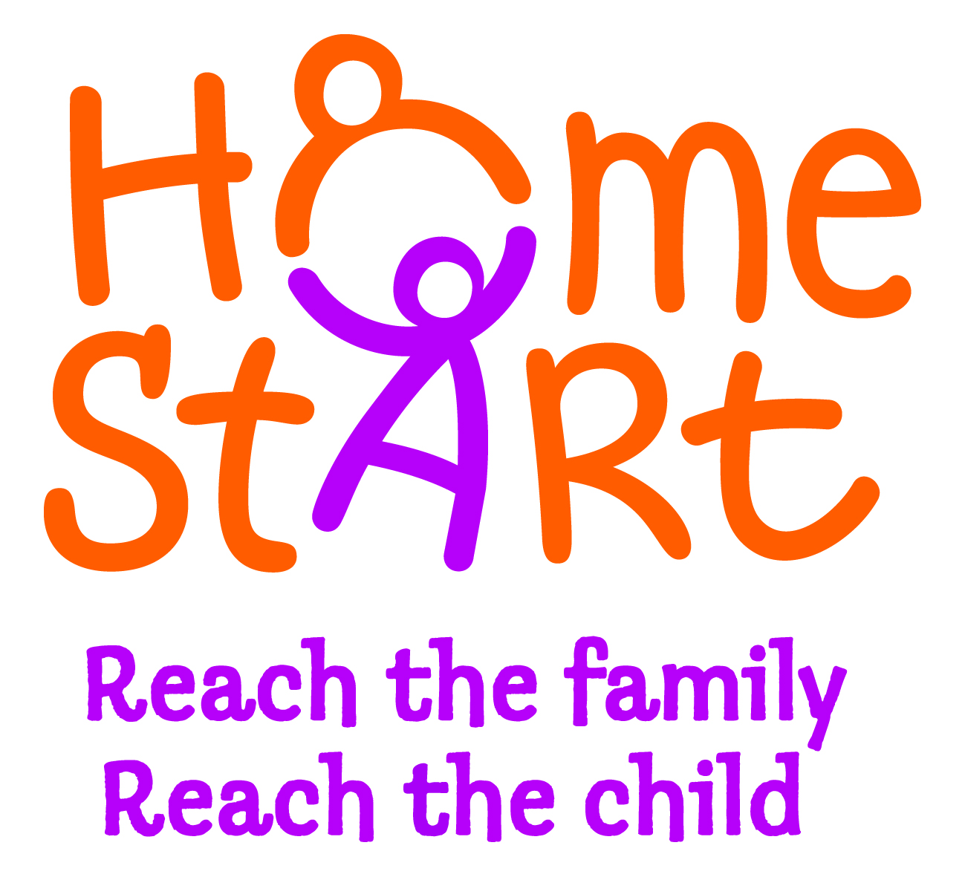

NEWS RELEASE

**40% OF YOUNG UK FAMILIES AT ‘BREAKING POINT’**

40% of parents with children under five have felt at ‘breaking point’ because of the stress and strains of family life, according to a YouGov Survey* commissioned by leading family support charity Home-Start UK. And 63% acknowledge that their stress can damage their relationship with their children, with 93% understanding the impact this could have on their children’s future mental and physical wellbeing.

The survey findings come at a time when the demand for Home-Start volunteers to provide families with practical and emotional support is greater than ever before. Home-Start’s Director for Fundraising and Communications, Vivien Waterfield says: “Every year 35,000 families who feel they have nobody to turn to are turning to us for help as they face crises such as poverty and isolation. We support almost 73,000 vulnerable children across the UK and our services are being stretched. In some parts of the country we just cannot keep up with demand.

“We believe that there are an unacceptable number of families at breaking point and, without the funding we need, we are forced to turn away potential volunteers because we simply do not have the money to train them. And the inevitable consequence is that struggling families and vulnerable children are left without much needed support.”

The survey confirms that 67% of parents with children under five understand the negative effect their money worries and family problems can have on their children. It marks the launch of Home-Start’s “Childhood Starts Now” campaign ([www.reachthechild.org.uk](http://www.reachthechild.org.uk)) to raise funds to help it continue its work with the UK’s families at breaking point.

Ends

**Tags:** Home-Start, Childhood Starts Now, families at breaking point, YouGov Survey

**Additional Notes:**

**\***All figures, unless otherwise stated, are from YouGov Plc. The total sample size for the Survey was 1201 parents with children aged under 5 years. Fieldwork was undertaken between 11th and 14th October 2011. The Survey was carried out online.

**The Good Agency**

* The Good Agency is the UK’s largest independent full service agency dedicated to social, ethical and environmental marketing communications.
* Working with charities, NGOs, trade unions, government and businesses for over 15 years, The Good Agency makes good thing happen.

**Home-Start UK**

* Home-Start was set up in 1973 and has been providing support, friendship and practical help to families in need with children under the age of five for almost 40 years.
* Home-Start is one of the UK’s leading family support charities. It is the only one in which volunteers provide the service.
* Over 330 local Home-Starts form the Home-Start network, co-ordinated and supported by Home-Start UK.
* Each local Home-Start is a registered charity, funded and managed locally.

**Key Facts & Figures**

* Home-Start supports almost **73,000 vulnerable children** across the UK.
* Home-Start has a network of **334 local Home-Starts**, reaching as far as British Forces families in Germany and Cyprus.
* Home-Start has **16,461** family support volunteers.
* These volunteers **help around 35,000 families every year, giving over 1 million hours of time.**
* **2,279 volunteer** trustees manage and support the work of the network of local Home-Starts.
* **Almost 25% of the families** refer themselves to Home-Start.
* It costs Home-Start **just £1,000** a year to support a family.

**Home-Start’s Unique Approach**

* Home-Start UK is the only national charity to go into homes to work with families to try to prevent their problems becoming a crisis. Trained volunteers, most of whom are parents themselves, offer support, friendship and practical help to parents in their own homes, enabling them to build better lives for their children in their own communities.
* Home-Start’s approach is unique, working directly with communities through locally managed Home-Starts where our volunteers help families cope with a wide range of issues including poverty, post-natal illness, isolation, bereavement, disability and domestic violence.
* The support provided by our network of volunteers is free, confidential and non-judgmental. Our volunteers are positive role models for parents, offering reassurance and guidance, and often simply giving parents a much-needed break.
* The right kind of support, given at the right time and in the right way, can help families under stress give their children a secure and loving space in which to grow up. It can keep families together and save many children from the trauma of break-up and removal.

**Spokespeople Available for Interview/Expert Comment**

* **Vivien Waterfield** – Director of Fundraising and Communications at Home-Start.
* **Sue Atkins** – Parenting expert, bestselling author of ‘Raising Happy Children for Dummies’ and regular contributor on parenting issues to BBC radio stations and national newspapers.
* **Oliver James** – Clinical psychologist and child expert. Oliver has published 6 books and numerous newspaper articles on childcare and was a trustee for Home-Start for eight years.

**Case studies and their Home-Start volunteers are also available for interview.**

**For further information or interview opportunities, please contact:**

Jo McLeish, Home-Start on 0116 258 7933 / [jmcleish@home-start.org.uk](mailto:jmcleish@home-start.org.uk) OR

Frederica Dawson, The Good Agency on 020 3031 3613 / [Frederica.dawson@thegoodagency.co.uk](mailto:Frederica.dawson@thegoodagency.co.uk)