PRESS RELEASE
Slow-braised Wagyu Beef Heaven at Atrium and Pacific Marketplace
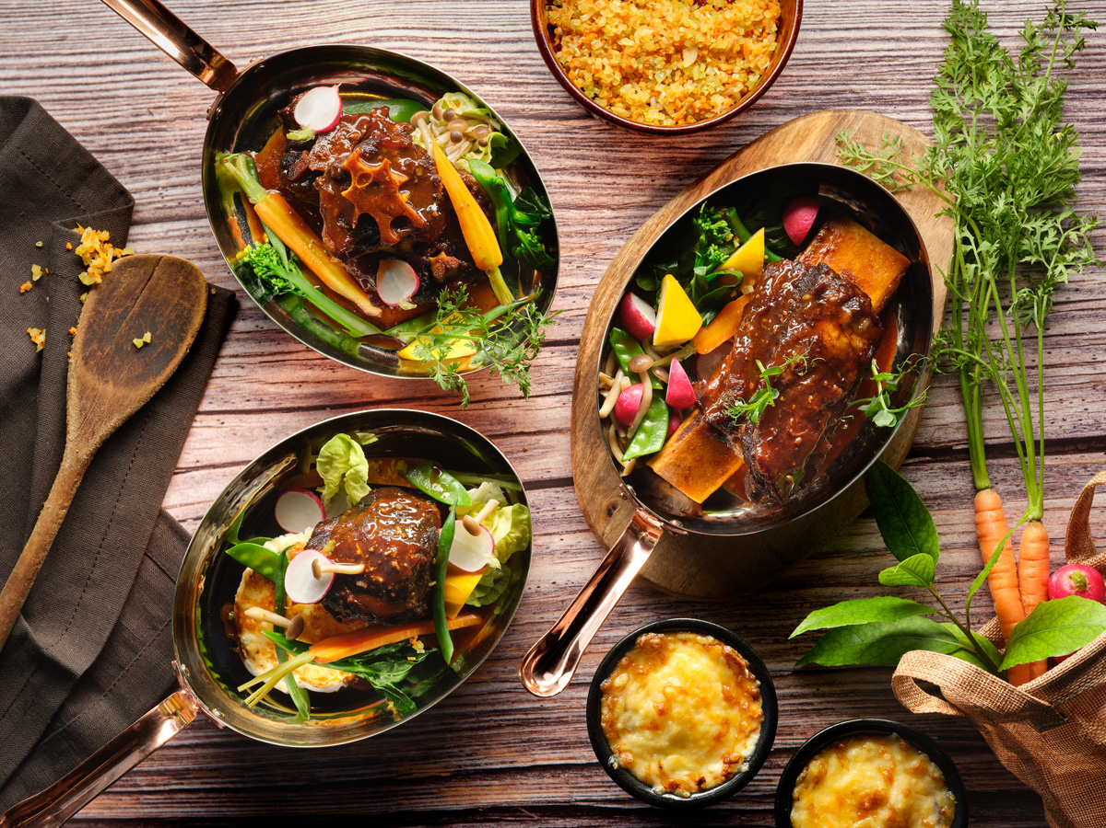
Singapore, 7 June 2019 – This July, Atrium and Pacific Marketplace delight their patrons by serving up a tantalising trio of slow-braised beef dishes. Available for one month only, guests can look forward to beautifully tender servings of Australian Wagyu featuring crowd-favourite cuts of short ribs, beef cheek and oxtail.

The meat cuts are sous vide for 18 hours in rich Carbernet Sauvignon jus, rosemary, thyme, shallots and garlic, resulting in an irresistible succulence and juicy aromatic meat with a melt-in-your-mouth deliciousness. The hearty delicacies are served with a satisfying Potato Dauphinoise and summer vegetables tossed in Pommery Mustard Vinaigrette.

Diners can perfectly complement their meal with house red wine, at a special price of SGD12++ per glass with any order of slow-braised beef dishes.

Availability:
1 to 31 July 2019, 11:00am to 10:00pm daily
Prices:
Slow-braised Wagyu Beef Cheek: SGD28
Slow-braised Wagyu Beef Oxtail: SGD28
Slow-braised Wagyu Beef Short Ribs: SGD32
Enjoy a glass of house red wine at SGD12 with any order of slow-braised beef dishes.
Venues:
Pacific Marketplace and Atrium (Ground Level), Pan Pacific Singapore, 7 Raffles Boulevard, Singapore 039595

All prices are subject to 10% service charge and 7% GST, unless otherwise stated.

For dining reservations and enquiries, please speak with us at +65 6826 8240 or email dining.ppsin@panpacific.com.

High-resolution Images can be downloaded here.

Media Contact
Ms. Gillian Teo
Assistant Director
Pan Pacific Singapore
E-mail: gillian.teo@panpacific.com
Tel: +65 6826 8095

Melissa Ng
Senior Marketing Communications Executive
Pan Pacific Singapore
Email: melissa.ng@panpacific.com
Tel: +65 6826 8094
Hotel Facebook: https://www.facebook.com/panpacificsingapore
Twitter: https://twitter.com/panpacificsgp
Instagram: http://instagram.com/panpacificsingapore

Pan Pacific Hotels and Resorts
With hotels, resorts and serviced suites across Asia, Oceania and North America, Pan Pacific provides a safe harbour in an ever-changing world. Places with less to worry about because, when you stay with us, rest assured that all will be taken care of. For this is where you will find your balance.

Pan Pacific Hotels Group
Pan Pacific Hotels Group is a wholly-owned hotel subsidiary of Singapore-listed UOL Group Limited, one of Asia’s most established hotel and property companies with an outstanding portfolio of investment and development properties.
Based in Singapore, Pan Pacific Hotels Group owns and/or manages 40 hotels, resorts and serviced suites with more than 12,000 rooms including those under development in Asia, Oceania, North America and Europe.

Voted “Best Regional Hotel Chain” by readers in Asia in 2017, Pan Pacific Hotels Group comprises two acclaimed brands: its signature brand, Pan Pacific and its deluxe brand, PARKROYAL.

Sincerity is the hallmark of Pan Pacific Hotels Group. The Group is known to its guests, partners, associates and owners for its sincerity in people and the sense of confidence which alleviates the stresses of today’s complex world.

About Pacific Marketplace
This gourmet grocery and café provides classic three-tier afternoon tea, croissants and pastries, as well as an extensive selection of cakes, chocolates, Asian delights, sandwiches and salads. The hotel’s signature Pan Pacific sausages and other exquisite deli goods are available for purchase at pacificmarketplace.sg.
About Atrium

Located in the heart of the lobby, Atrium presents a curated collection of craft beers, boutique wines and spirits. Guests can enjoy a bespoke cocktail at the dramatic 44-metre (144 feet) long bar – the longest in Asia – or have an intimate tête-à-tête at a private pod floating over a reflection pool.

