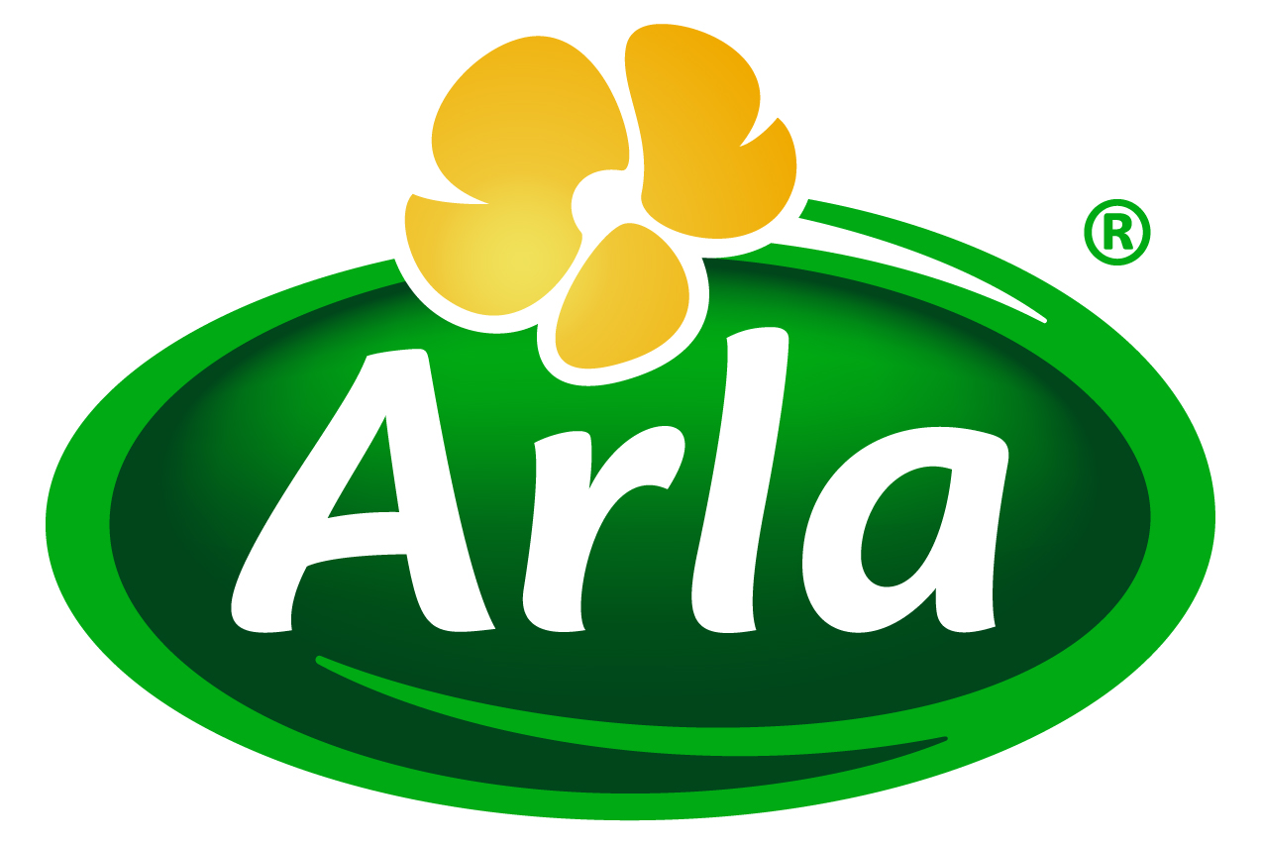

16 August 2016
PRESS RELEASE
New clean-label cooking solutions
cater for the foodservice market
Arla Foods Ingredients is serving up a new range of clean-label, dairy-based solutions for the foodservice sector.

The innovative ready-made cooking ingredients will make it easy for food companies to develop and supply foodservice products that are natural, healthy, convenient and stable – all of which are all key priorities for restaurant and catering businesses today.

Global foodservice sales are forecast to rise by 17% between 2015 and 2020. Growth in this market presents food companies with an excellent opportunity to expand their portfolio to include high quality products that will appeal to foodservice businesses all over the world.

As the sector grows, major trends commonly seen in the packaged foods market – such as clean labels and nutrition declarations – are rapidly migrating from supermarkets and into the out-of-home space, too. Arla Foods Ingredients’ new foodservice range addresses these trends by delivering distinct benefits, such as ease of handling, stability, improved texture and great taste.

The solutions available are:

- Cake topping
- Cooking cream
- Bake-stable cream cheese
- Cheesecake cream cheese

Produced with dairy proteins, they are much higher in protein and significantly lower in fat, calories and carbohydrates than standard equivalent products. They can easily be customised with colours, flavours and inclusions as required to create a wide variety of products that will excite both chefs and diners.

Torben Jenson, Category & Application Manager at Arla Foods Ingredients, said: “These cooking solutions will enable our customers to widen their product offering and take advantage of the great opportunity that foodservice offers. Our new concepts are healthy, convenient and clean-label, which means they are completely on-trend. They can be supplied as they are, or tailored to meet specific requirements, unlocking a world of new opportunities.”

The new foodservice solutions have been launched under Arla Foods Ingredients’ Goodness of Dairy* campaign, which highlights how dairy ingredients are key to tapping into growing consumer demand for food that is natural, healthy and offers great taste and texture.

*Protein contributes to growth in muscle mass, and calcium is needed for the maintenance of normal bones

ENDS

For more information contact: Richard Clarke, Ingredient Communications
Tel: +44 7766 256176 Email: richard@ingredientcommunications.com

About Arla Foods Ingredients
Arla Foods Ingredients is a global leader in natural whey ingredients for products in a range of categories – from sports, clinical and infant nutrition to beverages, bakery, dairy and ice cream. The cornerstones of our business are innovative ingredients, world-class facilities and a staff of dedicated experts. Drawing on our portfolio of functional and nutritional whey proteins, milk minerals, lactose and permeate, our expert team delivers solutions that bring new food products quickly and efficiently to market. Our application centres run hundreds of customer product trials every week. All ingredients are produced using state-of-the-art processing technology at our plant in Denmark, or by one of our joint ventures in Argentina, Germany and the UK. Arla Foods Ingredients Group P/S is a 100% owned subsidiary of Arla Foods, a global dairy company and cooperative owned by dairy farmers in Denmark, Sweden, the UK, Germany, the Netherlands, Belgium and Luxemburg.

RSS Feed
Visit our website at http://www.mynewsdesk.com/arla-foods-ingredients and sign up to our News RSS feed for all the latest developments – updated regularly.

Twitter
Follow us on twitter for all the latest updates @ArlaIngredients

LinkedIn
http://www.linkedin.com/company/arla-foods-ingredients

Facebook
https://www.facebook.com/arlaingredients

Consumer Foodservice: Euromonitor, from trade sources/national statistics, Date exported: 20-06-2016

