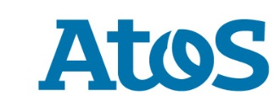
Press Release

Atos receives NATO Secret certification for its HSM TrustWay Proteccio®

Paris, September 29th 2016 – Through its technological brand Bull, Atos announces that the North Atlantic Military Committee has granted NATO Secret certification to the latest HSM TrustWay Proteccio®, the range of high-performance cryptographic appliances fully developed and made in France.
Obtaining this approval enables all members of the North Atlantic Treaty Organization (NATO) to meet their obligations to protect and secure keys with confidence.
Faced with the proven threat of cyberattacks that could threaten the very existence of governmental and military organizations, TrustWay Proteccio® is the benchmark security solution both in France and around the world. It offers a very high technological level of physical protection to manage keys and cryptographic operations to the benefit of critical applications in place in governmental administrations and defense companies.
"This new approval granted to TrustWay Proteccio® confirms Atos's position as a major European player in the design of cybersecurity solutions at a very high level that can meet the requirements of demanding international customers," says Chris Moret, VP of Cybersecurity at Atos. "It is part of our continuing efforts to develop high-security systems that are recognized and verified by the relevant certification bodies at both national and international level, in order to support the allied forces and ensure their operations are carried out successfully."
This year the TrustWay Proteccio® range from Bull has already received the Common Criteria EAL 4+ certification from the French Network and Information Security Agency (ANSSI), in addition to SOG-IS and the "Qualification Renforcée" (the highest qualification level from the ANSSI).
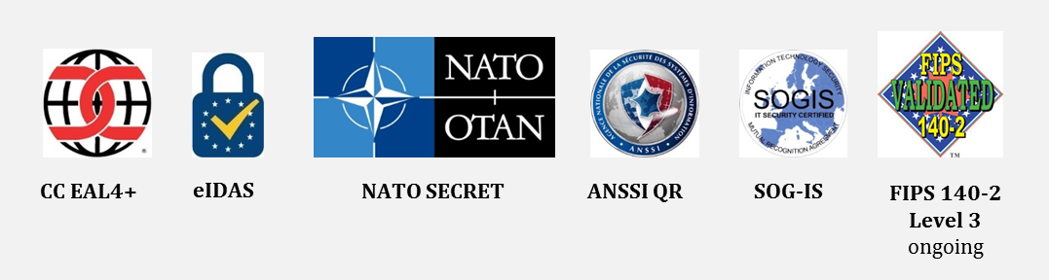
####

About Atos
Atos SE (Societas Europaea) is a leader in digital services with pro forma annual revenue of circa € 12 billion and circa 100,000 employees in 72 countries. Serving a global client base, the Group provides Consulting & Systems Integration services, Managed Services & BPO, Cloud operations, Big Data & Cyber-security solutions, as well as transactional services through Worldline, the European leader in the payments and transactional services industry. With its deep technology expertise and industry knowledge, the Group works with clients across different business sectors: Defense, Financial Services, Health, Manufacturing, Media, Utilities, Public sector, Retail, Telecommunications, and Transportation.
Atos is focused on business technology that powers progress and helps organizations to create their firm of the future. The Group is the Worldwide Information Technology Partner for the Olympic & Paralympic Games and is listed on the Euronext Paris market. Atos operates under the brands Atos, Atos Consulting, Atos Worldgrid, Bull, Canopy, Unify and Worldline.
Bull is the Atos brand for its technology products and software, which are today distributed in over 50 countries worldwide. With a rich heritage of over 80 years of technological innovation, 2000 patents and a 700 strong R&D team supported by the Atos Scientific Community, it offers products and value-added software to assist clients in their digital transformation, specifically in the areas of Big Data and Cybersecurity and Defense. www.bull.com|Follow @Bull_com
For more information, please contact:
Rhoda Dinesen
+65 6730 8524
rhoda.dinesen@atos.net

