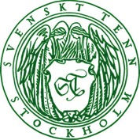
Press Release
Stockholm, April 8, 2016

Inspiration by Anika Reuterswärd at Svenskt Tenn’s spring exhibition

The iconic interior and furniture designer Anika Reuterswärd is curating the spring season exhibition ”Inspirations – Then and Now” at Svenskt Tenn in Stockholm. The displays are inspired by the collaboration between Svenskt Tenn’s founder Estrid Ericson and the designer Josef Frank, including sample works of her own and by other contemporary designers.

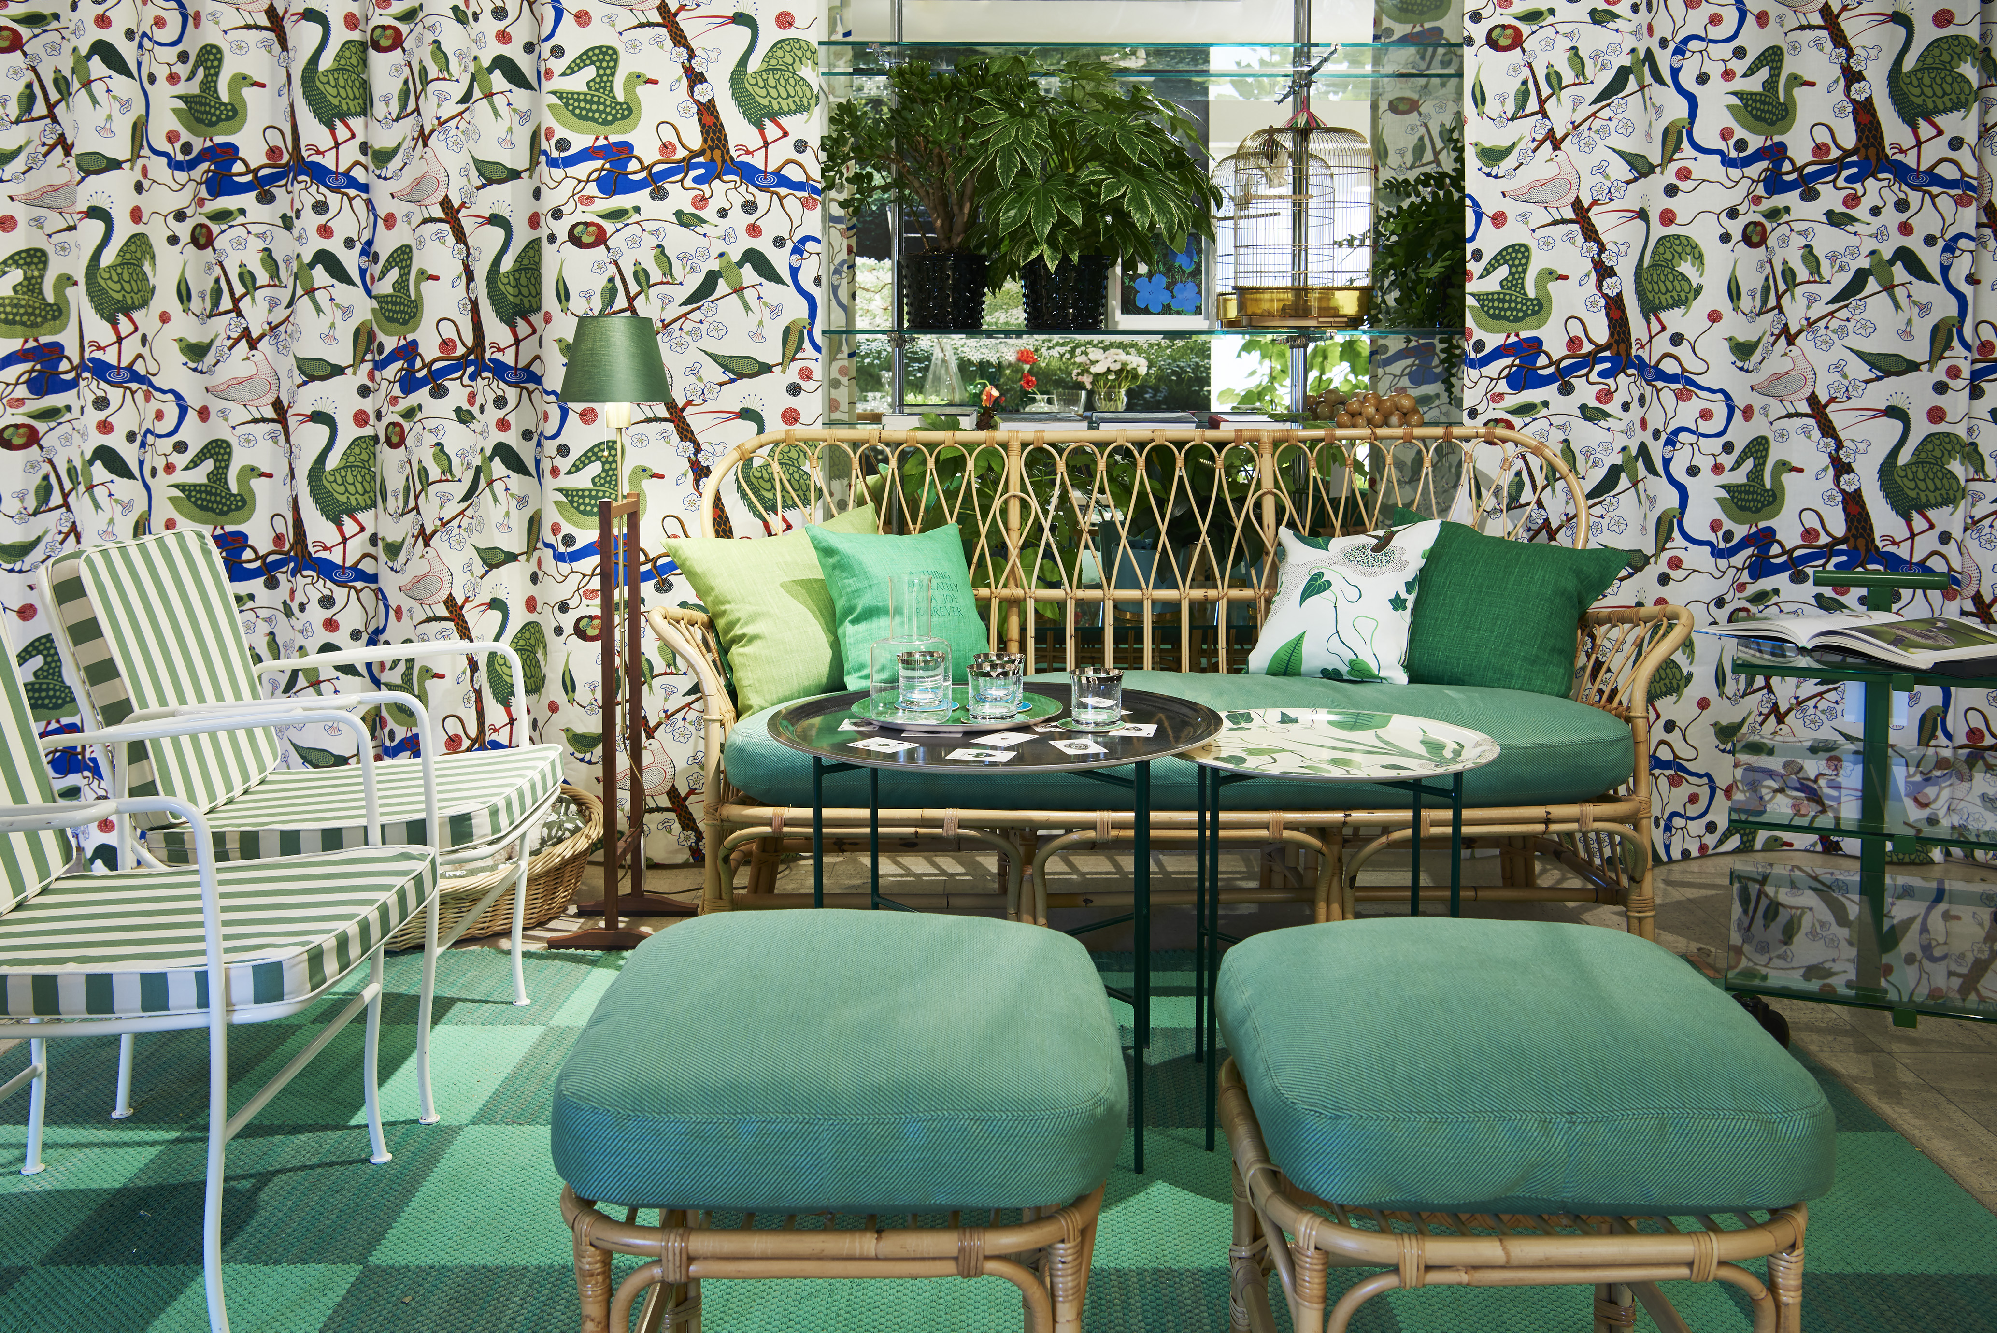
Interior and furniture designer Anika Reuterswärd began her career with the women’s weekly Femina as a trendsetting writer on style and design. In the early 1980s, she was recruited to the interior design magazine Sköna Hem, where she developed a uniquely personal style, using a blend of art, design and antiques.

”Anika Reuterswärd resembles a Grand Old Lady of Swedish interior design,” says Thommy Bindefeld, Marketing Director at Svenskt Tenn. “She devised a novel approach to the display of interiors and her work has had a profound impact on Swedish interior design. She has worked with Svenskt Tenn on several occasions before, most recently for our 85th anniversary when she created an exhibition at the Röhsska Museum in Gothenborg.”
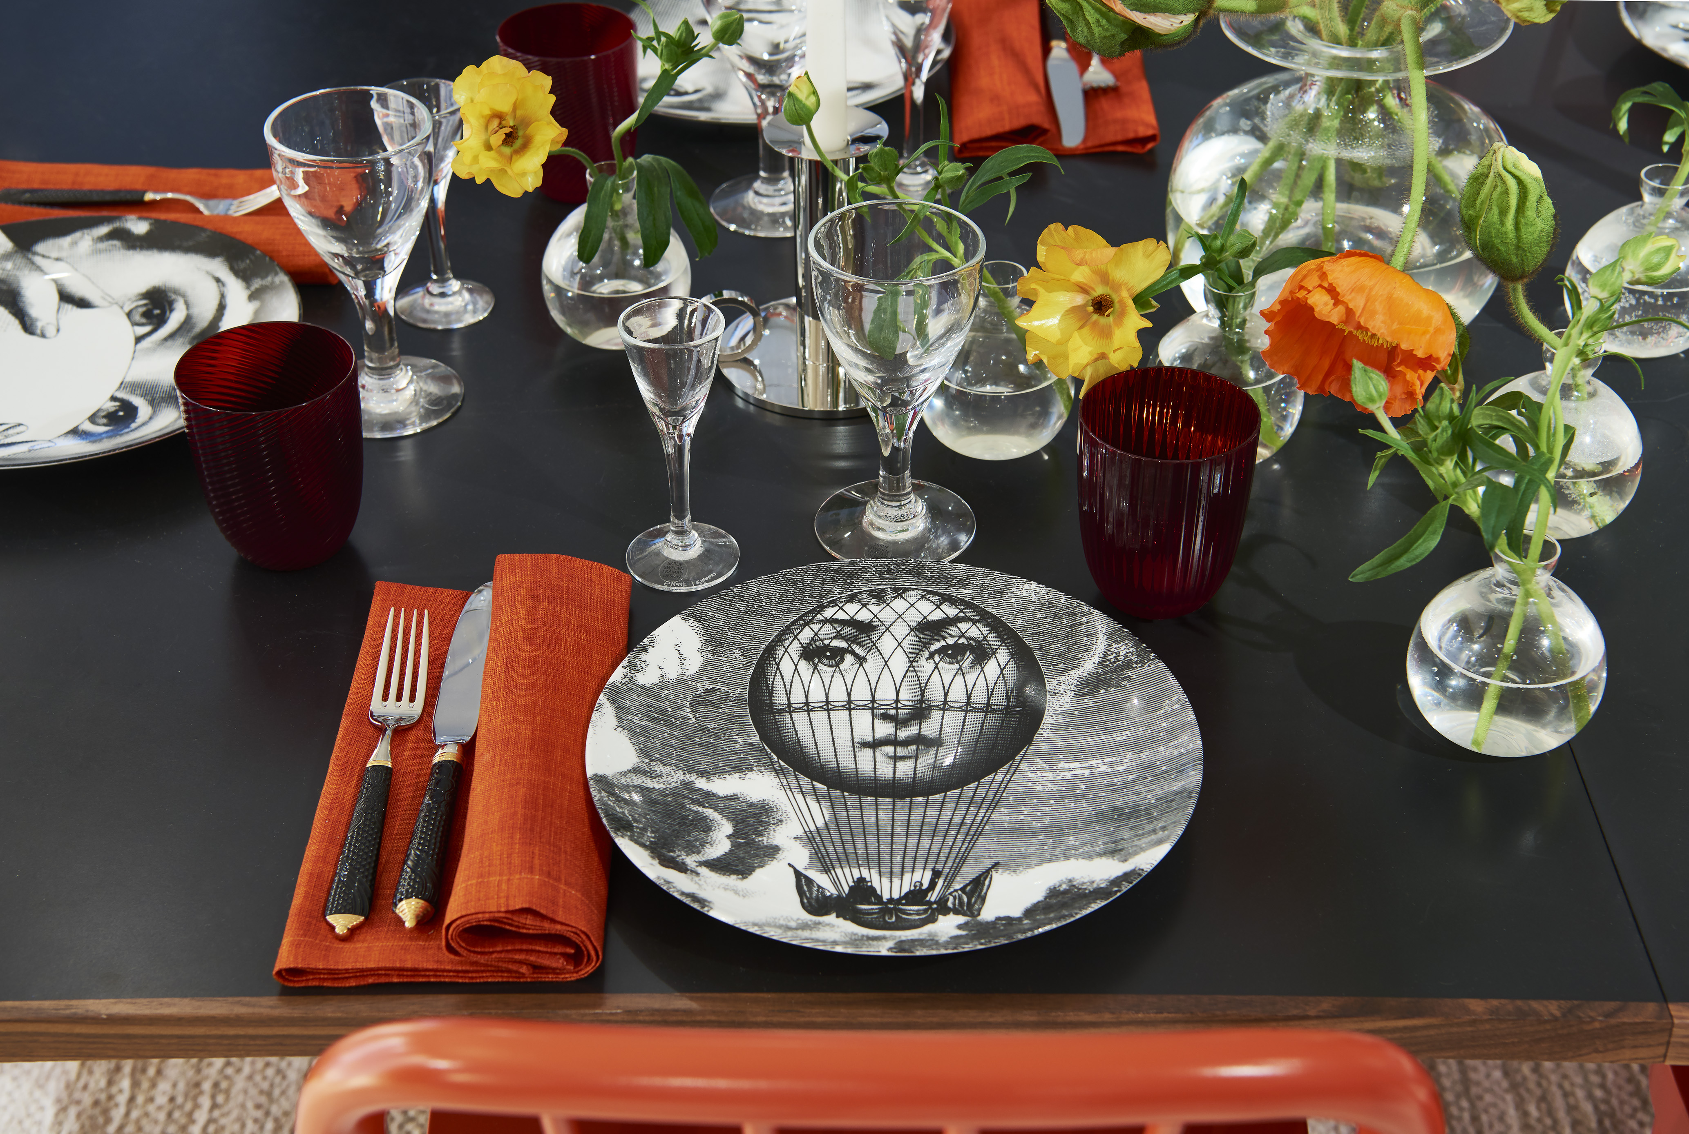
The spring exhibition is divided into four rooms using different colour themes that bring to mind the pure elegance of Estrid Ericson, as well as Josef Frank’s vivid environments. Comfortable seating, a set table and a lit fireplace are accompanied by birdsong and numerous plants that together will dissolve the line between indoors and outdoors.

”Svenskt Tenn has always stayed with me as a constant source of inspiration, and now, as my professional life is winding down, the circle is closed,” says Anika Reuterswärd. ”Once again, I have had the opportunity to curate an exhibition for Svenskt Tenn, this time offering my interpretation of Estrid Ericson and Josef Frank. The exhibition is complemented by a selection of my own designs, and works by some of my contemporary colleagues. It is my heartfelt wish that both Josef Frank and Estrid Ericson would have approved of my interpretation.”

The exhibition opens on April 8 and runs through May 22, 2016.

For further information, please contact:

Vicky Nordh, Marketing Assistant: +46 8-670 16 23 or vicky.nordh@svenskttenn.se

Thommy Bindefeld, Marketing Director: +46 8 670 16 02 or thommy.bindefeld@svenskttenn.se

Svenskt Tenn is an interior design company with retail stores at Strandvägen in Stockholm and online. Since 1975, Svenskt Tenn is owned by the Kjell and Märta Beijer Foundation, which provides research grants within ecology, medicine and the preservation of Swedish interior design tradition.

