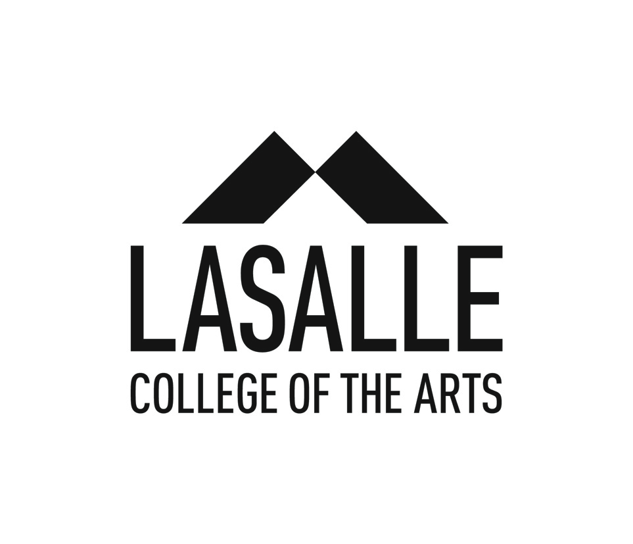

**MEDIA RELEASE**

**The LASALLE Show 2019 Season Celebrates the Promising Future of Arts Education in Singapore**

*Singapore, 21 March 2019*

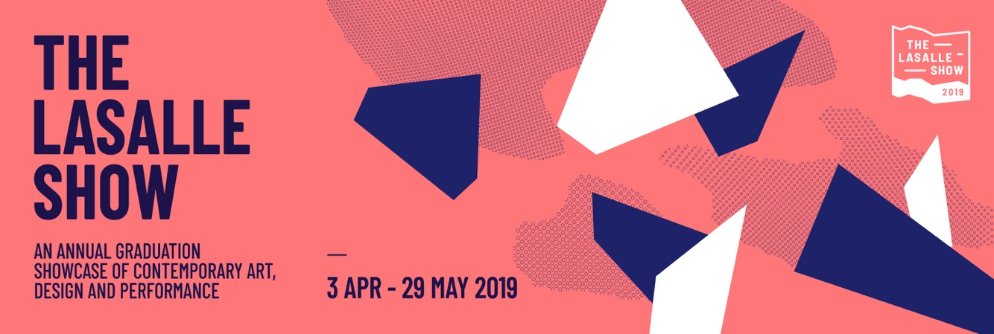

From early April to end May, almost 900 graduating students’ works will be up for public and industry viewing as part of LASALLE College of the Arts’ annual graduation showcase. Developed over the course of a student’s final year, The LASALLE Show represents the culmination of their artistic journey, as well as the manifestation of their dreams and passions. For the creative industries in Singapore, The LASALLE Show serves as a barometer of the state of contemporary arts and design, and the emerging practices of young artists.

Kicking off the season, the production of Joe Harbot’s ***A New and Better You***, by the graduating BA(Hons) Acting cohort of 2019, is an engaging and electrifying piece directed by **Edith Podesta** (2014, The Straits Times’ Life! Theatre Best Actress Award winner- Illogic, and 2017 Production of the Year and Best Original Script- BITCH: The Origin of the Female Species).

Following closely is ***Into the Dawn***, the springboard from which LASALLE’s Dance programme launches its graduating students into the world. This is a repertoire that will challenge them physically and expressively with a wide range of works from eclectic artists such as **Theo Clinkard (UK)**, **Liz Roche (Ireland)**, **Jacky Yu (Hong Kong)**, **Olee Khamchanla (France/Laos)** and **Kuik Swee Boon (Singapore)**.

Bringing the glitz and glamour, the show season transits into May with a full-fledged fashion show featuring shortlisted collections by the graduating students of LASALLE’s BA(Hons) Fashion Design and Textiles programme on the catwalk. An invite-only show, ***Simulation*** is also an opportunity for its fashion-savvy students to meet and establish relationships with industry heavyweights from the local and regional fashion scene.

Film lovers will want to obtain their tickets to the ***Avant Premiere***, a blockbuster screening of BA(Hons) Film students’ short films and documentaries at The Projector. This year’s graduating films showcase the best fiction and documentary narratives from LASALLE’s Puttnam School of Film & Animation, celebrating a multitude of stories ranging from the widest spectrum of landscapes, people, and emotions.

Drawing a close to the season is ***The LASALLE Show Exhibition 2019***. This grand finale showcases the best of artistic education in creativity and imagination, and the transformation of these young talents into professional artists in the larger creative industries ecosystem.

“The LASALLE Show has become an iconic season where we celebrate our graduands’ original work that showcases their creative journey with us. It sets the stage for these rising stars as they take the first step into their future careers in the arts and cultural scenes. The LASALLE Show is an annual celebration of creativity and passion that promotes critical discourse, as well as the promising future of arts education in Singapore,” said Professor Steve Dixon, President of LASALLE College of the Arts.

As Singapore’s leading contemporary arts and design tertiary institution, The LASALLE Show annually attracts strong attendance from government agencies, both local and regional, as well as distinguished individuals from the creative industries, attending to demonstrate their support of an arts education and to witness how today’s young talents might shape the trajectory of Singapore’s tomorrow.

The season runs from 3 April 2019 to 29 May 2018. Highlights include:

* ***Aida* (16 Apr – *20 Apr, 7:30pm; Matinee on 20 Apr, 2:00pm)***

An epic tale of love, loyalty and betrayal, *Aida* is a musical rock opera that embraces multicultural casting and exuberant dancing, soaring ballads and rousing choral numbers. With music by Elton John, lyrics by Tim Rice, and book by Linda Woolverton, Robert Falls, and David Henry Hwang, it went on to win 4 Tony Awards in the year 2000. *Aida* continues to be performed worldwide, with recent successful local performances in both Japan and Korea.

* ***Simulation:* LASALLE Graduate Fashion Show (9 May, 7:00pm)**

A concept inspired by philosopher Jean Baudrillard, this year’s BA(Hons) Fashion Design and Textiles students invite you to delve into an imaginative realm where the digital and the analog intertwine.

* ***The LASALLE Show Exhibition 2019* (Opening 16 May, 7:00pm; Exhibition period till 29 May, 12:00pm – 8:00pm daily)**

The LASALLE Show Exhibition is an annual exhibition by the final year students from the Diploma, Bachelor of Arts (Honours) and Master of Arts programmes. Showcasing the works of students from Design, Fine Arts, Film, Media Arts, Dance, Music, Theatre, Art Therapy and Arts Management.

Attached for your attention is the full-length The LASALLE Show Guide. For more information on The LASALLE Show Season, please head to: [www.thelasalleshow.com](http://www.thelasalleshow.com) The site will go live on April 1 2019.

To register for any of these shows, please reach out to Selena Sheikh at Pinpoint PR.

**About LASALLE College of the Arts**

LASALLE College of the Arts in Singapore is a leading tertiary institution in cutting edge contemporary arts and design education and practice. The college offers over 30 undergraduate and post-graduate programmes in art, design, film, animation, fashion, dance, music, theatre, arts management, artist education, art therapy, Asian art histories, and creative writing.

Its faculty is led by a community of award-winning artists, designers, educators and researchers, and their practice-led research sets LASALLE apart as an international centre of excellence. Critically acclaimed alumni form the core of the cultural and creative sectors in Singapore and increasingly internationally.

Founded in 1984 by de la Salle Brother Joseph McNally – a visionary artist and educator – LASALLE is a not-for-profit, private educational institution. LASALLE receives tuition grant support from the Singapore Ministry of Education. Its degree programmes are validated by Goldsmiths, University of London.

**For Media Enquiries, please contact:**

|  |  |
| --- | --- |
| Sabrina Zhang  Division of Communications  LASALLE College of the Arts  6496 5221  [sabrina.zhang@lasalle.edu.sg](mailto:sabrina.zhang@lasalle.edu.sg) | Selena Sheikh  Pinpoint PR  on behalf of LASALLE College of the Arts  9746 8519  [selena@pinpointpr.sg](mailto:selena@pinpointpr.sg) |