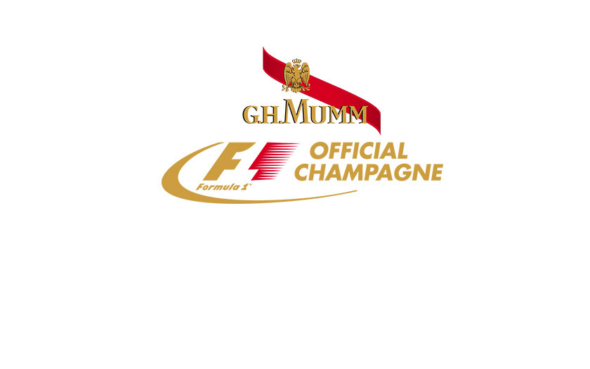
29 May 2013
Press release
Formula 1 Grand Prix de Monaco 2013
G.H.MUMM UNVEILS THE NEW LOOK OF ITS
ICONIC FORMULA 1 CORDON ROUGE JEROBOAM

Having recently revealed the new identity of its entire classic range, G.H.MUMM unveiled last week-end at the Monaco Grand Prix, the new design of its Formula 1 Cordon Rouge Jeroboam. Recognisable all over the world as an icon of Champagne, the G.H.MUMM Cordon Rouge Jeroboam has been awaiting the winner on the podium of every Formula 1 Grand Prix since 2000, perpetuating one of the most striking champagne rituals.

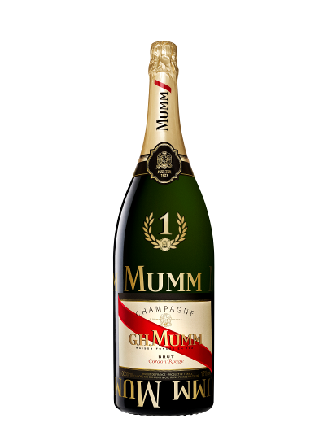
The F1 Champions’ Jeroboam enhanced
In line with the rest of the range, the new design of the Formula 1 Jeroboam reinforces the brand’s famous attributes whilst expressing its noble heritage. The emblematic red ribbon, originally created in 1876 as a tribute to the Legion of Honor, sees its grandeur restored with a more intense colour, gaining in volume, depth and texture. The initials of the founder of the House, Georges Hermann Mumm, are bolder and thicker, underpinning its historical status on the label. The crowned eagle symbol of nobility has been lightly reworked while preserving its original shape.

Asserting its association as the champagne dedicated to Formula One champions, the three-litre bottle now proudly features the laurel crown, traditional symbol of victory, enriched by a glorious number 1.

PLEASE DRINK RESPONSIBLY

An iconic Formula 1 ritual…
For the past 12 years, G.H.MUMM has been sharing the podium with the winning teams of Formula One racing, perpetuating an iconic victory ritual, today watched by more than 2 billion television viewers over the course of the season.

Every year the flagship Cordon Rouge, symbol of excellence of the House, echoes a tradition that has been part of Formula 1 since the creation of the World Championship in 1950. Indeed it was that very same year that the first tribute with champagne began, when the pre-eminent Formula One championship was created. The tradition of paying tribute to the winner with a bottle of champagne started that same year at the Reims-Gueux circuit in the Champagne region of France. But it was actually 16 years later when the prize-giving ceremony on the podium took the form that we know today. Jo Siffert, after winning his category of the 24 Hours of Le Mans, unwittingly enriched the tradition. On the podium, the cork popped out of his overheated bottle of champagne, showering the onlookers below. The following year, in 1967, Dan Gurney celebrated his victory by deliberately spraying the crowd, a gesture that is now a Formula 1 ritual.
Charles-Armand de Belenet, International Marketing Director of Martell Mumm Perrier-Jouët: “G.H.MUMM Cordon Rouge is the perfect expression of this shared celebration. The new identity of our Jeroboam reasserts our strong position as the champagne dedicated to Formula One champions”.

The new Formula One Jeroboam will be visible in all relevant Formula 1 Grand Prix.

For the Formula One fans, the celebrated Jeroboam will be available for sale in a prestigious wooden case as well as in a limited edition gift box, only available from quality Wine sellers and Department stores.
For more news about G.H.MUMM & Formula One, please visit: http://www.ghmumm.com/#/uk/formula1/podium-celebration

For more G.H.MUMM news, please visit our Press Room: http://digitalpressroom.ghmumm.com/fr/

PLEASE DRINK RESPONSIBLY

About G.H.MUMM
G.H.MUMM is part of Martell Mumm Perrier-Jouët, the prestigious cognac and champagne business of Pernod Ricard, world’s co-leader in Spirits & Wines. With its distinguished heritage dating back to 1827, G.H.MUMM is the leading international champagne House in France and third worldwide*. G.H.MUMM Cordon Rouge, recognisable by its red ribbon—a symbol of excellence—is the perfect embodiment of the spirit of the House: it stands out through the freshness and intensity of its style, which successive generations of cellar masters have successfully maintained and handed down. * IWSR 2012

Find more information about G.H.MUMM
Website : www.ghmumm.com/
Facebook : https://www.facebook.com/champagne.gh.mumm?fref=ts

For media inquiries
G.H.MUMM House of Champagne - Communication Department
Stéphanie Mingam Email: stephanie.mingam@pernod-ricard.com
Julia Burg Email: julia.burg@pernod-ricard.com
Frederik Willadsen Email: Frederik.willadsen@pernod-ricard.com

PLEASE DRINK RESPONSIBLY

