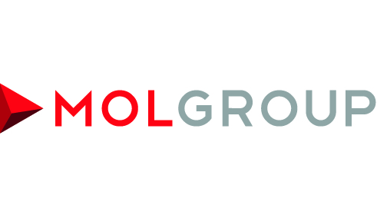

MOL Extends its Upstream Portfolio in the Central North Sea

* **MOL Group acquired offshore assets in 6 licenses from Premier Oil**
* **MOL’s 2P reserves increased by 14.3 MMboe from three producing fields**
* **MOL Group’s overall UK peak production is expected to reach 20-22 mboepd in 2018**
* **Purchase price USD 130 mn is subject to adjustments at closing**

**BUDAPEST – 30th June, 2014 – In line with MOL Group’s active portfolio development strategy, a Sale and Purchase Agreement has been signed with Premier Oil UK Limited (“Premier”) to acquire shareholding interest in Central North Sea offshore assets in 6 licences. The transaction contains certain assets of Premier Oil UK Limited including a balanced mix of existing and new production as well as both operated and non-operated exploration opportunities in the Scott-Telford and Rochelle Area** **for a consideration amounting to USD 130mn.**

The portfolio includes non-operated equity stakes in the Scott (21.84% unitised Working Interest (“WI”)), Rochelle (15% unitised WI) and Telford (1.59% unitised WI) fields, as well as participating interest in further exploration licences such as the Rochelle Upper Jurassic deep prospect.

The acquisition is estimated to increase MOL’s 2P Reserves by 14.3 MMboe from the three producing fields (Scott 9.3 MMboe, Rochelle 4.4 MMboe, Telford 0.5 MMboe), deriving from 73% oil and 27% from gas. Besides the reserves, further Prospective Resources (7 MMboe, unrisked) provide additional upside potential.

Year to date production from above-mentioned assets has averaged 3.7 mboepd, while the peak production of the assets is expected to reach 6.2 mboepd in 2016. Overall UK peak production for MOL now is expected to reach 20-22 mboepd in 2018. Together with MOL Group’s already existing assets in the UK North Sea, this transaction will combine to create considerable operational synergies. Key assets (Scott, Telford and Rochelle) are operated by Nexen, one of the largest and most reputable and experienced operators in the region.

Alexander Dodds, Group Executive Vice President for Upstream commented: *“This transaction extends the presence of MOL Group on the global map of offshore E&P and provides several additional strategic rationales. Building on our already existing assets in the UK North Sea, this acquisition represents a significant step forward in growing a solid sizable North Sea portfolio. I am certain that these assets are of considerable quality and will bring further positive results. The synergies gained with this transaction will complement MOL‘s ambitions, and help realize the company’s vision of considerable growth of its international portfolio.”*

**Press contact**

|  |  |
| --- | --- |
| Judit Németh MOL Group International Communications Expert             m: +36 20 254 5169 | @: [junemeth@mol.hu](mailto:junemeth@mol.hu) | Tamás Berzi MOL Group International Communications Expert             m: +36 20 409 7632 | @: [tberzi@mol.hu](mailto:tberzi@mol.hu) |