Press release
Düsseldorf, 01/08/2023
Earth overshoot Day:
Over 25,000 tons of CO₂ saved through the trade of used machinery
2nd August 2023 is this year’s Earth Overshoot Day. Through the global trade of used machinery on Surplex.com, more than 25,000 tons of CO₂ were saved last year, which pushes back the Earth Overshoot Day by more than 11.5 seconds. Because a globally networked market for used machinery acts as a circular economy for production resources and thus contributes to a sustainable future.
The Earth Overshoot Day is an annually calculated date, from which the resources consumed by humans exceed the Earth’s capacity for regeneration in that year. In other words: From this date, we are living on credit and consuming more natural resources than the Earth can reproduce in a year. The Earth Overshoot Day is calculated by the Global Footprint Network. Various factors, such as the production of greenhouse gases, resource consumption, and deforestation, are taken into account.
This year, it will be on 2nd August 2023. By then, we will have already consumed all the resources that our Earth can regenerate and provide in this year.
Every contribution shifts the date
CO₂ emissions are responsible for 60% of humanity’s ecological footprint. Therefore, the decarbonisation of our economy would be a significant opportunity. Trading in used machinery is one opportunity, as it saves considerable resources. If discarded machines are not scrapped but sold and thus continue to be utilised, the used machinery market can serve as an element in the circular economy. The circular economy is a system based on the reuse and recycling of resources, rather than consuming and disposing of them. Used machinery plays a central role in this. Reusing machinery not only extends their life cycle but also reduces the need to manufacture new machines, thereby consuming fewer resources and producing less waste. This leads to a significant reduction in the ecological footprint.
#MoveTheDate with Surplex
In 2022, 14,000 larger machines, plants, and equipment were sold through Surplex.com – plus many other industrial goods, operational facilities, and accessories that were not included here. If these machines and systems had been manufactured anew instead, over 20,000 tons of steel would have had to be produced. This alone would have emitted more than 25,000 tons of CO₂. These could be saved through the Surplex platform, which has pushed back the Earth Overshoot Day by more than 11.5 seconds. With this, Surplex is making a sustainability contribution for the future. If we are able to push back the date of the Earth Overshoot Day by six days every year, humanity could reach the limits of sustainability by 2050.
So, 11.5 seconds are still far from enough. The current problem of the used machinery market is that European production facilities and machine trading are not sufficiently networked with each other. This deficiency has been identified by the partners of the EU project ALICIA. Twelve teams from industry and research, including Surplex and especially the Surplex site in Spain (Surplex Ibérica), are researching for three years under the leadership of the Technical University of Munich. The project is being funded as part of the Horizon programme by the European Union. The ALICIA’s vision: In five to ten years, production resources – such as entire production lines, individual machines, and spare parts – should be traded and reused among the individual factories in Europe until their lifespan is fully exhausted. Current estimates suggest that, for example in the automotive industry, up to 70% of the production equipment is taken out of service prematurely, which is both uneconomical and unecological. ALICIA, short for “Assembly Lines in Circulation”, wants to change this. And Surplex can only support this.

Photo 1
The Earth Overshoot Day in industrialised countries is much earlier than in less developed countries. With #PowerOfPossibility, industry can also make its sustainability contribution.
(© Thungphoto / Shutterstock.com).
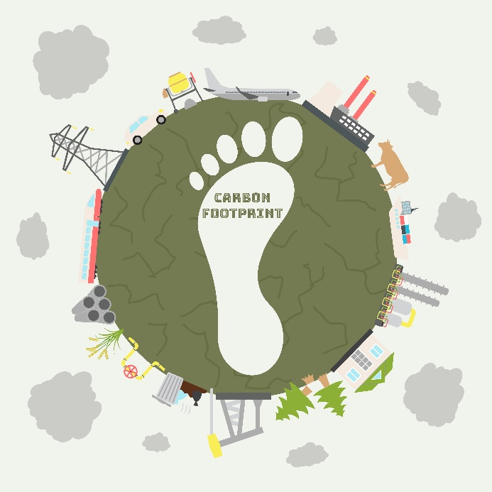 | Photo 2  CO₂ emissions account for 60% of the ecological footprint. Halving the carbon component would postpone Earth Overshoot Day by 93 days. Trading used machinery on Surplex.com could contribute over 11.5 seconds in 2022.  (© m.malinika / Shutterstock.com).

