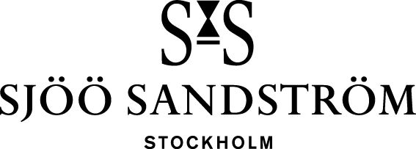

Press release, Stockholm, 2023

**The new Royal Capital in stainless steel.**

Building on a long tradition of esteemed watchmaking, this exclusive timepiece intermingles enduring knowledge with Swedish luxury, which thrives on freedom, sensuality and experiences in nature. The achievement of an exclusive partnership between Sjöö Sandström and Vaucher, Royal Capital is an unprecedented creation in which Swedish design meets Swiss perfection. The result is an extraordinary work of art that transcends time.

We have since the launch of Royal Capital in 2014 taken a giant leap in Swedish watchmaking and will carry on the development of this exclusive timepiece. Now it’s once again time to carry on the legacy within the Royal Capital family.

The new Royal Capital in stainless steel comes with the complication date and in two different executions, black and blue. And being as rare as nature itself, it is available in only 50 pieces manufactured each year. Swedish luxury is not measured in abundance or material wealth, it is rather about freedom, sensuality, and experiences in nature. True to its native heritage, Royal Capital celebrates this minimalistic luxury also in its upgrades.

The new Royal Capital in stainless steel is the epitome of Swedish Luxury, with a movement crafted in the heart of Switzerland. Vaucher movement 5400 provides the backbone of Royal Capital. At 2,9mm caliber 5400 is an extra-thin movement that smoothly combines finesse and robustness. A rare gem with an exceptionally high level of finishing.

Vaucher Manufacture have been crafting movements in Fleurier, Switzerland, since the mid-18th century and we are extremely proud to continue our journey together.

**Specifications:**

CASE: Stainless steel Ø40 mm, thickness 8,1 mm incl. curved sapphire crystal.

DIAL/HANDS: Black or Blue, satin and polished index and hands.

CASE-BACK: Stainless steel, see-through with sapphire crystal.

CROWN: Stainless steel with engraved logo.

WATER-RESISTANCE: 10 ATM (100 m)

BRACELET: Black or Blue genuine alligator bracelet with curved fitting, 20 mm.

BUCKLE: Pin buckle with engraved logo.

**MOVEMENT:** Automatic movement with micro rotor (Vaucher Manufacture 5400)

**CALIBER**: SSG8

**POWER RESERVE:** 48h

RRP: 82.300 SEK

[www.sjoosandstrom.com](https://www.sjoosandstrom.com/collection/royal-capital)

**For more information, please contact:**   
Kristofer Johansson

Press contact, Sjöö Sandström Sweden AB

[kristofer.johansson@sjoosandstrom.se](mailto:kristofer.johansson@sjoosandstrom.se)

Telephone: +46 760 06 82 90