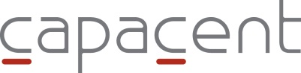 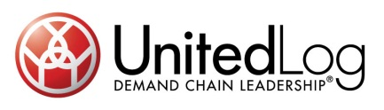

Press Release, June 29, 2011

**Change in management consulting industry – Capacent and UnitedLog Consulting join forces**

**Capacent and UnitedLog Consulting are joining forces to form a leading management consulting company in Sweden and Finland. Together with Capacent's activities in the other Nordic countries, and with its 275 employees, Capacent offers the market an alternative to the global consulting firms.**

With operations in Sweden, Finland and China, UnitedLog Consulting has a strong position in Operational Excellence and Supply Chain Management consulting services.

The merger entails that Capacent will acquire the consulting business – UnitedLog Consulting – from UnitedLog Group. Through the deal, UnitedLog Group will become a major owner of Capacent in Sweden and Finland.   
  
As a result of the deal, Capacent's operations in Sweden in Finland will include a total of 100 employees.

"UnitedLog Consulting's orientation and strong position in Supply Chain Management strengthens Capacent's management consulting offering. Together we will have a comprehensive offering, and Capacent will now have a clear position as the largest and leading Operational Excellence consultancy in the Nordic countries", said the two companies' boards' in a joint statement.

**For further information, please contact:**

Hendrik Trepp, Chairman, Capacent Sweden and Finland

Tel: +46 70 558 53 64

E-mail: [hendrik.trepp@capacent.se](mailto:hendrik.trepp@capacent.se)

Jimmy Tjärnlund, Chairman, UnitedLog Group AB

Tel: +46 70 299 97 72

E-mail: [jimmy.tjarnlund@unitedlog.com](mailto:jimmy.tjarnlund@unitedlog.com)

**About Capacent**

Capacent is a Nordic management consulting firm with 275 employees in Sweden, Finland, Denmark, Iceland and Norway. Our business concept is to work according to our clients' strategic agendas and delivery enduring results in their critical business processes by blending solid consulting expertise with depth of industrial knowledge. Our clients consist primarily of large industrial and service companies, private equity firms, financial institutions and the public sector. For more information, go to [www.capacent.co](http://www.unitedlog.co)m

**About UnitedLog Group**

UnitedLog is the leading Supply Chain company in the Nordic region. We develop and streamline Nordic based customer's global flow of goods, information and capital. UnitedLog offer Management Consulting in SCM, specialized software for Control Tower Applications and Outsourcing Services for Logistical Processes. Being Nordic based with global reach, UnitedLog are active through own offices and partner networks in Europe, North America and Asia. The company is owned and operated by the founders together with the 6th AP-fund and AB Arvid Svensson. For more information, go to www.unitedlog.com