**Treatment solutions from** **DENTSPLY Implants   
for improved quality of life**

*March 2015*—A prosthetic solution with the comfort of a fixed restoration; a patient-specific suprastructure on transgingival implants that eliminates the need for additional abutments; and an implant for sloped ridge situations for excellent esthetic results.

These are the respective benefits of DENTSPLY Implants’ treatment solutions   
ATLANTIS Conus concept, ATLANTIS ISUS implant suprastructures on XiVE TG implants,

and the OsseoSpeed Profile EV implant.

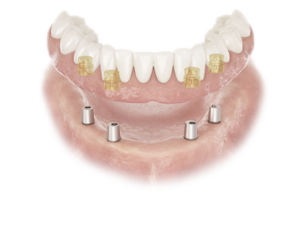

**ATLANTIS Conus concept**

ATLANTIS Conus concept,for all major implant systems, is a new prosthetic solution that provides removable prosthesis with the comfort of a fixed restoration; the patient-specific ATLANTIS Conus Abutment together with prefabricated SynCone caps provide patients with a unique, cost-effective, friction-retained and non-resilient prosthetic solution; this solution offers renewed patient comfort and confidence, and helps to eliminate problems often associated with dentures, such as pain.

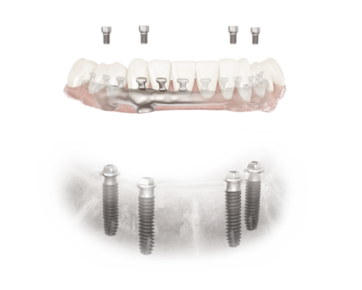

**Patient-specific suprastructures on transgingival XiVE implants**

ATLANTIS ISUS implant suprastructures on XiVE TG implants provide the advantages of a patient-specific custom restoration and the cost-effectiveness of a transgingival implant design, eliminating the need for additional abutments. With the XiVE TG implant, high primary stability is achieved in all types of bone.

**OsseoSpeed Profile EV implant**

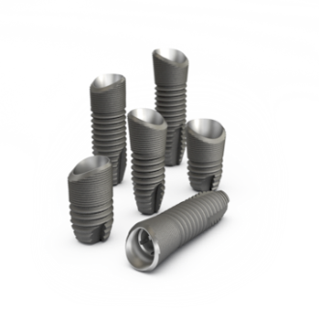The OsseoSpeed Profile EV implant is the second generation of the uniquely shaped, patented implant specifically designed for sloped ridge situations that allow you to achieve 360° bone preservation, a prerequisite for excellent esthetic result. This innovative implant was first introduced in 2011 and is now upgraded with the simplicity and design principles of ASTRA TECH Implant System EV.

The launch of the ASTRA TECH Implant System EV has been very successful and well received around the world, and the OsseoSpeed Profile EV implant will be a welcome addition to the product line.

**Treatment solutions & product highlights**

The advantages of an extensive and comprehensive product portfolio include the possibility for many treatment solutions for all indications. At IDS, DENTSPLY Implants’ treatments solutions and product highlights include:

* SIMPLANT computer guided implant treatment with the ASTRA TECH Implant SystemEV, a unique combination that unlocks the potential of computer guided implant treatment and digital crown-down planning with a simple implant procedure and a digital workflow to ensure an efficient treatment process, predictable results, and enhanced outcomes for patients;
* the release of SIMPLANT 17 software, where the implant relations calculator shows important planned implant relations, such as the distances between implants, implant vertical heights and implant inclination compared to the desired insertion direction; in addition, multiple implants can be moved and rotated as a group, making it easy to plan for optimal implant prosthetics;
* the SYMBIOS regenerative solutions portfolio, including bone graft material,   
  membranes and instruments, with a presentation of SYMBIOS Collagen   
  Membrane SR (slow resorbable) and SYMBIOS Biphasic Bone Graft Material;
* the introduction of the ATLANTIS Abutment Insertion Guide, making it easier and safer to install a patient-specific, cement-retained ATLANTIS Abutment;
* intraoral scanning for ATLANTIS Abutment with iTero; and
* new interfaces for ATLANTIS abutments, including ANKYLOS C/X C/ non-indexed and NobelReplace Conical Connection.

The implant systems and ATLANTIS patient-specific solutions beyond CAD/CAM are covered by DENTSPLY Implants comprehensive warranty program.

**DENTSPLY Village**

In the large DENTSPLY Village, a joint presence of DENTSPLY divisions, DENTSPLY Implants presents their solutions portfolio in various areas, highlighting the freedom to create predictable and lasting patient-specific implant solutions with an extensive line of dental implants, bone regenerative products, digital technologies and professional development tools.

You will find DENTSPLY Implants in **hall 11.2, aisle K-M, booth 030-039.**

**About DENTSPLY Implants**

*DENTSPLY Implants offers comprehensive solutions for all phases of implant therapy, including ANKYLOS®, ASTRA TECH Implant System™ and XiVE® implant lines, digital technologies, such as ATLANTIS™ patient-specific CAD/CAM solutions and SIMPLANT® guided surgery, SYMBIOS® regenerative solutions, and professional development programs. DENTSPLY Implants creates value for dental professionals and allows for predictable and lasting implant treatment outcomes, resulting in enhanced quality of life for patients.*

**About DENTSPLY International**

*DENTSPLY International Inc. is a leading manufacturer and distributor of dental and other healthcare products. For over 110 years, DENTSPLY’s commitment to innovation and professional collaboration has enhanced its portfolio of branded consumables and small equipment. Headquartered in the United States, the Company has global operations with sales in more than 120 countries.*

**For further information, please contact:**

Kerstin Wettby – Senior Manager, Global Marketing | Communication & PR, DENTSPLY Implants, Sweden

Cell phone +46 705 16 32 02 | [kerstin.wettby@dentsply.com](mailto:kerstin.wettby@dentsply.com) | [www.dentsplyimplants.com](http://www.dentsplyimplants.com)

As a member of the press, you can also visit our News & Press Room at:

[www.dentsplyimplants.com/en/Resources/News-and-Press](http://www.dentsplyimplants.com/en/Resources/News-and-Press)



###