sika simplifies its range of MARINE PRIMERS

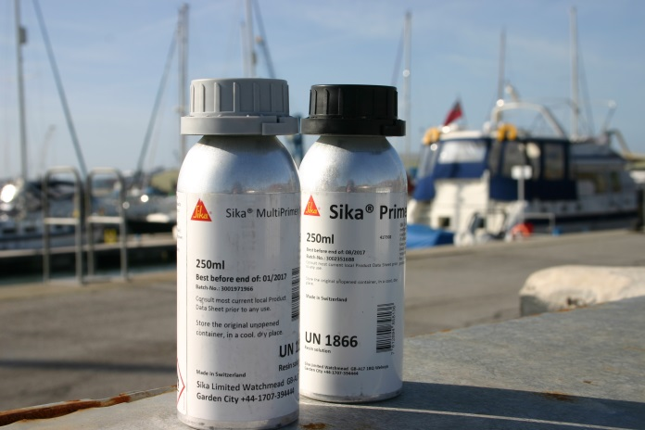

**Sika, a world leader in bonding, sealing, waterproofing, and insulation products, has streamlined its range of marine primers to offer greater transparency of use for its customers. Sika now offers just two marine primers, Sika® MultiPrimer Marine and Sika® Primer-207, which have been designed to improve the adhesion of Sikaflex® adhesives on a range of substrates.**

Sika® MultiPrimer Marine has been designed to offer excellent adhesion performance on substrates such as wood, metal, plastic and two component painted areas. As a low viscosity liquid primer, it is easy to use and apply and offers excellent durability.

Sika® Primer-207 Areas of Application Sika® Primer-207 is a black, moisture curing liquid primer specifically formulated to give improved adhesion on substrates such as float glass, ceramic-coated glass, plastics, pre-coatings, painted surfaces, e-coats and metals. Sika® Primer-207 combines reduced flash-off time and fast adhesion built-up and fluoresces under long-wave UV light.

Gareth Ross, Sika UK’s Marine Market Field Specialist explains why using a primer is important, “Good preparation lays the foundation for a properly bonded or sealed substrate so using products such as cleaners and primers prior to adhesion will ensure the best long-term results.”

Alongside its two marine primers, Sika also offers two products which have been designed to prepare the surface prior to priming it. Sika® Remover 208, a solvent based cleaner, is used to remove traces of Sikaflex® products as well as for cleaning painted substrates. Sika®Aktivator-205 (previously Sika® Cleaner-205), is pre-treatment agent for non-porous substrates containing a bond activating substance.

Sika’s marine primers, cleaners and pre-treatment agents are manufactured in line with the ISO 9001 / 14001 quality assurance system and meets the low spread of flame requirements specified by the International Maritime Organisation (IMO). They are also Wheelmark approved.

Sika® MultiPrimer Marine and Sika® Primer-207 are available in 250ml and 1 litre bottles. For retail prices, please contact your nearest Sika® stockist.

For further information, visit [www.sikamarine.co.uk](http://www.sikamarine.co.uk) or contact Sika on Tel: +44 (0) 01707 394444.

Ends

For further information, please contact:

Karen Bartlett

Saltwater Stone

Telephone: +44 (0) 01202 669244

Email: k.bartlett@saltwater-stone.com

**Notes to Editors:**

Sika Limited is a wholly owned subsidiary of Sika AG, a specialty chemicals company with a leading position in the development and production of systems and products for bonding, sealing, damping, reinforcing and protection in the building sector and automotive industry. Sika has subsidiaries in 97 countries around the world and manufactures in over 170 factories. Its more than 17,000 employees generated annual sales of CHF 5.49 billion in 2015.

In the UK, Sika provides market-leading solutions for flooring, sealing and bonding applications, waterproofing, roofing, structural sealing and strengthening and many other construction applications.

Sika UK’s head office is based in Welwyn Garden City at Watchmead, Welwyn Garden City, Hertfordshire, AL7 1BQ. Call 01707 363866, or visit [www.sika.co.uk](http://www.sika.co.uk).